*Biology Name
Date Period

STUDYING PEDIGREES ACTIVITY
Introduction: A pedigree is a visual chart that depicts a family history or the transmission of a specific trait. They can be interesting to view and can be important tools in determining patterns of inheritance of specific traits. Pedigrees are used primarily by genetic counselors when helping couples decide to have children when there is evidence of a genetically inherited disorder in one or both families. They are also used when trying to determine the predisposition of someone to carry a hereditary disease for example, familial breast cancer.

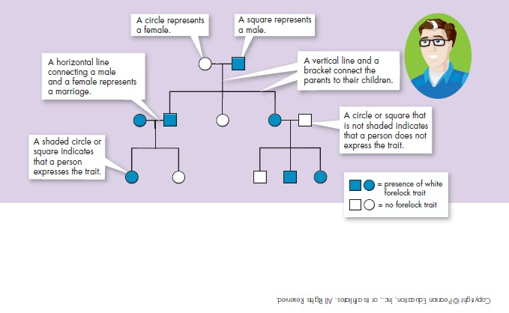

The Components of a Pedigree:

Squares are used to indicate males in a family. Circles are used to indicate females.
If the individual is “affected" by the trait (dominant or recessive) we darken the shape.

A line between a male and a female indicates a marriage or union. A line drawn down from the marriage line indicates offspring.

Sometimes, you will see some shapes filled in only half way -
this notation indicates a hybrid (heterozygous) or carrier of the trait.

Read pages 396-397 (Sect. 14.1) in your textbook for more information.

Analyzing Simple Pedigrees:

A pedigree is just like a family tree except that it focuses on a specific genetic trait. A pedigree usually only shows the phenotype of each family member. With a little thought, and the hints below, you may be able to determine the genotype of each family member as well!

Hints for analyzing pedigrees:

- If the individual is homozygous recessive, then both parents MUST have at least one recessive allele (parents are heterozygous or homozygous recessive).

- If an individual shows the dominant trait, then at least one of the parents MUST have the dominant phenotype. This one will be pretty obvious when you look at the pedigree.

3) If both parents are homozygous recessive, then ALL offspring will be homozygous recessive.

NOTE: In a pedigree, the trait of interest can be dominant or recessive. The majority of harmful genetic conditions are only seen when an individual is homozygous recessive - examples of conditions caused by recessive alleles include cystic fibrosis (a disease of the secretory glands, including those that make mucus and sweat), Falconi anemia (a blood disorder), albinism (a lack of pigmentation), and phenylketonuria (a metabolic disorder). Some genetic conditions are caused by dominant alleles (and may therefore be expressed in homozygous dominant or heterozygous individuals)- examples of conditions caused by dominant alleles include polydactyly (presence of extra fingers), achondroplasia (a type of dwarfism), neurofibromatosis (a nervous disorder), and a disease known as familial hypercholesterolemia in which affected individuals suffer from heart disease due to abnormally high cholesterol levels

Human Pedigrees
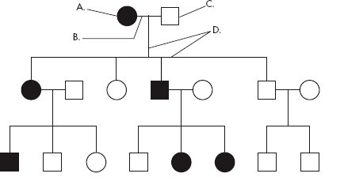For Questions 1-9, use the pedigree chart shown below. Some of the labels may be used more than once.

___C_____ 1. A male
A 2. A female
___B_____ 3. A marriage

A 4. A person who expresses the trait
C 5. A person who does not express the trait
D 6. A connection between parents and offspring

____3____ 7. How many generations are shown on this chart?

Assuming the chart above is tracing the dominant trait of "White Forelock (F)" through the family. F is a tuft of white hair on the forehead.
___Ff_____8. What is the most likely genotype of individual “A”? (FF, Ff or ff?)
___ff_____9. What is the most likely genotype of individual “C”? (FF, Ff or ff?)

Example 1: Tracing the path of an autosomal recessive trait

Trait: Falconi anemia

Forms of the trait:
⇧ The dominant form is normal bone marrow function - in other words, no anemia.
⇧ The recessive form is Falconi anemia. Individuals affected show slow growth, heart defects, possible bone marrow failure and a high rate of leukemia.

A typical pedigree for a family that carries Falconi anemia. Note that carriers are not indicated with half- colored shapes in this chart.

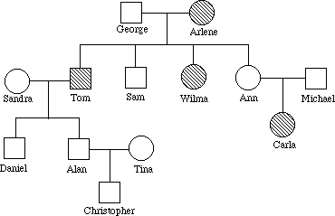
Ff
ff
Ff

F-
Analysis Questions.

To answer questions #1-5, use the letter "f" to indicate the recessive Falconi anemia allele, and the letter "F" for the normal allele.

- What is Arlene's genotype? ff

- What is George's genotype? Ff

- What are Ann & Michael's genotypes? Ff

- Most likely, Sandra's genotype is FF .

- List three people from the chart (other than George) who are most likely carriers of Falconi anemia.
George, Ann, Michael

*Example 2: Tracing the path of an autosomal dominant trait

Trait: Neurofibromatosis

Forms of the trait:
 The dominant form is neurofibromatosis, caused by the production of an abnormal form of the protein neurofibromin. Affected individuals show spots of abnormal skin pigmentation and non-cancerous tumors that can interfere with the nervous system and cause blindness. Some tumors can convert to a cancerous form.
 The recessive form is a normal protein - in other words, no neurofibromatosis.

A typical pedigree for a family that carries neurofibromatosis is shown below. Note that carriers are not indicated with half-colored shapes in this chart. Use the letter "N" to indicate the dominant neurofibromatosis allele, and the letter "n" for the normal allele.

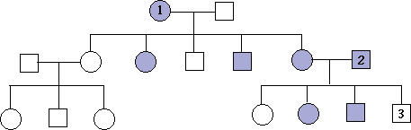
nn
nn
Nn
nn
N-

Analysis Questions:

- Is individual #1 most likely homozygous dominant or heterozygous? Explain how you can tell.

Heterozygous. She has children without the disorder that would have inherited the “n”

- What is the genotype of individual #3? nn

- Can you be sure of the genotypes of the affected siblings of individual #3? Explain.
No. Since both parents are heterozygous, there is a 50% chance of inheriting each allele from each parent.

