**Pedigree Worksheet** Name: _________________________

A sex-linked recessive characteristic is determined by an allele that is carried only on the X chromosomes. The shorter Y chromosome does not carry an allele for a sex-linked trait. Since there is only one X in his genotype, XY, a male who carries a particular recessive allele on the X chromosome will have the sex-linked condition. A female who carries a recessive allele in one X chromosome will not show the condition if there is a dominant allele on her other X chromosome. She will express the recessive condition only if she inherits two recessive alleles – one from each parent. Her chances of inheriting the condition are thus greatly reduced. One sex linked trait is hemophilia, a condition in which the blood does not clot properly. Most people who have hemophilia are men.

**A. Interpreting a human pedigree. Refer to the pedigree below that depicts red-gree colorblindness, a recessive, X-linked trait.**

1. Number all individuals on the pedigree at the top of each shape.

*2. How many males are there? ______8____________*

*3. How many males have hemophilia? ____3________*

4. *How many female are there? ______8___________*

5. *How many females have hemophilia? ___2_______*

6. How many marriages are there? ______3_________

7. *How many children did the first couple (couple in row I) have? _____2_________*

*8. How many children did the third couple (couple in row III) have? ___7__________*

9. *How many generations are there? ____4___________*

10.*How many members are there in the fourth generation? ___7__________*

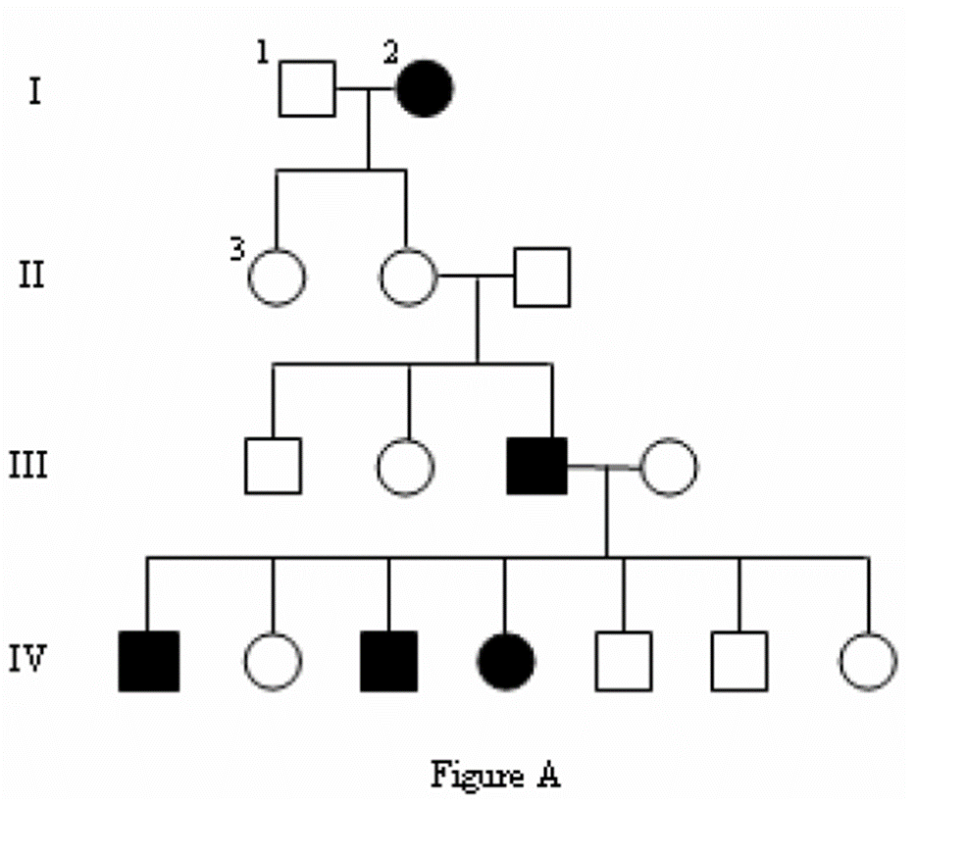*11. What is the genotype for Individual #1? XRY*

*Phenotype? normal color vision*

*12. What is the genotype for Individual #IV-1? XrY*

*Phenotype? colorblind*

*13. What is the genotype for the first born female in generation II? XRXr*

*Phenotype? Normal color vision*

*14. How many females have the genotype XrXr? 2*

15. *What would be the genotype for the female who marries into the family in generation III? XRXr*

**B. Create Your Own Pedigree**

In the space below, use colored pencils to create a pedigree with the following information:

Ray and Elaine were married in 1970. They both had normal vision. They had 2 daughters and then a son. Both daughters, Alicia and Candace, had normal vision and never had any children of their own. The son, Mike, was colorblind. The son married Beth who also had normal vision and they had 2 children of their own, first Greg then Victoria. Victoria was colorblind, but Greg was not. ***Colorblindness is a sex-linked recessive trait.***

***Do not forget what shapes are male and female. Place the names and genotypes of the people under their shape. .***

***Circle- in color your individuals who fit the following:***

*Red- for colorblindness*

*Blue- for individuals with regular vision but are carriers*

*Green- unknown genotype*

