Genetics Review Worksheet

1. For each genotype below, indicate whether it is heterozygous (He) or homozygous (Ho)

AA | Ee | Ii | Mm
Bb | ff | Jj | nn
Cc | Gg | kk | oo
DD | HH | LL | Pp

2. For each of the genotypes below determine what phenotypes would be possible.

Purple flowers are dominant to white flowers.

PP
Pp
pp
Round seeds are dominant to wrinkled seeds.

RR
Brown eyes are dominant to blue eyes

BB
Bb
bb

Bobtails in cats are recessive.
TT Tt

Rr
tt

rr

3. For each phenotype below, list the genotypes (use the letter of the dominant trait or the characteristic)

Straight hair is dominant to curly.
Pointed heads are dominant to round heads.

straight
pointed

straight
pointed

curly
round

4. Set up the Punnet squares for each of the crosses listed below. Round seeds are dominant to wrinkled seeds.

Rr x rr What percentage of the offspring will be round?

RR x Rr What percentage of the offspring will be round?

Rr x Rr What percentage of the offspring will be round?

Practice with Crosses. Show all work!

5. A homozygous tall (dominant) plant is crossed with a homozygous short plant.

What percentage of the offspring will be tall?

6. A heterozygous tall plant is crossed with another heterozygous tall plant.

What percentage of the offspring will be short?

7. A homozygous round seeded plant is crossed with a homozygous wrinkled seeded plant.

What are the genotypes of the parents? x

What percentage of the offspring will also be homozygous?

8. In pea plants purple flowers are dominant to white flowers.

If two white flowered plants are cross, what percentage of their offspring will be white flowered?

9. A white flowered plant is crossed with a plant that is heterozygous for the trait.

What percentage of the offspring will have purple flowers?

10. In guinea pigs, the allele for short hair is dominant.

What genotype would a heterozygous short haired guinea pig have?

What genotype would a purebreeding short haired guinea pig have?

What genotype would a long haired guinea pig have?

11. Two short haired guinea pigs are mated several times. Out of 100 offspring, 25 of them have long hair. What are the probable genotypes of the parents?

x Show the cross to prove it!

12. A “testcross” is used to determine the genotype when we can only see that the individual is showing the dominant trait. A red-eyed fly could be either RR or Rr.
A.Cross a heterozygous red-eyed fruit fly in with a homozygous white-eyed fruitfly.
Red eyes (dominant) | White eyes (recessive)
Genotype of parent #1 ________ Genotype of parent #2 _________ Punnett square: Phenotypic ratio of offspring: ______________

B. Now let’s assume the red-eyed fly was homozygous in part A. What would have be the phenotypic ratio of the offspring? _________________

Dihybrid cross – one in which there are 2 traits.
For peas, the alleles for tallness are T and t and the alleles for seed shape are R and r (round vs. wrinkled).
Let’s take a pea plant that is homozygous for being tall and is homozygous wrinkled. This plant would have the genotype: TTrr. 4 letters – 2 alleles for each trait.
Let’s cross it with a pea plant that is heterozygous for height and seed shape genes. Its genotype would be TtRr.
According to Mendel’s Law of Independent Assortment, during meiosis, each of the alleles separates into a gamete randomly. So we don’t know if a gamete will get the T or t or if it will get the R or r.
But we know it will have to get at least one allele for each trait. That means that each gamete must have one “t” and one ”r”.
Let’s put it into a Punnett square. First put the possible gametes on top of each box.
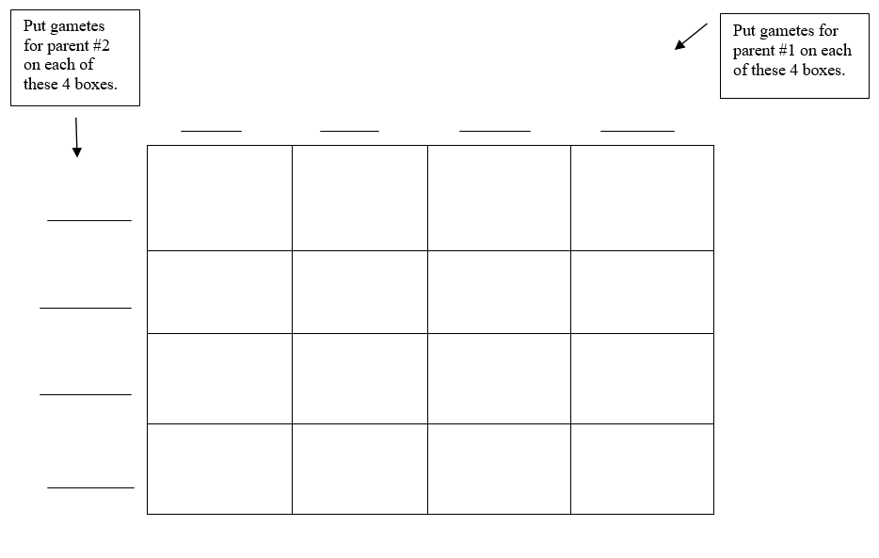
List the phenotypic ratios of the offspring:

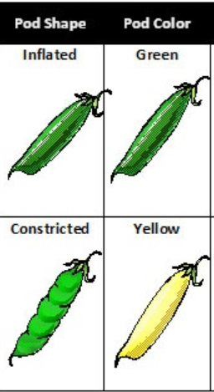
Both parents are heterozygous for Yellow seed color and Inflated pod shape.
1. What are the genotypes of the parents? ___________________________
2. What are the possible alleles in the gametes?
(Remember there must be one letter for each trait!)
___________ __________ ___________ ___________
3. Complete the Punnett square.

4. List the phenotypes and the ratios of each possible offspring .

5. If 640 seeds from this cross were planted, how many would have green and constricted pods? _________

