Fold along the line and glue this side down in your Biology Interactive Learning Log (BILL)
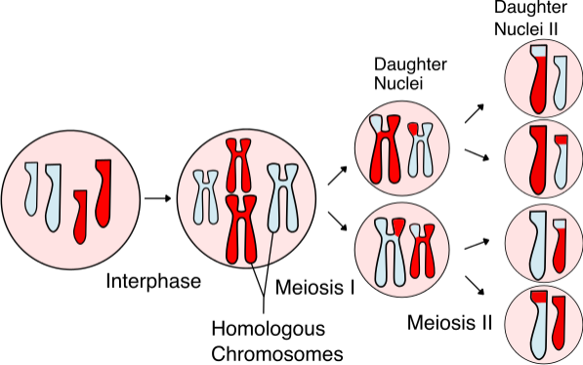

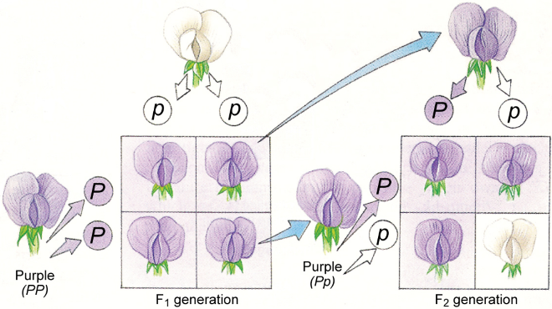
Unit 6: Mendel & Genetics
Learning goals: Long before humans discovered DNA, we were studying the effects genes had on organisms (traits) and how these characteristics were passed down from parent to offspring. Gregor Mendel, the father of genetics, studied, analyzed, and understood inheritance worked in a systemic and rational manner, allowing us to predict offspring traits using Punnett squares and probabilities. His curiosity led him to explore inheritance in pea plants, and he proposed that each trait was passed on in a single unit (a gene) rather than offspring being a true blend of their two parents. Later, scientists discovered how chromosomes that carried genes were distributed between sex cells to produce unique gametes: meiosis. Errors in chromosome distribution, evident in karyotypes, result in disorders caused by chromosomal mutations.
Key concepts:
Mendel’s experiments Independent assortment Punnett squares
Probability Chi-square test Karyotyping
Dominant & recessive alleles Chromosome mutations
Can you show what you know?

Essential Questions:
- How does an organism inherit its unique traits?
- How are alleles of the same gene distributed to offspring?
- How do alleles segregate when more than one gene is involved?
- How can two alleles from different genes be inherited together?
- How can Punnett squares be used to predict offspring phenotypes and genotypes?
- How does a chi-square test help scientists determine if data obtained in a genetic cross follow ratios expected based on Mendel’s Principles?
- How is a karyotype used to diagnose genetic conditions?

Vocabulary: (+) = Can explain it; (-) = Only heard it; 0 = No idea
Study Guide - What I Need to Know/Be able to do:

      - Identify the 5 types of chromosome disorders from an abnormal karyotype.
      - Differentiate between trisomy, monosomy, aneuploidy, euploidy, and diploidy.
      - Explain how X-inactivation is responsible for calico cats and what the effects are to humans.
      - Describe Mendel’s studies and conclusions about inheritance.
      - Explain how geneticists use the principles of probability to make Punnett squares.
      - Explain the principles of dominance, segregation, and independent assortment and how each relates to meiosis and inheritance of traits.
      - Describe how alleles from different genes can be inherited together.
      - Demonstrate the ability to figure phenotypic and genotypic probability percentages and ratios for Punnett square problems.
      - Demonstrate the ability to perform a monohybrid and a dihybrid cross.
      - Perform Chi-square analysis of offspring ratios to demonstrate how traits are inherited.
      - Explain how and why a test cross is performed.

Term | Pre | Post | Memory Clue
amniocentesis
karyotype
autosome
nondisjunction
monosomy
trisomy
euploidy
aneuploidy
translocation
inversion
duplication
deletion
genetics
allele
locus
genotype
phenotype
gene
homozygous
heterozygous
hybrid
cross-pollination

self-pollination
Gregor Mendel
Principle of dominance
Principle of segregation
Principle of Independent assortment
Chi-square analysis
Test cross

