Unit 6 : Mendel and Genetics
Daily Warm Ups

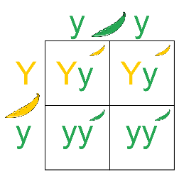
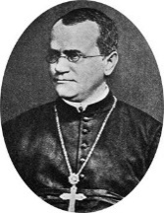

The very first thing that you will do every day when you walk into class is a science warm up. This will usually be a question that will either get you thinking about what we will be learning that day or will help you think about what we learned during the day before. You should first try to answer the question from your own memory and using your own thoughts but, if you are having difficulty, you may look for the answer outside the class (book, internet, etc).
At the end of the week you will hand them in. This booklet will be glued into your BILL on test day. You can change your answers at any time prior to when it is graded (in fact, it is encouraged! Learning is a process). If you ever miss a day, it is your responsibility to make-up the warm ups for the day you missed.

Warm Up questions are worth 4 points each. I will be looking for any misconceptions you might have, how thoroughly you answer a question, how much you used resources available to you, and even how well a particular Warm Up question is constructed.
Scoring Rubric:
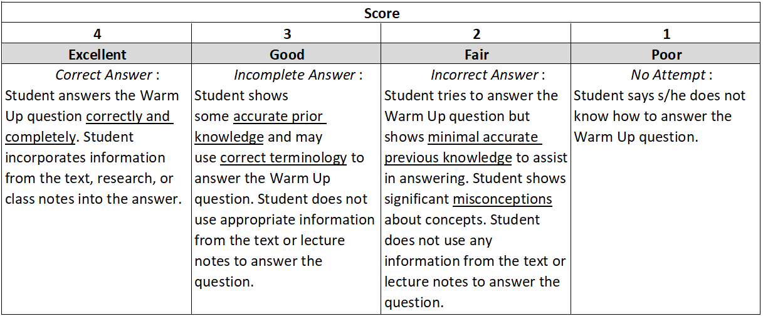

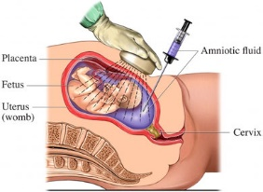
Date __________
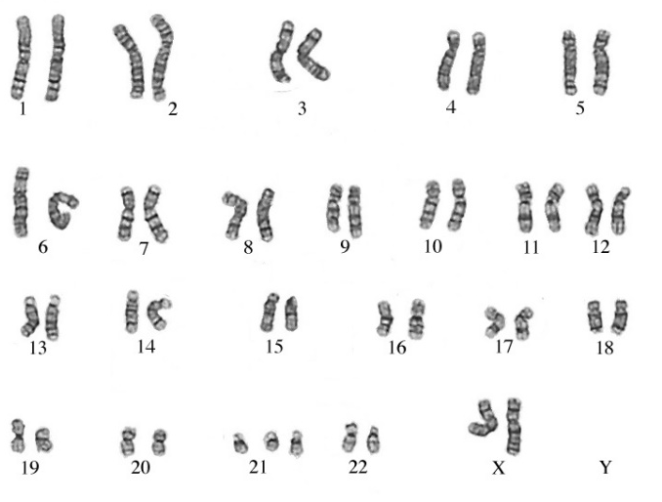
Concept covered: Karyotpyes
A. How many chromosomes does this person have? _________
B. What is the normal human chromosome number? _________
C. Is this karyotype showing a monosomy or trisomy? __________________
D. What is this disorder? ________________________
E. Is this person male or female? _________________

Date _________

Concept Covered: Nondisjunction

Watch the following animation: https://www.youtube.com/watch?v=EA0qxhR2oOk
1. Describe how nondisjunction happens? _____________________________________
2. During which phase of Meiosis did the nondisjunction happen in the video? _______________
3. Which other phase of Meiosis could the nondisjunction happen? Sketch how it happens in the space below.
__________________________

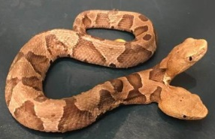
Date _________

Concept Covered: Chromosome Mutations

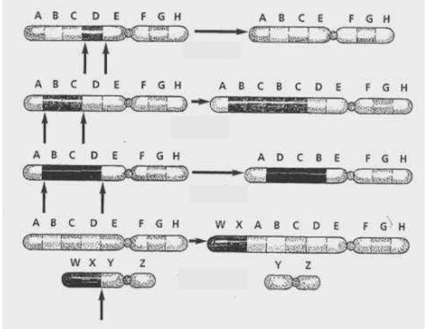
The normal chromosome is shown on the left. The mutated chromosome on the right. Letters A-H are genes. Identify which mutated chromosome shows Translocation, Inversion, Deletion, and Duplication

A. ______________________

B. ______________________

C. ______________________

D. ______________________

Date _________
Concept Covered: Chromosome Mutations#2

Write the term that best matches the karyotype. Choose from the following: duplication, aneuploidy, haploid, euploidy, translocation, inversion.

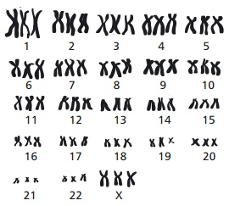

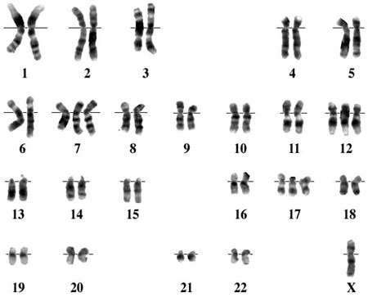

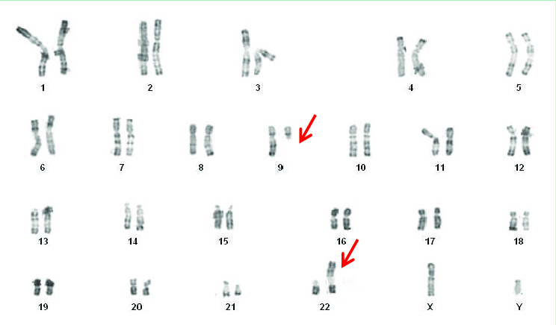

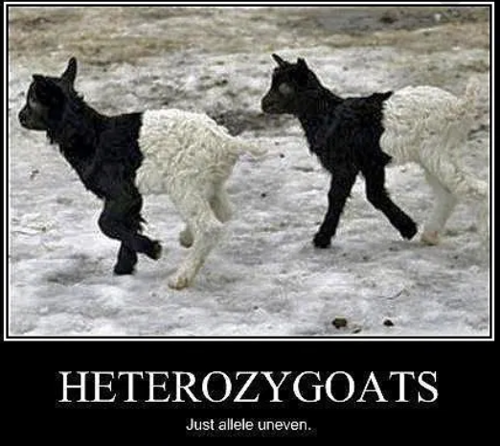
Date _________

Concept Covered: Genetics Terminology #1

Below each of the following words are choices.
Circle the choices that are examples of each of those words

1. Dominant allele 4. Diploid
D e k L S Yy N RR f Gh GgHH
2. Recessive allele 5. Homozygous dominant
M n d F P AA Gg KK uu Rr
3. Haploid 6. Homozygous recessive
D Dd CC a aD Eeff ee Ff HH Oo qq

Date _________
Concept Covered: Genetic Terminology #2

Below each of the following words are choices. Circle the choices that are examples of each of those words.
- Genotype
Bb black rr long yellow FF Yy crooked
- Phenotype
blue HH seedless Ss hairy striped ww
- Genotypes in which dominant gene must show
AA Dd EE ff Jj RR Ss
- Genotypes in which dominant gene must show
AA Dd EE ff Jj RR Ss
- Genotypes in which recessive gene must show
Aa Gg Ff KK rr Oo Tt
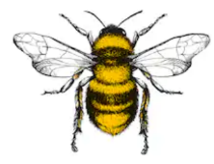
Date _________

Concept Covered: Pollination

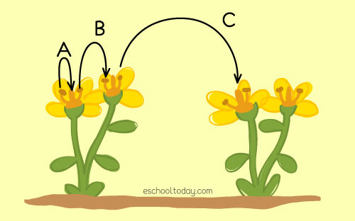

1. Which letter(s) refer to self-pollination? ________________
2. Which letter(s) refer to cross-pollination? ______________

3. Differentiate between a plant that is true-breeding (purebred) and a hybrid. ____________________________
___________________________________________________________________________________________
___________________________________________________________________________________________

Date _________
Concept Covered: Flower Structures

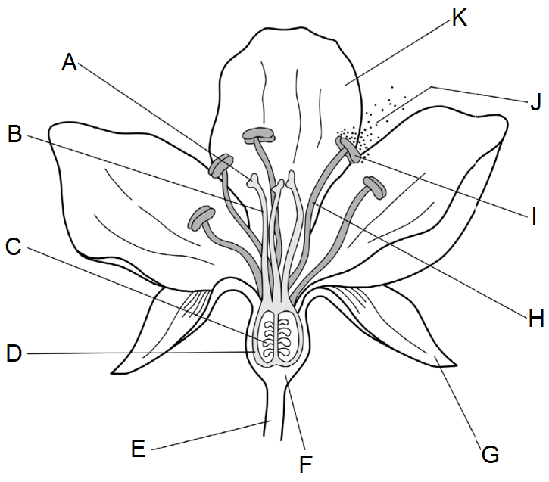
- Which structures make up the stamens (male parts)? ____________
__

- Which structures make up the carpel (female parts)? ________________

- Which parts are neither female nor male? ______________________
Date _________

Concept Covered: Inheritance of Traits

1. Label the F1, P, and F2 generations on the
right of the image.

2. What is the dominant trait for height of these
Pea plants? _______________________

3. What would be the genotype of the “all tall”
plants in the 2nd generation assuming
their parents were true breeding. __________

Date _________
Concept Covered: Punnett Squares

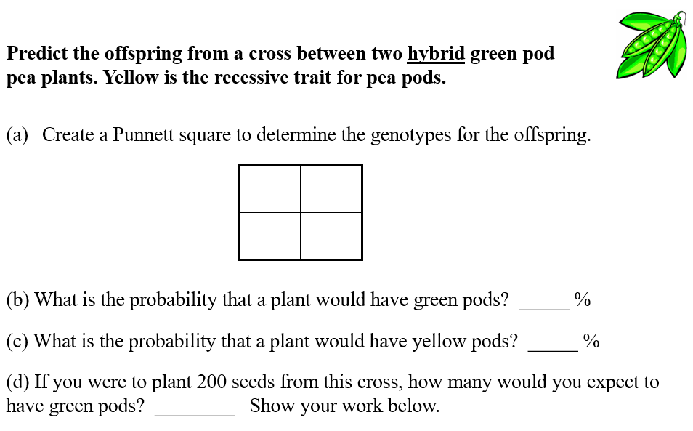

Date _________

Concept Covered: Dihybrid squares

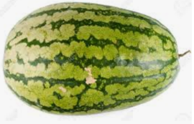
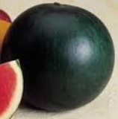
A. A watermelon is hybrid for both dominant traits green and short. It is crossed with a watermelon that is recessive for both traits and is striped and long. Complete the Punnett Square for this cross then answer the question below the square.
Parent 1 genotype: _________ Parent 2 genotype: ____________

B. The grocery store has ordered only long, striped watermelons to sell. If the farmer gathered 320 seeds from this cross and planted them, how many long, striped watermelons will he be able to sell to the grocery store? Show your work. ________________

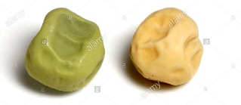
Date _________

Concept Covered: Chi Square

In peas, smooth seeds (R) are dominant over wrinkled seeds (r). In the P generation, a plant homozygous for smooth seeds is crossed with a plant with wrinkled seeds. The resulting F₁ plants are crossed. The seeds of the observed F₂ generation were 5474 smooth seeds and 1850 wrinkled seeds. Does the data fit the predicted phenotypic ratio?
A. Use 2 Punnett squares to represent the crosses.

B. What is the predicted phenotypic ratio in the F2 generation? ________________________________
C. Complete the data table and calculate the Chi-square value.
Phenotype | Expected Number | Observed Number | (O – E)² ÷ E
 |  | X² value

* Use the probability chart for the p-value and degrees of freedom from your M&Ms lab to answer D-F.
D. What are the degrees of freedom for this experiment? __________
E. Do you accept or reject the null hypothesis at 0.05 probability? _________
F. Does the data fit the predicted phenotypic ratio? __________

Date _________

Concept Covered: Testcross

In pea plants, purple flowers (P) is dominant over white flowers (p). When we look at a purple flower, there is no way of knowing its genotype. We don’t know the flower’s parents, but we can cross pollinate it and look at the genotypes of the offspring.
1. What are the 2 possibilities for the purple flower’s genotype? _________ or ________
2. Why are we always sure about the genotype of a white flowered pea plant?
____________________________________________________________________________
3. Perform the Punnett squares for the following testcrosses: PP x pp and Pp x pp

*Note, we don’t “testcross” humans, but we can determine the genotype of a parent using the same methodology. A 50-year old man had his gallbladder removed, and the doctor noted that he had a condition called situs inversus, where all of his digestive organs are on the opposite side of the body than is expected. His wife does not have situs inversus. One of their 4 children was discovered to also have situs inversus when he had an attack of appendicitis. What is the mother’s genotype? ____________________

This page left intentionally blank.

