Unit 3a: Cellular Energy
Daily Warm Ups

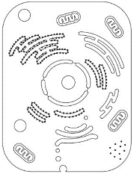
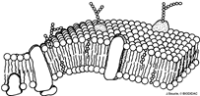

The very first thing that you will do every day when you walk into class is a science warm up. This will usually be a question that will either get you thinking about what we will be learning that day or will help you think about what we learned during the day before. You should first try to answer the question from your own memory and using your own thoughts but, if you are having difficulty, you may look for the answer outside the class (book, internet, etc).
At the end of the week you will hand them in. This booklet will be glued into your BILL on test day. You can change your answers at any time prior to when it is graded (in fact, it is encouraged! Learning is a process). If you ever miss a day, it is your responsibility to make-up the warm ups for the day you missed.

Warm Up questions are worth 4 points each. I will be looking for any misconceptions you might have, how thoroughly you answer a question, how much you used resources available to you, and even how well a particular Warm Up question is constructed.
Scoring Rubric:
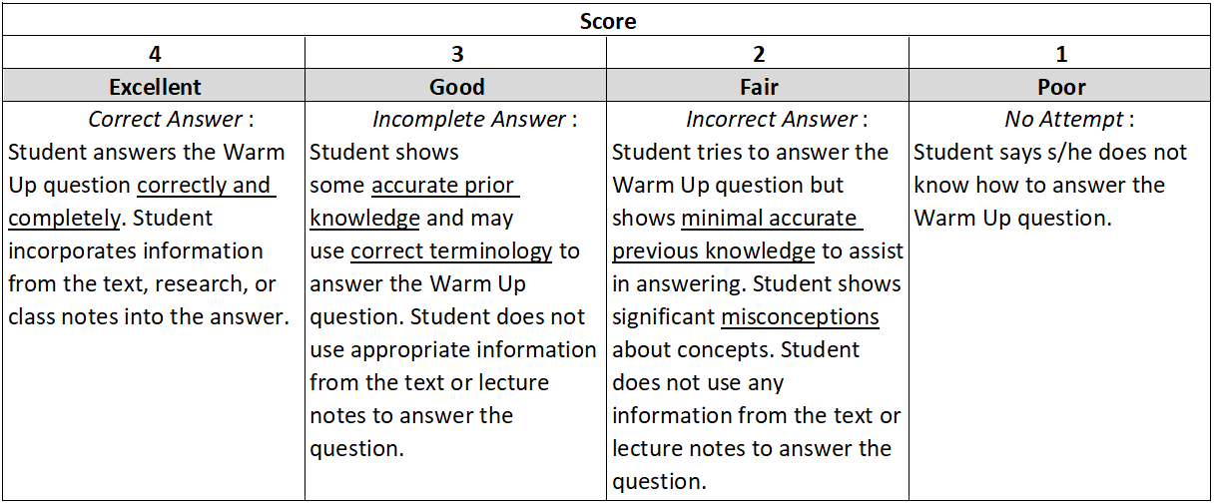

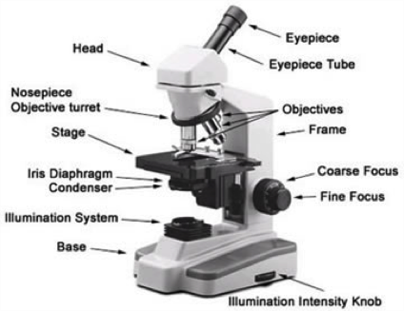
Date _________

Concept Covered: Microscopes

When using a compound microscope, which of the objective lenses should you always start out with? (Circle your answer)
Scanning/low power Medium power High power

Refer to the microscope image above or in your BILL, which part do you NEVER touch when on high power?

Date _________

Concept Covered: Autotrophs vs. Heterotrophs

For each of the organisms listed below, state if it is an autotroph (A) or a heterotroph (H).
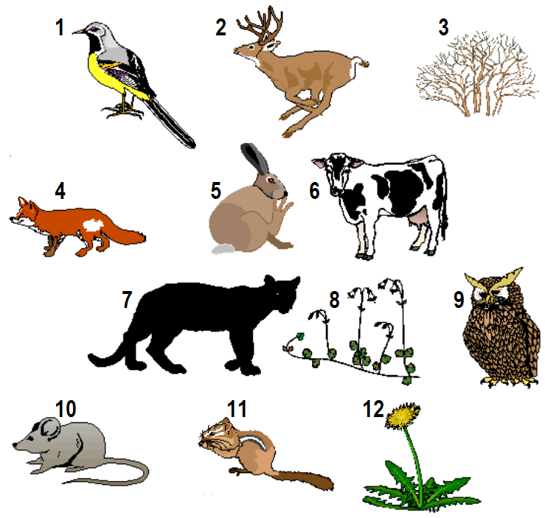

- _____
- _____
- _____
- _____
- _____
- _____
- _____
- _____
- _____
- _____
- _____
- _____

Date _________

Concept Covered: Photosynthesis – Electromagnetic Spectrum

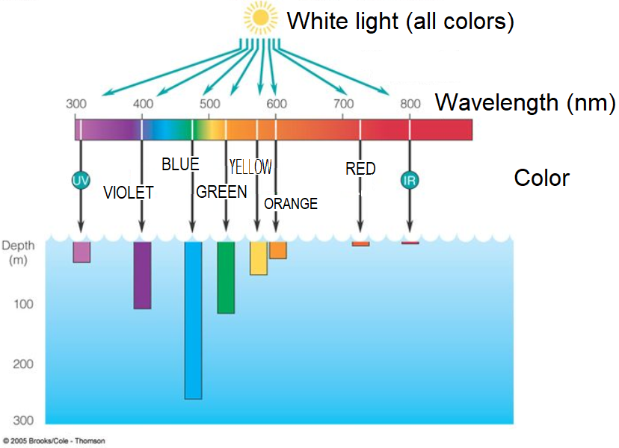
There are three types of algae, named after their colors: green algae, brown algae, and red algae. Only red algae grow at a depth greater than 200 feet, with one type of red coralline algae having been discovered on the ocean floor (884 feet deep) in the western Atlantic off the Bahamas in 1984.

The diagram shows how deep different colors of light penetrate water. Given this information, why do you think red algae can grow so deep in the water?

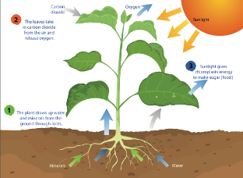
Date _________

Concept Covered: Photosynthesis

- Write the chemical reaction for photosynthesis in the space below.

- How does this reaction compare to the cellular respiration reaction?

- Which reactant of photosynthesis provides the carbon to make glucose (C₆H₁₂O₆)?
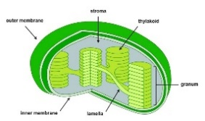
Date _________

Concept Covered: Photosynthesis

Circle the correct letter/answer for each question #1-3. Fill in the blank for #4.
- Chloroplasts have the most in common with:
- Mitochondria C. Cytoplasm
- Nucleus D. Golgi apparatus

- Which of these is NOT part of the structure of a chloroplast?
- Granum C. Chlorophyll
- Stroma D. Thylakoid

- The numerous thylakoids increase _______________, which increases the amount of glucose produced.
- DNA molecule numbers C. the amount of endoplasmic reticulum
- surface area D. the amount of diffusion

- Name a type of plant cell that does NOT have chloroplasts. _______________________

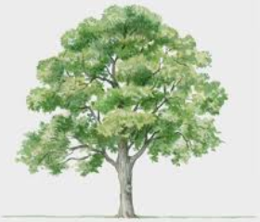
Date _________

Concept Covered: Photosynthesis

Watch Veritasium’s “Where Do Trees Get Their Mass From?” and answer the following questions. https://www.youtube.com/watch?v=2KZb2_vcNTg

- Trees get their mass from (yes or no):

  - Oxygen __________
  - Carbon dioxide __________
  - Water __________
  - Soil __________

- Explain your answers.

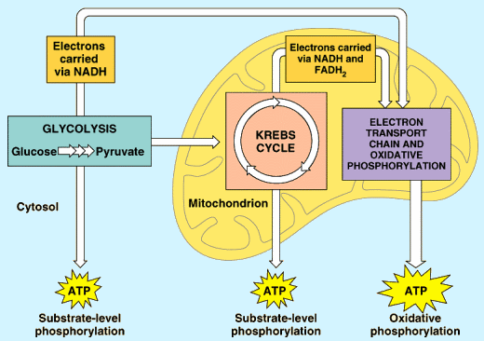
Date _________

Concept Covered: Cellular Respiration

- Write the chemical reaction for cellular respiration in the space below.

- Where do we “get” each of the reactants in the chemical reaction?

- What organ system in your body is responsible for eliminating the waste products of cellular respiration?

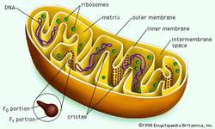
Date _________

Concept Covered: Cellular Respiration

The inner membrane of the mitochondria is bigger/longer than the outer membrane. This gives the inner membrane a great deal of surface area. Think about the function of the inner membrane.
- What important nucleic acid is produced on the inner membrane of the mitochondria?

- Why is it an advantage to have such a large surface area on the inner membrane?

- What digestive organ in your body also uses a large surface area to its advantage? Explain how.

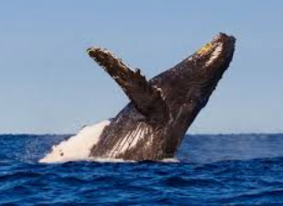
Date _________

Concept Covered: Cellular Respiration

Watch SciShow’s “How Do Marine Mammals Hold Their Breath For So Long?” and answer the following questions. https://www.youtube.com/watch?v=UGhim3Gch2Q
- What two proteins helps marine mammals carry oxygen around their body?

- Name 3 adaptations that marine mammals have that allow them to still undergo aerobic respiration while on deep long dives.

  - __________________________________________________________________
  - __________________________________________________________________
  - __________________________________________________________________

Date _________

Concept Covered: Fermentation

- When humans undergo ___________________ respiration, without oxygen, we produce ______________ acid from glucose.

- When bacteria and fungi, like yeast undergo _______________ respiration, without oxygen, they produce ______________.

- When bread rises, it is due to the _______________ gas that is given off by the yeast during cellular respiration.

- Would bread rise better in colder or warmer temperatures? _____________________
Explain why.

