Fold along the line and glue this side down in your Biology Interactive Learning Log (BILL)

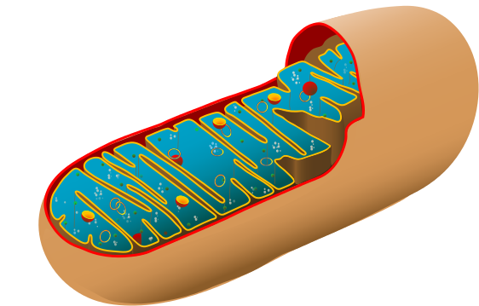
Unit 4: Cellular Energy
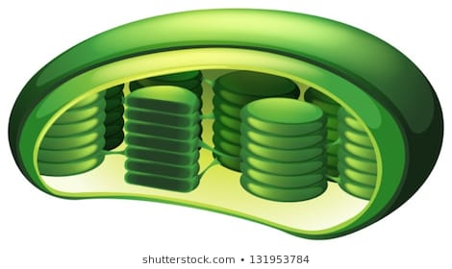
Objectives: Energy comes in several forms – heat, light, electricity, and chemical. Plants have the amazing ability to convert light energy into chemical energy. Heterotrophs use the energy captured by plants to also produce the chemical storage molecule called ATP. Specialized organelles within cells are structured specifically to produce the maximum amount of ATP that is used to fuel all of life’s processes. Knowledge of these chemical processes can be used to study sports performance and our own existence.

Key concepts:
Photosynthesis Cellular Respiration Chemosynthesis
Endosymbiotic theory
Can you show what you know?

Essential Questions:
- How are cell structures adapted to their functions?
- How do microscopes work?
- What is the role of ATP in cellular processes?
- How are the reactions of photosynthesis and cellular respiration used in cells?
- How is the structure of chloroplasts and mitochondria important to producing the maximum amount of products?
- How do the structures and functions of chloroplasts and mitochondria provide evidence for evolution of eukaryotic cells?

Vocabulary: (+) = Can explain it; (-) = Only heard it; 0 = No idea
Term | Pre | Post | Memory Clue
1. autotroph
2.heterotroph
3. producers
4. consumers

Term | Pre | Post | Memory Clue
5. cell wall
6. central vacuole
7. chlorophyll
8. chloroplast
9. thylakoid
10. granum
11. stroma
12. guard cells
13. stomata
14. cuticle of leaf
15. turgor pressure
16. palisade layer
17. mesophyll
18. vascular bundle
19. transpiration
20. aquifer
21. sublimation
22. cellular respiration
23. cristae
24. matrix
25. aerobic respiration
26. anaerobic respiration
27. glycolysis
28. Krebs Cycle
29. Electron Transport Chain
30. lactic acid fermentation
31. alcoholic fermentation
32. ATP synthase
33. chemosynthesis
34. endosymbiotic theory
35. sedimentation
Vocabulary: (+) = Can explain it; (-) = Only heard it; 0 = No idea

Study Guide:

- Describe the role of ATP in cellular activities.
- Sketch and label the general structure of an ATP molecule, and identify the high-energy bond that is broken.
- Describe the function of the chloroplasts and mitochondria in the cell.
- Label and describe the functions of the parts of a leaf.
- State the overall equations for photosynthesis and cellular respiration.
- Describe how a water molecule cycles through the water cycle. Be able to label a diagram. *do the same with Carbon cycle.
- Demonstrate the ability to prepare a temporary wet mount.
- Identify the parts of a microscope and their functions.
- Compare and contrast photosynthesis with chemosynthesis.
- Label and describe the functions of the parts of a mitochondrion.
- Explain the advantages of highly folded membranes in cells.
- Compare the reactants and products of glycolysis, Krebs Cycle and ETC.
- Compare how autotrophs and heterotrophs obtain energy.
- Differentiate between aerobic and anaerobic respiration and the 2 types of fermentation.
- Explain how organisms produce energy in the absence of oxygen.
- Identify the pathways the body uses to release energy during exercise.
- Explain the evidence for the Endosymbiotic Theory and the role of chloroplasts and mitochondria in this theory.
- Sketch how endosymbiosis occurs.

