Stop-Motion Animation Projects to show the process of Active Transport
Stop-motion (aka stop-action) is an animation technique to make a physically manipulated object appear to move on its own. The object is moved in small increments between individually photographed frames, creating the illusion of movement when the series of frames is played as a continuous sequence.

What will you do?
- Create a stop motion animation video to demonstrate their knowledge and understanding of one of the 3 types of active transport (exocytosis, endocytosis, phagocytosis or the Na⁺/K⁺ pump).
  - Plan thestop motion animation video by creating a…
    - Storyboard to serve as a road map for taking pictures
    - Script for the process that you will use to narrate the video
Materials:
- You may use different types of materials which may include modeling clay, play doh, whiteboard, dry erase markers, cut outs (colored), pipe cleaners, etc.
- Storyboard sheet
- Technology- stop motion animation app or camera or computer/chromebook

Procedure:
- You will be assigned one of 4 types of active transport.
- Research your active transport type.
- Write a script detailing the chronological order of events during your active transport.
- Create a storyboard using the given storyboard template.
- Using your chosen materials, construct a model of the physiological process. Take a minimum of 24 pictures to illustrate the chronological order of events for the active transport. Make very small changes to transition for each movement. Label the stages (if applicable) and important parts of process as you are taking your pictures.
- Upload the pictures to a software program to create your Stop-motion video (if applicable).
- Narrate your video.
- Edit your video, if necessary.
- Turn in completed project via a link (emailed to me) or a shared file.

Technology:
You will upload your pictures into a program that will help you create your animation. Stop Motion Studio and JellyCam is a free download that will upload your pictures and create the animation for you. iMovie or Windows Movie Maker can also be used. Also, depending on your personal device, there are loads of free apps for creating a stop motion animation video that you can use.

Grading: Please see rubric for specific grading of the project.
Resources:
Videos
- How to Make a Stop Motion Animation Video- https://www.youtube.com/watch?v=_ppedXZHhE0
- How to Storyboard Your Animation- https://www.youtube.com/watch?v=ji2nwkH2JRo
- Example: Mitosis Stop Motion Animation- https://www.youtube.com/watch?v=oe5o0vgql6I
- Example: Digestion- https://www.youtube.com/watch?v=abUJQJvz5mQ

Websites
- Stop Motion Animation Lesson Plan- https://www.commonsense.org/education/lesson-plans/stop-motion-animation
- Stop Animation With Google Slides- https://www.controlaltachieve.com/2017/04/stop-motion-slides.html
- Stop-Motion with WeVideo https://www.wevideo.com/blog/for-schools/using-wevideo-with-chromebooks-to-create-stop-motion-videos
Grading Rubric:

 | 3 | 2 | 1
Understanding of Active Transport Process | Video clearly demonstrates the students’ understanding of the process; chronological order of events is precise; students use vocabulary correctly and appropriately | Video demonstrates that the students have mostly an understanding of the process; chronological order of events is mostly correct; some steps are incorrect or missing; students use vocabulary correctly and appropriately throughout most of the video; only a few errors | Video demonstrates that the students have some understanding of the physiological process; chronological order of most events are incorrect; more than a few steps are incorrect or missing; students’ use of vocabulary is mostly incorrect throughout the video; more than a few errors
Accuracy of Active Transport Process | AT process is scientifically correct, accurate and complete; parts/structures of the process are clearly and correctly labeled; there are no errors | AT process is mostly scientifically correct, accurate, and complete; most parts/structures of the process are clearly and correctly labeled; few errors; some ambiguity | AT process is somewhat scientifically correct, accurate, and complete; more than a few parts/structures of the process are unclear and incorrectly labeled; more than a few things errors; a lot of ambiguity
Use of Materials | Students’ use of materials was excellent and enhanced the understanding of the AT process. | Students use of materials was good and contributed to the understanding of the AT process. | Students could have chosen better materials to enhance the understanding of the AT process.
Planning | The sequence of frames and syncing the audio exhibited detailed planning by the students; the timing of audio to frames was exact; use of a storyboard is very evident | The sequence of frames and syncing the audio exhibited planning by the student; the timing of audio to frames was mostly in sync; very few timing issues where narration did not match frame; use of storyboard is evident | The sequence of frames and syncing the audio exhibited little planning by the students; the timing of audio to frames was mostly not in sync; more than a few timing issues where narration did not match frame; use of storyboard is not evident
Final Product | Overall animation of AT process was entertaining and is something that could be used for learning. | Overall animation of AT process was entertaining, but because of a few errors cannot be used for learning. | Overall animation of the physiological process seemed to be a “rush job” just to turn something in.

Name(s) ________________________________________________ Due Date __________________

Storyboard for Stop Motion Animation Project

Use the storyboard to plan your stop motion animation video project. The boxes represent your frames. In each box, sketch the idea of what each frame should look like. Below each box, write what is happening in each frame. This will help you with syncing your narration with your frames.

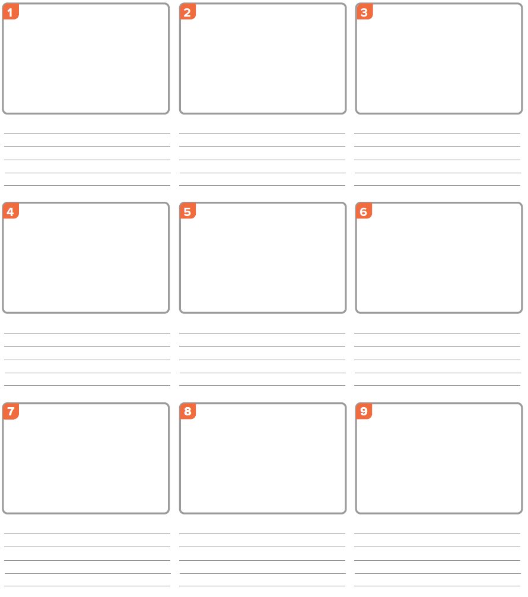
**If you need more frames, obtain white paper and draw as many boxes as you need for your planning.

