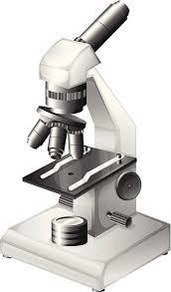
Unit 3: Cell Structure and Function

Fold along the line and glue this side down in your Biology Interactive Learning Log (BILL)
Objectives: Cells are the basic unit of life and the processes that occur at the cellular level provide the energy and basic structure organisms need to survive. Cells come in different forms – prokaryotic and eukaryotic, plant and animal – that all have specialized structures that allow them to perform their functions. Organelles interact with each other to complete functions in a cell that allow it to maintain homeostasis. In particular, raw
materials required for cellular processes need to be moved into cells and products for export, as well as
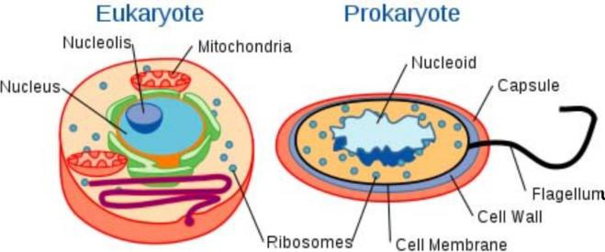
wastes, need to be transported out of cells. Cells also interact with one another using antigens on their cell membranes and sending and receiving chemical messengers. Scientists explore cells and cell function by observing cells under microscopes, some of which allow us to view cells in action!

Key concepts:
Microscopes Plasma membrane Membrane transport
Organelle structure & function

Essential Questions:
Can you show
what you know?

- How are cell structures adapted to their functions?
- How do microscopes work?
- How do different types of cells specialize to have different functions – prokaryotic vs. eukaryotic, plant vs. animal?
- How do cell structures enable a cell to carry out basic life processes?
- How does a cell transport materials across the cell membrane?
- How does a cell maintain homeostasis within itself and as part of a multicellular organism?

Vocabulary: (+) = Can explain it; (-) = Only heard it; 0 = No idea
Term | Pre | Post | Memory Clue
- Cell Theory
- flagellum
- plasmid
- pili

Vocabulary: (+) = Can explain it; (-) = Only heard it; 0 = No idea
Study Guide/Learning Goals:
- State the 3 parts of the cell theory.
- Distinguish between prokaryotes and eukaryotes.
- Identify the parts of a typical prokaryotic cell.
- Describe the structure and function of the cell membrane.
- Locate the hydrophilic and hydrophobic ends of a phospholipid and explain how this structure is essential for maintaining cell homeostasis.
- Identify channel, receptor, integral, peripheral, and glycoproteins on an image of the cell membrane. Know the functions of channel, receptor and glycoproteins.
- Explain how a concentration gradient is used by cells to transport substances.
- Compare and contrast passive and active transport.
- Distinguish between simple diffusion, facilitated diffusion, and osmosis.
- List factors that affect the rate of diffusion.
- Predict what will happen to animal and plant cells placed into isotonic, hypotonic, and hypertonic solutions.
- Distinguish between solute pumping and bulk transport.
- Compare and contrast endocytosis and exocytosis.

Term | Pre | Post | Memory Clue
- ribosomes
- cell wall
- cilia
- plasma membrane
- hydrophilic
- hydrophobic
- fluid mosaic model
- channel/transport protein
- receptor protein
- integral protein
- peripheral protein
- glycoprotein
- selectively permeable
- concentration gradient
- passive transport
- simple diffusion
- osmosis
- aquaporin
- facilitated diffusion
- isotonic solution
- hypertonic solution
- hypotonic solution
- osmotic pressure
- dialysis
- lysis
- active transport
- protein pump
- endocytosis
- exocytosis
- phagocytosis

