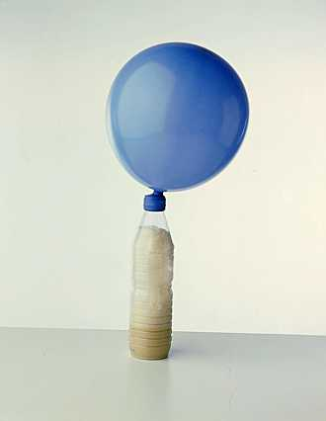
Is Yeast Alive?

Humans use yeast every day. What is yeast, and what are some common uses of yeast? You can buy yeast to make bread in the grocery store. This yeast consists of little brown grains. Do you think that these little brown grains of yeast are alive? Why or why not?
To find out whether yeast is alive, we first need to think about what makes something alive. What are some characteristics of living organisms? To begin to answer the question, "Is yeast alive?” you will test whether the grains of yeast have two characteristics of living things -- the ability to grow and the ability to use energy (referred to as metabolism).

Scientific Experiment to Test for Metabolism

We will carry out an indirect test for metabolism. In other words, we will be indirectly testing whether yeast can use energy, which is one of the characteristics of living organisms. When living organisms use energy, they break down high-energy molecules like sugar to get the energy they need and give off a gas called carbon dioxide as a by-product of this reaction. We will test whether yeast can metabolize sugar and produce a gas which we will presume is carbon dioxide. Specifically, we will test whether yeast produces a gas when it has sugar available as a food vs. when no sugar is available.

Answer the following pre-lab questions in your lab notebook:
1. The type of metabolism most organisms use to generate energy is called oxidative respiration. Write out the equation for oxidative respiration in words.

2. Where did you find this equation (url or page in your text)?

3. What are the 9 characteristics of life?

4. Do you expect yeast to use energy and produce a gas when sugar is available? Why or why not?

5. Do you expect yeast to produce a gas when no sugar or other food is available? Why or why not?

Read the lab procedure to answer the following questions:

6. What is your Independent Variable in this lab (what is being changed/manipulated)?

7. What is your Dependent Variable in this lab (what will we be measuring)?

8. What is your control group for this lab?

9. Name three controlled variables for this lab.

10. Write a Scientific question and Null hypothesis for this lab.

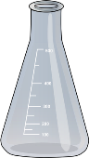
Procedure to Test Your Predictions
- Add 1g of dry yeast to a 125mL Erlenmeyer flask.

2. Team #1 will do the following: In a small beaker add 10g of sugar to 100mL of distilled water and mix thoroughly until all the sugar is dissolved.
Team #2 will do the following: In a small beaker, add 20 g of sugar to 100mL of distilled water and mix thoroughly until all the sugar is dissolved.
Team #3 will do the following: Use only 100mL of distilled water and NO sugar.

If we have enough students:
Team #4 will do the following: In a small beaker, add 30 g of sugar to 100mL of distilled water and mix thoroughly until all the sugar is dissolved.

3. Pour the solution from step 2 into the Erlenmeyer flask containing your yeast.

4. Swirl the yeast and sugar solution mixture a few times to thoroughly saturate the yeast with sugar solution.

5. Turn on the Vernier LabQuest and wait for it to boot up. Once it has booted, plug in the gas pressure sensor and wait for the unit to register the presence of the probe.

6. With the stopcock on the white stopper in the vertical position (open), firmly press the white stopper into the mouth of the Erlenmeyer flask containing your yeast and sugar water.

7. Record the initial readings on a data table that you design in your lab notebook (both lab partners must have a data table). Make sure you give it a descriptive title and label all your columns with headings. Use units for your measurements.

8. Close the stopcock by moving it to the horizontal position. Record your observations and data every 5 minutes for 25 minutes. The starting point will be considered 0 minutes.

Postlab Questions:
Record your data into the Google doc data table shared with you. Copy your group’s data table into your BILL. Give it a title and make sure to include the units at the top label of each column.
- Prepare a full page graph into your notebook showing the pressure change over time you observed for all 4 flasks. You will be making a “scatter plot” with 4 lines. Use a different color for each line. Make sure you have a legend, correctly labeled axis and a good title. Remember: DRY MIX and TAILS. Use a ruler!
2. Data Analysis: Using the mean values, perform a t-test to determine if there is a statistical difference between the control group and experimental group #1. What are the p values? Also t-test the 3 experimental groups to see if increasing the amount of sugar made a statistical increase in pressure/metabolism. What is the p value here? Do you reject or fail to reject your null hypothesis? Refer to your data and statistical analysis to explain why.
3. Using your graph, predict what might have occurred if we used only 4.0 g of sugar. Sketch a line and label it to show where you think the line might have been. What if we had used 40.0 g of sugar? Sketch a line and label it to show where you think the line might have been. Explain.
4. When you make bread, if you just mix flour, sugar, and water, the dough does not rise, and the bread will be flat and hard. If you include yeast in the bread dough, then the dough rises and the bread is bigger and fluffier. Explain how the yeast helps the bread dough to rise.
5. Based on your data, do you think the little brown grains of yeast are alive? Explain why or why not in terms of the EVIDENCE gathered in this lab (state specific data).
6. The system of classification that scientists use groups organisms into Kingdoms, phyla, classes, orders, families, genus, and species. In what kingdom is yeast found?_________
7. Explain why the “dried” form of the yeast is an important evolutionary adaptation?

