POPULATION DENSITY ON A SUBURBAN LAWN

Biodiversity is a measure of the number and variety of different plant and animal species that live in an ecosystem. A high biodiversity leads to a more stable ecosystem because there is a wider variety of food and shelter/nesting resources for creatures to use. If there is a shortage of one, they can turn to another and still survive.

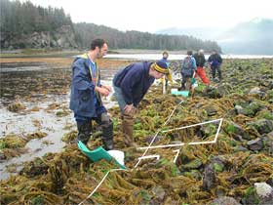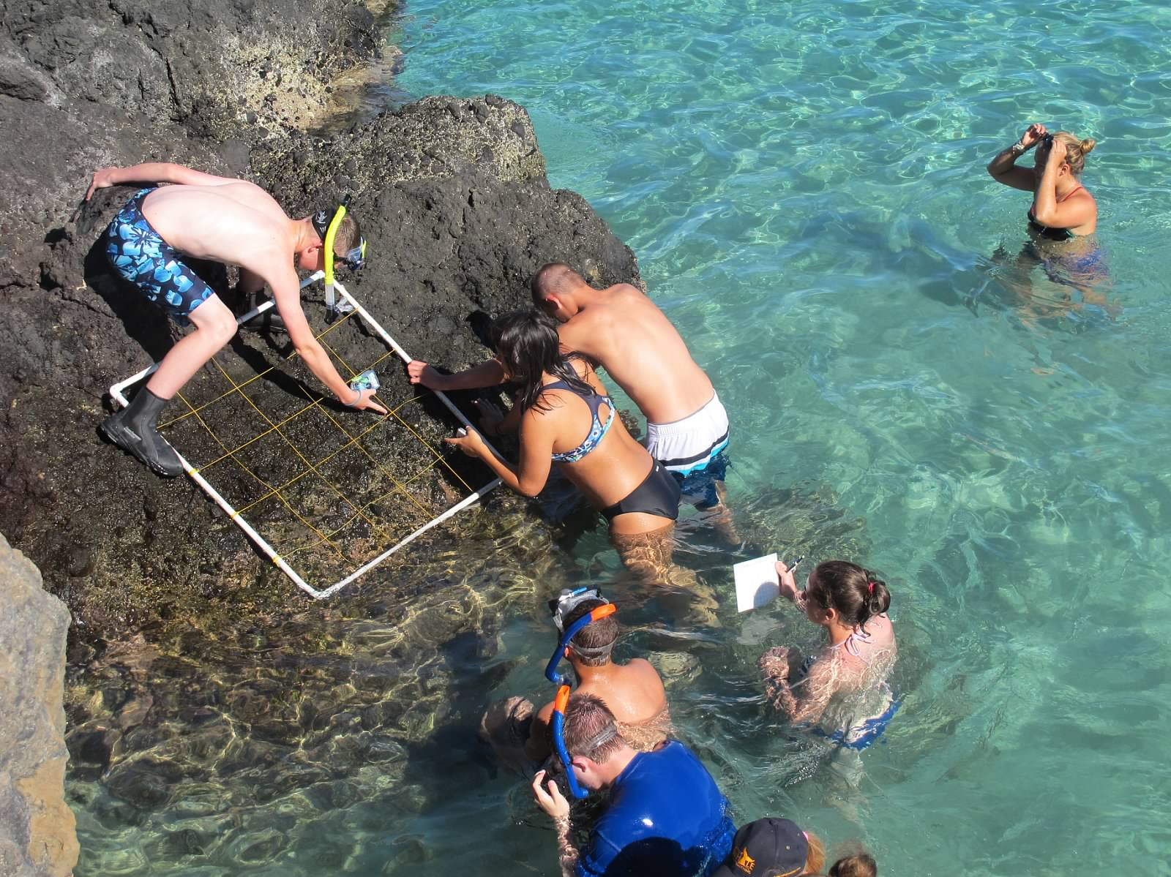

When studying an ecosystem, ecologists — scientists that study natural communities — first try to survey what populations of organisms naturally live there. They then also measure how many of each creature lives there. This is referred to as the population density of that species. Ecologists measure population density by counting the number of each species in a sample area, called a quadrat. If they count the population size in a number of quadrats chosen at random around the ecosystem, scientists can estimate how many of each species live in the whole ecosystem. The population size of each creature that the environment can support is called the carrying capacity of that community. The carrying capacity is how many of a certain species that can survive in an area given the resources (food, water, and nesting sites) available.

In this lab, we are going to practice the technique of measuring population density in quadrats by sampling the plant species that live in the lawn of the school.

PROCEDURE

1. Go to the area of the school lawn designated by your teacher. To randomly choose your sampling site, gently toss (underhand) the poker chip onto the lawn.

2. Lay down your 1 square meter quadrat (1 meter long on each side). To make your counts more accurate, it is best to divide your quadrat into smaller areas. Use string to divide your quadrat into10 equal rectangles.

3. In the square (Figure 1) on the following page, draw any large features that happen to fall in your quadrat like trees, rocks, pavement, etc.

4. Study Figure 2 to familiarize yourself with the four common plant species found in local lawns.

5. Count the number of each plant species in each rectangle of your quadrat and record the population size in Table 1 on the following page. You can first use “tic” marks in the table and then write in a number as a final count for each rectangle when you are done.

6. Using the symbols shown alongside the plant diagrams (Figure 2), also plot the approximate location of the plants on your quadrat drawing below (Figure 1).

7. Total the number of each plant species in Table 1. These totals will be shared with the class, once we return to the classroom.

8. Copy the class data in Table 2. Total each column to get the class totals for the lawn. Now we want to calculate the average population density for the lawn. This will be expressed in plants/meter2.

Describe the area of your quadrat (sun/shade; soil; surrounding area…..) _________________________
____________________________________________________________________________________

Figure 1. YOUR QUADRAT
Population density of four weed species in a suburban lawn.

string

Figure 2. Common Lawn Weed Species of Indiana
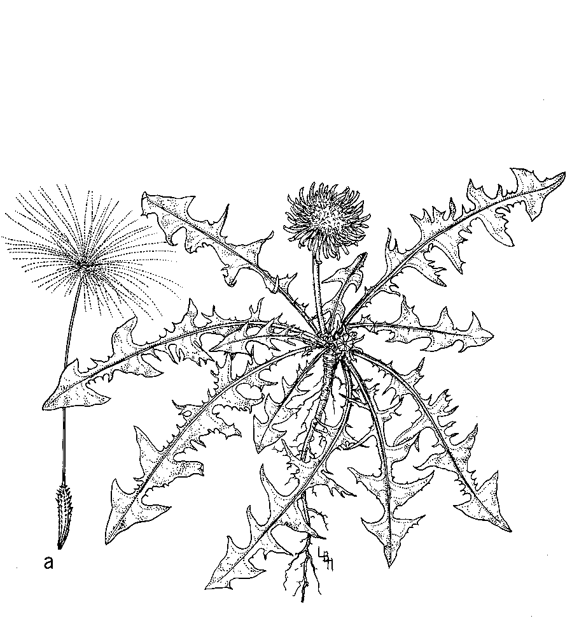

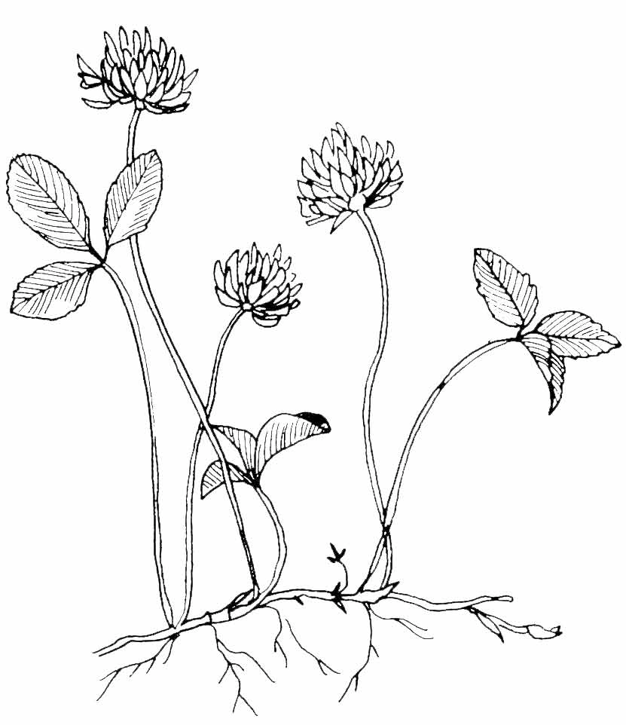

Dandelion White Clover

Buckhorn Plantain Broadleaf Plantain
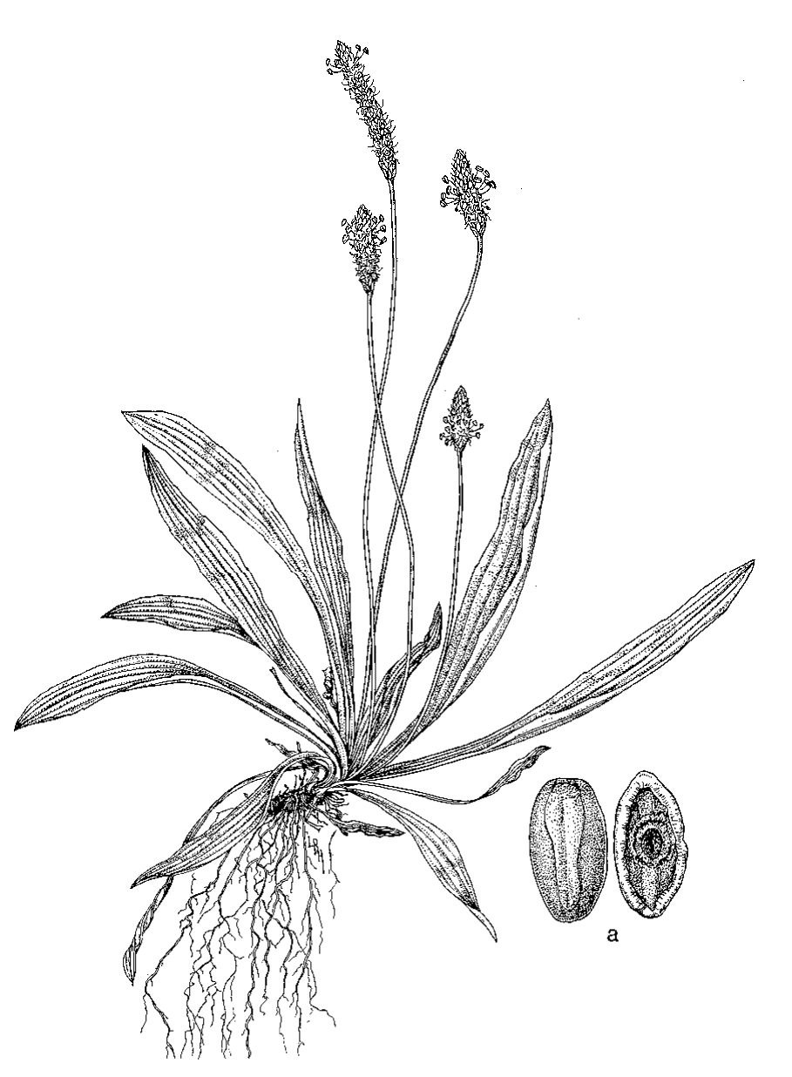

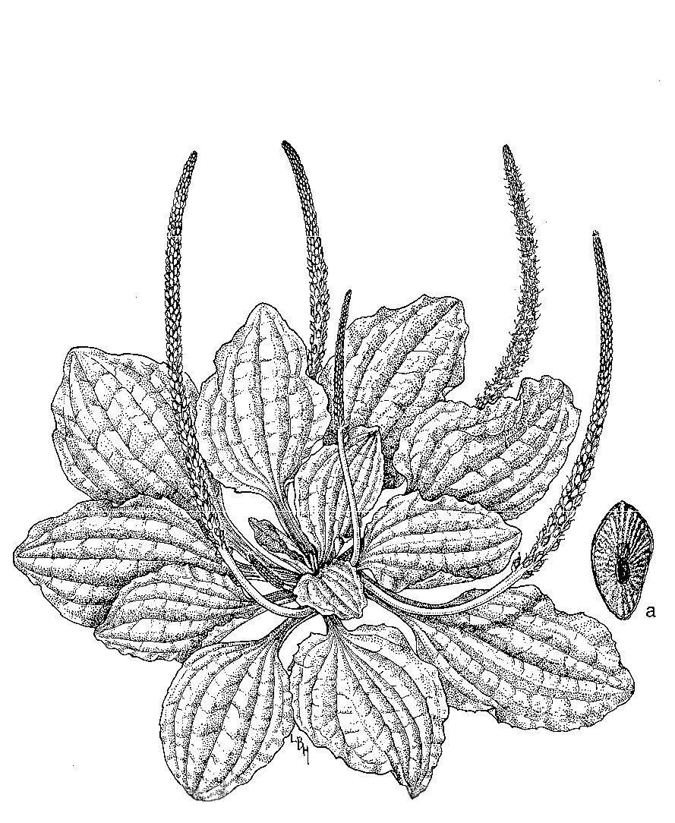

Table 1. GROUP Data — Number of Plants in a 1 m² Quadrat

Quadrat  Section | Dandelion | White Clover | Buckhorn  Plantain | Broadleaf  Plantain
1
2
3
4
5
6
7
8
9
10
Total

Table 2. CLASS Data — Population Densities of Plants in a Community

Class  Group | Dandelion  (total) | White Clover  (total) | Buckhorn Plantain (total) | Broadleaf Plantain (total)
1
2
3
4
5
6
7
8
9
10
Total
Population  Density | 2  /m | 2  /m | 2  /m | /m2

Graph of the Class Data:

SUMMARY QUESTIONS

1. To show that you understand the concept, list 4 examples of biotic factors in this local ecological community.

2. To show that you understand the concept, list 4 examples of abiotic factors in this local ecological community.

3. Explain the term biodiversity.

4. Which plant species had the highest population density?

5. Which plant species had the lowest population density?

6. What density-dependent or density-independent environmental factors might affect the population densities of these plants? Explain.

7. When these lawns were originally planted, only grass seed was sprinkled on the lawn. Then where did the other plants come from?

8. If you look under the older trees around the lawn, you will notice a lot less grass growing there, even leaving bare spots. Offer an ecological reason for why this is the case.

9. Would you consider a suburban lawn to be a high or low biodiversity community? Explain.

10. What do you think would happen to the lawn if no one mowed it anymore and it was left alone for the next 30 years. Explain.

11. What is meant by carrying capacity?

12. How could we, as humans, artificialy alter the carrying capacity of this area?

13. Why is the class average a better measure of the population density for the lawn than using the counts from an individual group’s quadrat?

