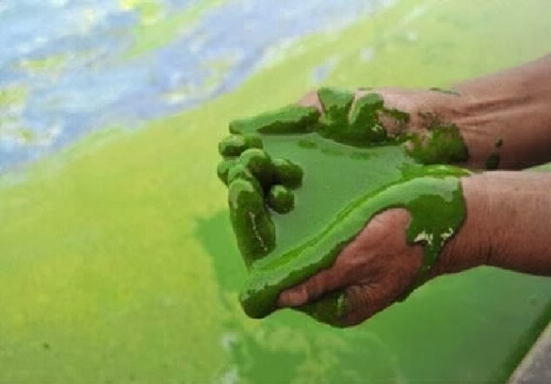
Limiting Nutrients and Eutrophication

Background

"Eutrophication" is derived from two Latin words meaning "good" and "food". In studies of freshwater ecosystems, the term is used to refer to the process by which lakes, ponds, and streams become enriched with inorganic plant nutrients, especially phosphorus and nitrogen. This process happens naturally over a long period of time as dead organic matter accumulates, and is one step in the normal succession of the freshwater ecosystem. However, when the nutrient enrichment is due to the activities of humans – fertilizer runoff from agriculture or private homes, for example – the rate of this natural process is greatly intensified. Human-induced eutrophication is sometimes referred to as "cultural eutrophication."

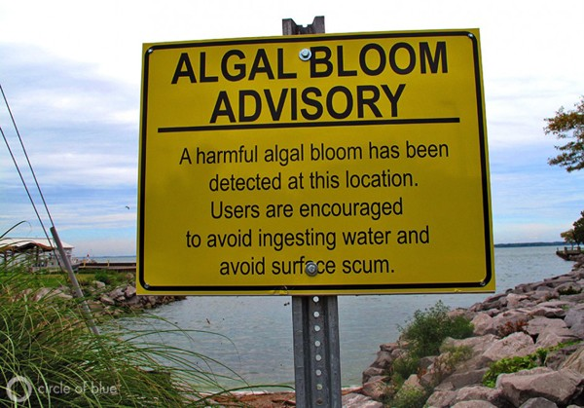
In freshwater systems, phosphorus and nitrogen serve as the limiting nutrients – the levels of these two nutrients determine the biological productivity of the lake, pond, or stream. A sharp increase in one or both of these elements can result in an algal bloom– a sudden population explosion of algae. There are several direct and indirect costs associated with algal blooms. As the algae population proliferates, waters become increasingly more turbid. This turbidity is due in part to the single-celled algal organisms present in the water and in part to dead and decaying organic material. The turbidity coupled with the appearance of algal mats, which can sometimes reach from shore to shore, render eutrophic bodies of water unappealing to swimmers and boaters.

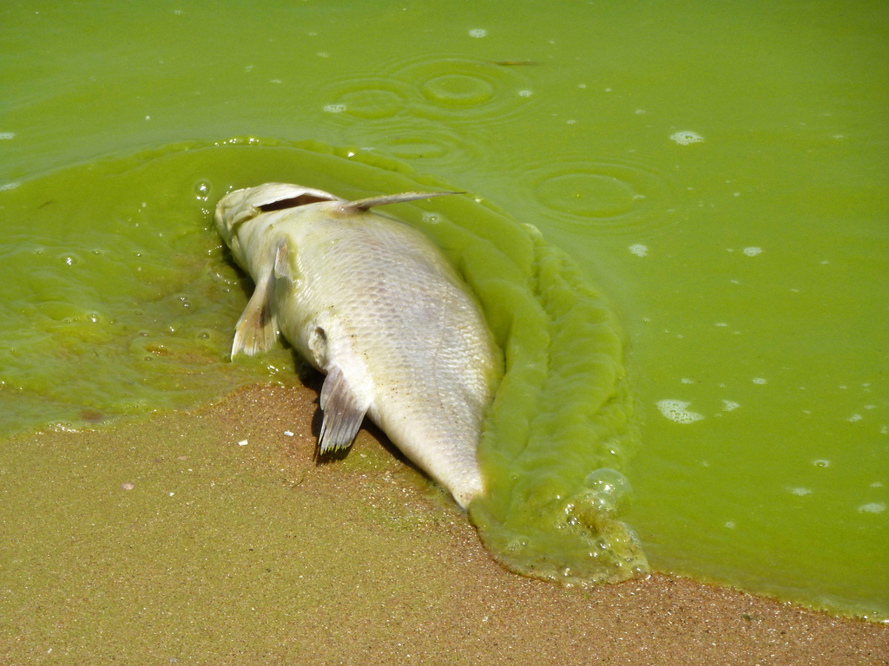
An algal bloom can also set off a chain of events whose effects are more far-reaching and more grave than these aesthetic considerations. As the algae begin to die, bacterial populations move in to decompose the organic matter. These aerobically respiring microbes can cause significant and sudden drops in the level of dissolved oxygen. During the daylight hours, there is a great deal of photosynthetic (oxygen-generating) activity, so this effect may not be apparent. At night, however, when photosynthesis ceases (but plant and animal respiration continues), the resulting net drop in dissolved oxygen can be devastating, sometimes leading to massive fish kills.

Goal: Design an experiment to assess the changes you might see within a freshwater system (such parameters as turbidity, pH, CO₂, O₂, etc.) as nutrients become more available.

Materials

Water samples from 2 different ponds disposable pipettes graduated cylinder
Algae culture test tubes test tube rack
Wax pencil grow light cotton ball
Various sources of nitrates and phosphates culture bottles
pH sensors Chemical Testabs Spectrophotometer
*other materials are available by request

Observe:

Add 20 mL of each pond water sample to a separate test tube.

Write observations of each pond sample in your notebook. Pay attention to details like color, turbidity, odor, and living organisms (use a microscope to look at a sample). You may include sketches or photographs. As a class, we will take initial measurements of turbidity, pH, nitrate levels, phosphate levels, CO₂, and O₂.

Write a short paragraph comparing these values/observations to average levels.

Explore:

1. Research sources of nitrate and phosphates in “run off”.

2. Identify a scientific question based on your research. Write it into your notebook. (You may handwrite it or type all of this and print out then add to your notebook later.)

3. Determine what materials you would like to use for your experiments and write a rough draft of your protocol (methods) on a separate piece of paper or on your computer. Don’t forget to include a control group and at least 3 experimental groups. Have your protocol approved by your teacher BEFORE you begin writing. Some ideas for you to choose from or choose your own:
    - Vary the amount of nutrients or source. Is PO₄ worse than NO₃?
    - How might amount of light, pH or temperature affect eutrophication?
    - Is it better to have a low-level for a long time or a high-level very suddenly?
    - What other factors might affect the eutrophication?

4. In your notebook: Identify your dependent variable(s) and your independent variable. Write a predicting hypothesis. Write your final draft of the protocol. Remember to be VERY specific.

5. Set up your experiment. Add 20 drops of the algae culture to each tube. Be sure to clearly label all your tubes and include your group members’ names. We will collect data every day for 2 weeks. Set up a large data table in your notebook that will include all quantitative and qualitative data. You may want to reserve space for small photographs.
Evaluate

Data Analysis:
Complete any data analysis necessary as per your data – averages, percentages, t-tests, graphs…….

Write a short paragraph summarizing your data.

Discussion:
Write a discussion using the Claim/Evidence/Reasoning approach. This should be about 5 paragraphs:
1. Claim and support or rejection of hypothesis
2. Evidence trends that cause you to support or reject hypothesis. Specific data are referred to but not restated.
3. Reasoning: link evidence to claim. Use research and correct terminology.
4. Describe sources of non-human error and how they may have impacted the data. Explain how you could have improved your protocol.
5. Explain real-life applications of this investigation. Why is it so important to learn about? Be specific.

