Transcription & Translation Pop Beads
Materials:
# component represents
24 pink beads ribose sugar
24 red beads phosphate group
6 orange beads adenine (A)
6 green beads guanine (G)
6 blue beads cytosine (C)
6 purple beads uracil (U)
15 white oval beads tRNA
15 white twist beads amino acid

Transcription:
Construct an mRNA molecule from the DNA strip included in your kit. Place the RNA polymerase between the sense and nonsense strands of the DNA strip. Remember to synthesize the RNA nucleotides from 5’ to 3’ using the sense strand of DNA at a template.
Write each of the eight codons below in the appropriate order. Use the codon translator chart in your kit to determine the amino acid for which each codon codes. Fill in the blank directly under each codon with the correct amino acid abbreviation. Note: when either AUG or GUG is present as the first codon of the mRNA, a special amino acid (fMet) is required to begin synthesis. When the AUG or GUG appears within the codon sequence, a methionine or valine respectively is required.

mRNA
codon 5’ ________ ________ ________ ________ ________ ________ ________ ________ 3’

AA ________ ________ ________ ________ ________ ________ ________ ________
1 2 3 4 5 6 7

*The last amino acid is not present because the final codon codes for the termination of protein synthesis (a STOP codon).

At this point, the mRNA would leave the nucleus through a nuclear pore.

Translation:
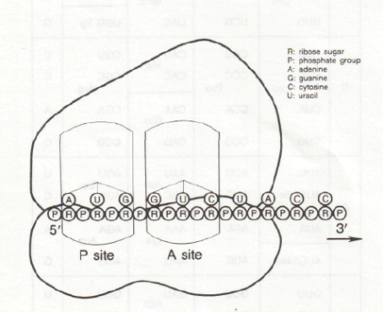
The mRNA moves into the cytoplasm and finds a ribosome. With your mRNA positioned 5’ to 3’ in front of you, slide the ribosome under your mRNA so that the first codon lies in the P site and the second codon lies in the A site.

Each amino acid is carried to one of the ribosome sites by a specific tRNA molecule. Connect the proper amino acid bead to a tRNA bead of the same type as show in the image below.
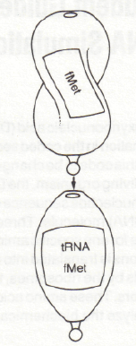

A tRNA recognizes its complementary codon on the mRNA strand, and the tRNAs attach in an orderly progression that lengthens the growing polypeptide chain. Begin by placing the first tRNA bead into the opening of the central nucleotide of the mRNA codon, which is uracil in the image below. In reality, the tRNA anticodon binds with all 3 nucleotides of the mRNA codon.
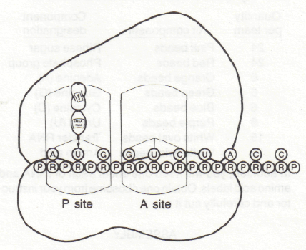
w

Bring in the appropriate tRNA that matches the second codon (in the A site) and attach it to the central nucleotide. Both the P and A sites should now be occupied.
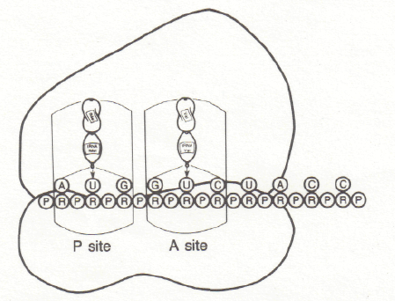
At this time a peptide bond forms between the amino acids. Detach the amino acid in the P site from its tRNA and place the peg into the opening of the amino acid in the A site as shown in the image below. This is not exactly how it happens, but we will show it this way for this simulation due to the limitations of the beads.
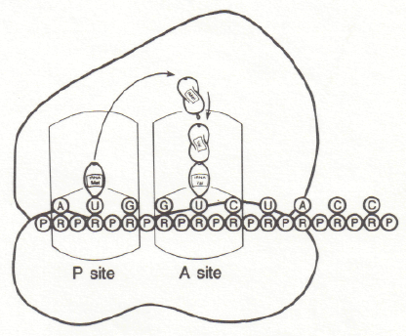

The ribosome now moves down the mRNA a distance of one codon so that the empty tRNA previously in the P site is expelled from the ribosome and released from the mRNA. The second codon now moves to the P site and a new tRNA comes in to match the new codon in the A site.
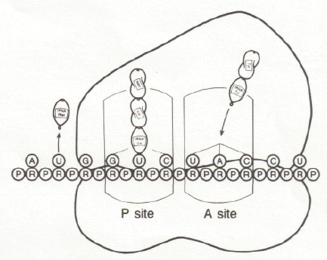

Complete the protein chain. The final codons UAA, UAG, and UGA all specify for termination and release of the protein and mRNA from the ribosome.

EXTEND YOUR KNOWLEDGE:

Rearrange your mRNA nucleotides to construct a new code. Remember to begin with a START codon and end with a STOP codon. Fill in the blanks below for your new mRNA and polypeptide sequence.

mRNA
codon 5’ ________ ________ ________ ________ ________ ________ ________ ________ 3’

AA ________ ________ ________ ________ ________ ________ ________ ________

Trade your mRNA with the other group at your lab table. Who did you get your new mRNA from? ______________________________________________________________

Using the same steps as before to get more practice, translate the mRNA you were given. Write the sequence of amino acids of the polypeptide you translated below:

AA ________ ________ ________ ________ ________ ________ ________

