ECA Review #2
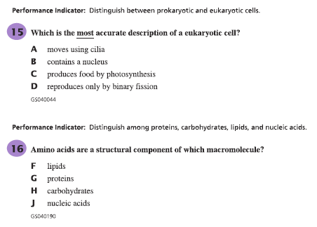
2
1
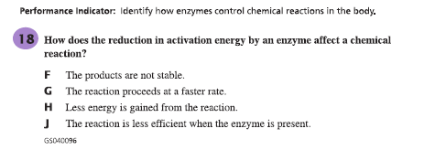
3
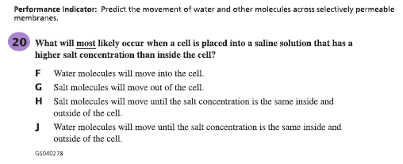
4

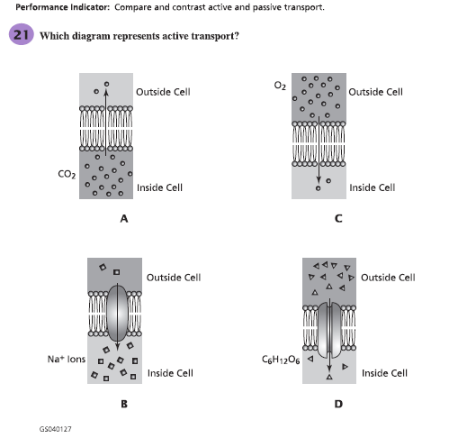
5
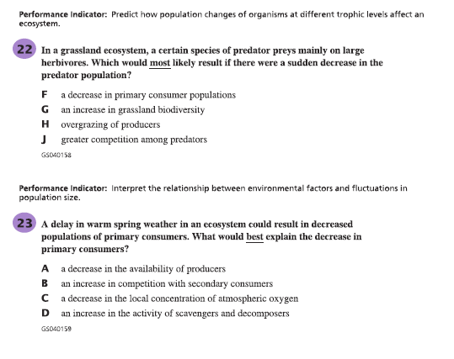
7
6
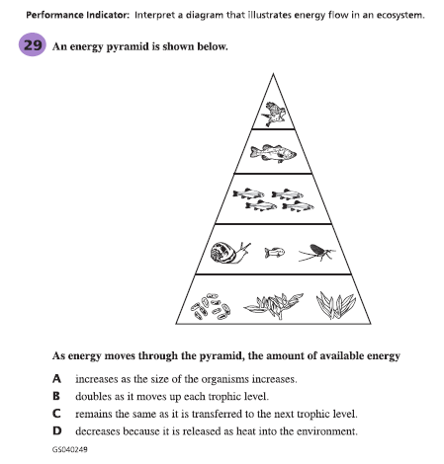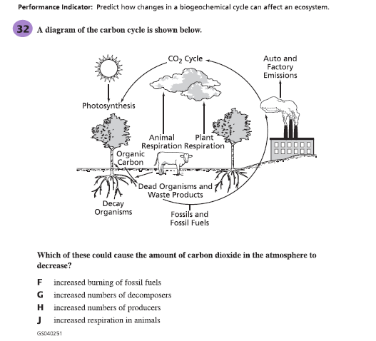
9
8
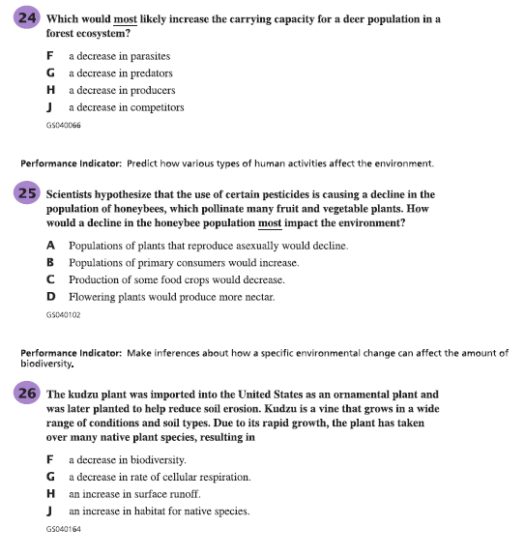
12
11
10
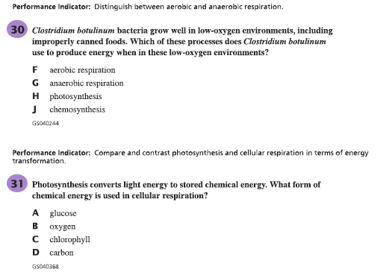
14
13

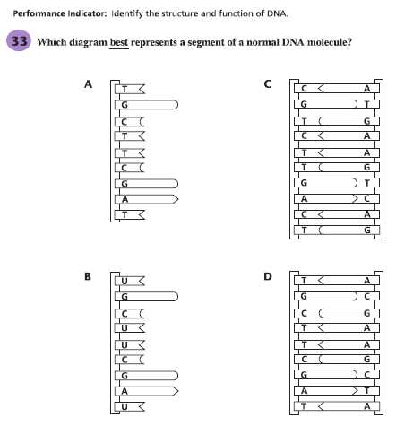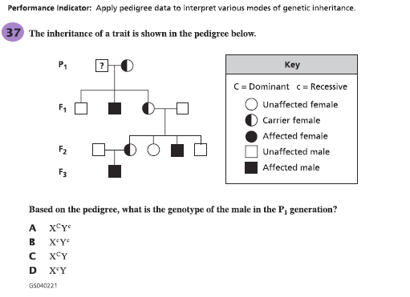
16
15
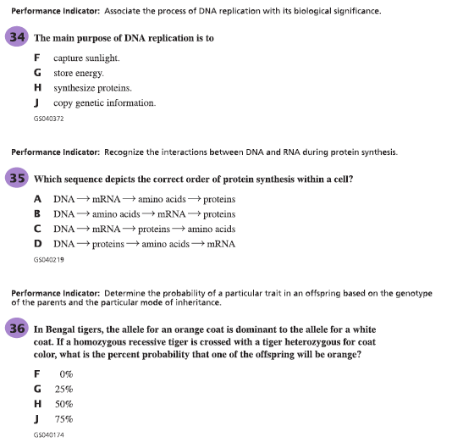
19
18
17

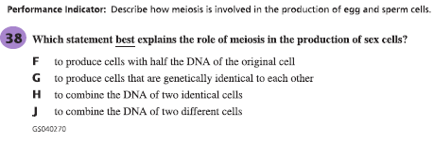
20
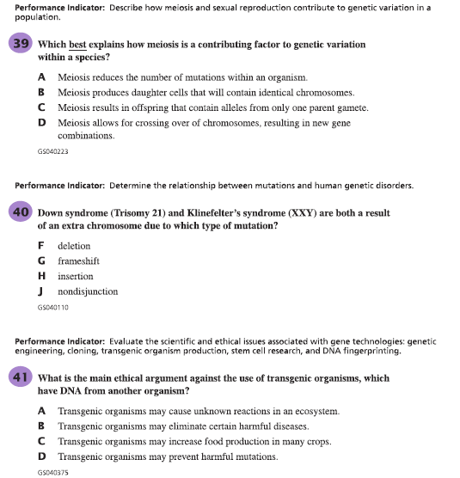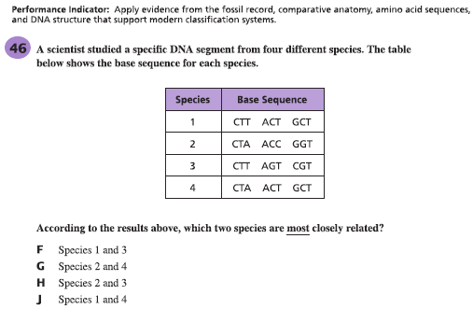
21
22
23
24
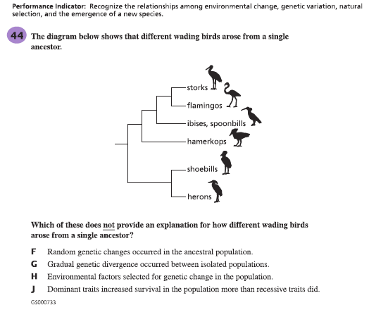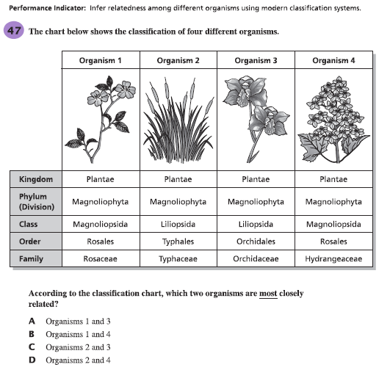
26
25
27
The stomach contains enzymes that aid in digestion and that are active within a small pH range.
Describe what would happen to the enzyme’s FUNCTION in the pH was outside this range.
_____________________________________________________________________________________________
_____________________________________________________________________________________________
_____________________________________________________________________________________________

Describe what would happen to the enzyme’s STRUCTURE if the pH was outside this range.
_____________________________________________________________________________________________
_____________________________________________________________________________________________
_____________________________________________________________________________________________
28
Explain 2 evidences for evolution. Give examples of how that evidence supports the theory of evolution.

_____________________________________________________________________________________________
_____________________________________________________________________________________________
_____________________________________________________________________________________________
Below is a sequence of bases that make up a segment of DNA.
29
A A C T A C A G T C T A C C A T A C
When this segment of DNA is translated into mRNA, how many codons would be represented in this segment?
_____________________________________________

How are codons used in the process of protein synthesis?
_____________________________________________________________________________________________
_____________________________________________________________________________________________
_____________________________________________________________________________________________

