**Name ____________________________________________________________**

**Primate Skull Analysis**

For this lab you will be analyzing the various Primate skulls to gain a better understanding of the various anatomical adaptations that have been acquired by hominids over time.

**Skull Types:**

|  |
| --- |
| *Pan troglodytes* (Chimpanzee) Modern *Gorilla gorilla* (Gorilla) Modern *Homo sapiens* (Human) Modern *Homo neanderthalensis* (Neandertal man) 120,000-30,000 years ago *Homo erectus*  (Upright man) 2.0 million years ago *Australopithecus boisei*  2.3-1.2 million years ago *Australopithecus afarensis*  (“Lucy”) 4.0 million years ago |
|  |
|  |
|  |

**Prelab:**

1. Look at the skulls in front of you. Which one (or 2) appears to be an **outgroup**? ________

2. Just by using appearance, arrange the 7 skulls into a **cladogram/phylogenetic tree**. You don’t yet know their names, so use the assigned letter.

**Measurements:** Complete the following measurements for each group (A-C).

ALWAYS MEASURE IN MILLIMETERS [mm] and round off to whole numbers.

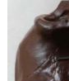

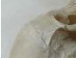**A. BRAINCASE: (7 items #1-7)**

1. Does the FOREHEAD (frontal bone) look more **vertical** OR **flat** when the skull is held in Standard Anatomical Position [SAP] (i.e., with the eyes oriented forward)?

2. Is a SUPRAORBITAL(above the orbital) BROWRIDGE **present** or **absent**?





3. If present, is the BROWRIDGE **DIVIDED** in the middle, or **CONTINUOUS**?

4. **Measure** (mm) the WIDTH OF THE BRAINCASE at the widest point

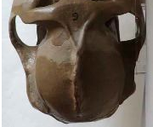

(take the measurement while looking at the skull from above).

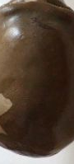

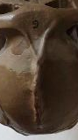

5. Is a SAGITTAL CREST prominent **(2)**, present **(1)**, or absent **(0)**?

6. **Measure** the distance from the front teeth to the front ridge of the FORAMEN MAGNUM [mm], the hole through which the spinal cord passes.

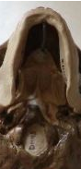

7. Is the MASTOID PROCESS relatively **flat** OR does it noticeably **protrude** (project)?

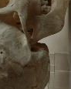

**B. FACE: (5 items: #8-12)**

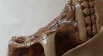8. Are the NASAL BONES **protruding** OR **flat**?

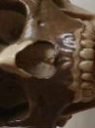

9. **Measure** the MAXIMUM BREADTH (width) of the NASAL OPENING [mm].



10. **Measure** the MAXIMUM HEIGHT of the NASAL OPENING [mm].

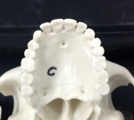

11. **Measure** the WIDTH of the MAXILLA

(the upper jaw) [mm].

(Measure from the outside of the back molars.)

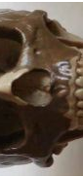

12. **Measure** the BIZYGOMATIC BREADTH [mm].

(This is the width or breadth of the face from the widest part of one zygomatic arch to the widest part of the other zygomatic arch.)

**C. DENTITION: (6 items #13-18)**



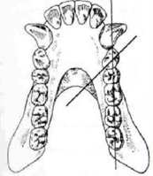 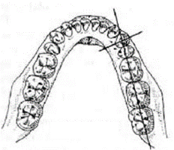13. SHAPE OF THE DENTAL ARCADE: Do the tooth rows diverge towards the back in a parabolic shape (**not parallel**) OR do the back teeth look straight-sided and **parallel** to one another?

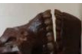14. When viewed from the side, are the INCISORS (front teeth)

**angled forward** OR are they **vertical**?



15. **Measure** the COMBINED WIDTH of the 4 INCISORS together.

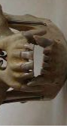

16. Place the MAXILLA and MANDIBLE together. Do the CANINE   
  
teeth **project** above and below the chewing surfaces of the other teeth   
  
OR do the CANINE teeth **meet** at the chewing surface?

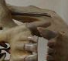

17. Is a CANINE DIASTEMA **present** or **absent**?

(Gap on the medial side of the canine)



18. **Measure** the COMBINED LENGTH of the LEFT 2 PREMOLARS and 3 MOLARS together by measuring from the back of the last molar to the front of the first premolar to determine the length of the chewing surface of the "cheek teeth". [mm].



Maxilla

Mandible

Frontal

Supraoribital browridge

Mastoid process

Nasal bone

Zygomatic bone

Zygomatic process



Sagittal suture or possibly crest

Zygomatic process



Foramen Magnum

Zygomatic process

**Once measurements are complete:**

* Create 3 graphs (one for each data group A, B &C) that illustrate the changes in the anatomy of the primates.
* Choose just one characteristic from each data set to illustrate in your graphs.
* Graphs should be completed with “specimen” on the X-axis.

Data

|  |  |  |  |  |  |  |  |
| --- | --- | --- | --- | --- | --- | --- | --- |
| A- Braincase | | | | | | | |
| Specimen | 1. Forehead | 2. Browridge | 3. Browridge | 4. Braincase | 5. Sagittal crest | 6. Foreamen magnum | 7. Mastoid |
|  |  |  |  |  |  |  |  |
|  |  |  |  |  |  |  |  |
|  |  |  |  |  |  |  |  |
|  |  |  |  |  |  |  |  |
|  |  |  |  |  |  |  |  |
|  |  |  |  |  |  |  |  |
|  |  |  |  |  |  |  |  |

|  |  |  |  |  |  |
| --- | --- | --- | --- | --- | --- |
| B - Face | | | | | |
| Specimen | 8. Nasal Bones | 9. Nasal opening width | 10. Nasal opening height | 11. Maxilla width | 12. Bizygomatic breadth |
|  |  |  |  |  |  |
|  |  |  |  |  |  |
|  |  |  |  |  |  |
|  |  |  |  |  |  |
|  |  |  |  |  |  |
|  |  |  |  |  |  |
|  |  |  |  |  |  |

|  |  |  |  |  |  |  |
| --- | --- | --- | --- | --- | --- | --- |
| C - Dentition | | | | | | |
| Specimen | 13. Dental Arcade | 14. Incisors | 15. Incisors width | 16. Canine | 17. Diastema | 18. Chewing surface |
|  |  |  |  |  |  |  |
|  |  |  |  |  |  |  |
|  |  |  |  |  |  |  |
|  |  |  |  |  |  |  |
|  |  |  |  |  |  |  |
|  |  |  |  |  |  |  |
|  |  |  |  |  |  |  |

**DISCUSSION:**

1. Based on the data you gathered, finalize the cladogram you drew in the prelab. Include the traits that separate each species and add the Latin names and the letter designation (A-G). Remember that you may shorten the genus name with just the first letter. Example: *Australopithecus africanus = A. africanus*

2. Why do you think the canine tooth reduced in size so much from earlier to later hominids?

__________________________________________________________________________________________

__________________________________________________________________________________________

__________________________________________________________________________________________

3. How does the position of the foramen magnum relate to the body posture and locomotion of the animal (how it walks)?  
__________________________________________________________________________________________

__________________________________________________________________________________________

__________________________________________________________________________________________

4. Which specific traits distinguish modern humans from modern apes?

__________________________________________________________________________________________

__________________________________________________________________________________________

__________________________________________________________________________________________

5. Based on your measurements, are the extinct hominids more closely related to modern humans or modern apes? Explain using specific facial features.

__________________________________________________________________________________________

__________________________________________________________________________________________

__________________________________________________________________________________________

6. If you were on an archeological dig and found the remains of a skull that only contained the mandible, could you use that determine if the remains are early hominid, modern human, or ape? Justify your answer using evidence from the lab.

__________________________________________________________________________________________

__________________________________________________________________________________________

__________________________________________________________________________________________

Graph A Title:

Graph B Title:

Graph C Title: