Mosaic Cats
*You will copy the title, scientific question, data table, results, and analysis/conclusion questions into your BILL.
Scientific Question: What effect does X-inactivation have on the phenotype of an organism?
Concepts
- Sex chromosomes
- X-inactivation
- Mosaicism
Background
Although males have only one X chromosome and females have two, females do not produce twice as much of the proteins encoded by genes on the X chromosome. Instead, one of the X chromosomes in females is inactivated early in embryonic development, shortly after the embryo's sex is determined. Which X chromosome is inactivated varies randomly from cell to cell.
In 1949, Murray L. Barr and E. G. Bertram described a small darkly staining body that was present in the somatic cells of female cats. Further studies found this dark staining body in the somatic cells of human females as well. It was named the "Barr body". It was found to be an X chromosome which was inactivated.
In 1962, Mary Lyon proposed an explanation for this phenomenon. According to •her hypothesis, at about the 32-cell stage in the process of early development, an X chromosome becomes inactivated at random and stays inactivated for the life of the cell. Any daughter cells derived from that original cell also maintain the X as inactivated. In some cells the inactivated X may be paternal and in others the inactivated X may be maternal. Since each female is made of a mixture of cells with randomly inactivated X chromosomes, the female is a mosaic for all of the genes found on the X.
There is a phenotype in female cats called "tortoise." Since X-inactivation does not occur until the
32-cell stage, female cats have coats that are a mosaic for the black and orange coat colors, and therefore, at random, each female cat has a different pattern of black and orange markings. The male cats are either black or orange; they are almost never tortoise (a patchwork coat of multiple colors). The gene for white patches (piebald) is a separate gene located on a different chromosome and is not inherited the same way as the orange/black. SS cats will have a lot of white patches, Ss cats will some white patches, and ss cats will have no white patches. Cats that are all white have a different dominant gene that hides all other colors. It’s complicated!

Materials: One coin colored markers
Procedure
1. Our lab cats will experience X-inactivation at the 16-cell stage. (Recall that this usually occurs later, but 16 cells will be used for simplicity.) At this stage of cell division either the black X will inactivate or the orange X will inactivate.

2. The cats on the Mosaic Cats data sheet are divided into 16 sections. These represent the 16 cells of the embryo that were present when inactivation occurred. Simulate the random inactivation of the X by the flipping of a coin. Heads will equal inactivation of the black gene, and tails will inactivate the orange gene.

3. Record the results of flipping the coin in the table on the worksheet. Color the sections of the cat that represent the black genes and the orange genes.

4. Repeat this process again for the second cat.

5. Compare your cats to someone else's at the same lab table.

Mosaic Cats Data Sheet – Cut out the data table and cats. Glue them into your BILL as the DATA section.

Table 1:
Trial | 1 | 2 | 3 | 4 | 5 | 6 | 7 | 8 | 9 | 10 | 1 1 | 12 | 13 | 14 | 15 | 16
Cat 1
Cat 2

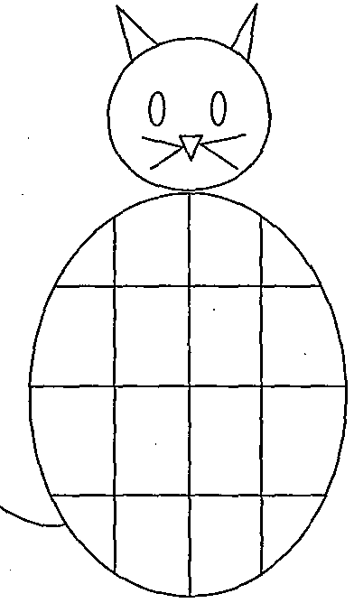

Cat #1 Cat #2

Analysis and Conclusions – answer the following questions in complete sentences in your BILL.

1. For this simulation, what is the probability of getting an all black female cat? Show your calculations.

2. When a female tortoise cat is bred to a male cat which is black, what will be the ratio of possible off­spring? (do a Punnett square)

3. Why are tortoise cats only female?

4. Challenge: Although it is extremely rare, it is possible to have a male tortoiseshell cat. Explain how this is possible.

