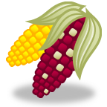 Corn Genetics Lab[1] C:\Users\tcurry\AppData\Local\Microsoft\Windows\Temporary Internet Files\Content.IE5\DDP6K8H1\MC900348429[1].wmf

**Introduction:**

This lab will test Mendel’s laws by making predictions about the **phenotypes** of the kernels of Indian corn and then doing actual counts of the kernels. Each corn kernel is the product (child) of two parnet corn plants. This makes corn an exellent model organism for studying genetics because we can see a large number of offspring all at once on a single ear of corn! This allows us to count a large number of individuals very easily.

The corn we will use in this lab was specially prouduced in a controled lab where the pollen from only one plant was used to pollinate each ear. Therefore, each ear demonstrates all of the possible phenotypes from the mating of two individuals.

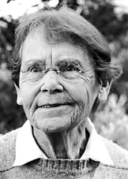

Barbara McClintock is the only woman to receive an unshared Nobel Prize for Physiology and Medicine. She won the Nobel Prize in 1983 for her work on the genetics of corn. She started out doing an experiment just like what you are doing today and then worked to develop the first genetic map for maize.

Gregor Mendel developed 4 “rules” of genetics based on his observations with pea plants.

1. For each trait, organisms inherit 2 alleles, one from each parent.
2. **The Principle of Dominance** - If the 2 inherited alleles differ, then the dominant allele is expressed and the recessive allele is not.
3. **The Law of Segregation** – two alleles of a given gene segregate (separate) from each other during gamete production (meiosis). The result of that gamete **randomly** receives one allele of each gene.
4. **The Law of Independent Assortment**:each member of a pair of homologous chromosomes separates independently of the members of other pairs during the formation of gametes so the results are random.

**Activity 1: Monohybrid Cross**

In corn plants, seed traits for color and texture demonstrate Mendel’s postulates. The trait studied in this activity is seed color. Seed color is controlled by a gene that has two **alleles** (forms of a trait). The **dominant** allele causes the production of **purple** pigment in the seed coat. The **recessive** allele results in the production of no pigment causing the seed coat to appear **white**.

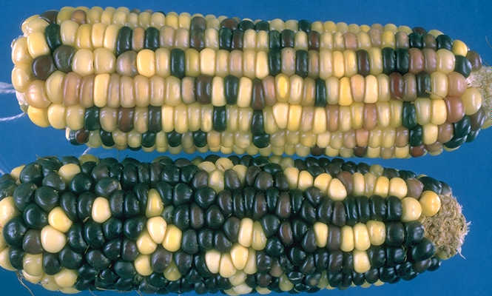

The ears of corn you will use are from the **F2 generation** of corn. What does this mean?

____________________________________________________________________________

The P generation of this corn was created by crossing a true breeding purple corn plant with a true breeding white corn plant. Perform the cross by doing the Punnett square below to determine the phenotype and genotype of the F1 generation.

Genotype of F1 generation:_______

Phenotype of F1 generation:________

**Prediction:**

Punnett squares are a neat trick but what is their actual use? They help us make predictions, or hypotheses in genetics. Since we cannont see the genes but we can see the phenotypes we must figure out genotypes from ratios of phenotypes. We will now make a prediction about the F1 corn that you do not have by predicting ratios of the F2 corn that you will count. F2 is the product of the mating of two F1 individuals.

What is the genotype of the parent corn used to produce the F2 corn? __________

Perform the Punnett square for the F1 cross:

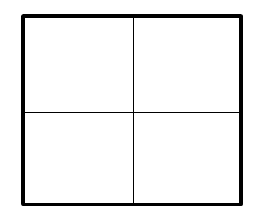

What percentage of F2 kernels should be purple? ________

White? _______

**Procedure:**

1. Use an ear of corn labeled “A”
2. Place a rubber band around a specimen **lengthways** so that it separates the corn into two equal long halves.
3. Count the kernels that have one phenotype on one half of the ear and then the other half. Record your counts on the data table below.
4. Count the kernels of the other phenotype on one half of the ear and then the other half. Record your counts on the data table below.
5. Caculate the percentage of each phenotype by dividing the number of kernels for a phenotype on an ear by the total number of kernels on the ear.

**Data:**

|  |  |  |
| --- | --- | --- |
| **Phenotype** | **Number Counted** | **Percentage** |
|  |  |  |
|  |  |  |
|  | **total:** | **the 2 boxes above should add up to 100%** |

**Analysis:**

1. What is the dominant alelle? _______________
2. The recessive allele? _______________
3. For each phenotype, compare the predicted percentages with the observed percentages in the data table. Are the observed results close to the predicted results?
4. Why would you expect a descrepancy between predicted and observed results?

**Activity 2: Testcross – What is the genotype of an organism that is showing the dominant phenotype????**

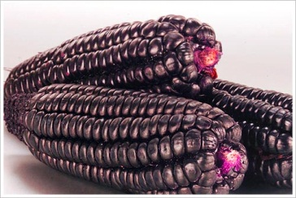

Sometimes a person might want to figure out what types of alleles are present in an organism. To do this a **testcross** is performed. A testcross is when an individual of an unknown genotype (either heterozygous or homozygous dominant) is mated with a individual of a known genotype and then the results of the mating are examined to figure out the genotype of the parent. Usually the known organism is the recessive phenotype because *we always know the genotype of the recessive phenotype*. Why do we always know the genothype of an organism showing the recessive phenotype?

_____________________________________________________________

In this experiment a purple seed of an unknown genotype and a white seed were planted. When the resulting corn plants were sexually mature, pollen from the purple plant was brushed onto the silk of the white plant. I bet you didn’t know that the ear of corn is a flower! Once again you will be making a prediction:

You have two possibilities with this cross so you will have to make a prediction (Punnett square) for both.

**Possibility 1** : the purple plant is homozygous. Parents to cross: ________ x ________



Penotypic ratio of offspring:_____________

**Possibility 2**: the purple plant is heterozygous, Parents to cross: _________x ________



Phenotypic ratio of offspring:______________________________

How are we going to know if the purple seed is homozygous or heterozygous?

____________________________________________________________________________

**Procedure:**

1. Use an ear of corn labeled “B”
2. Place a rubber band around a specimen lengthways so that it separates the corn into two equal halves.
3. Count the kernels that have one phenotype on one half of the ear and then the other half. Record your counts on the data table below.
4. Count the kernels of the other phenotype on one half of the ear and then the other half. Record your counts on the data table below.
5. Calculate the percentage of each phenotype by dividing the number of kernels for a phenotype on an ear by the total number of kernels on the ear.

**Data:**

|  |  |  |
| --- | --- | --- |
| **Phenotype** | **Number Counted** | **Percentage** |
|  |  |  |
|  |  |  |
|  | **total:** | **100%** |

**Analysis:**

1. What was the genotype of the original purple kernel and how do you know?

____________________________________________________________________________

1. Where could this process be useful in a real-life situation?

______________________________________________________________________

**Activity 3: What is Dominant?**

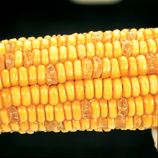

Corn specimen D is from the ***F2 generation*** – the final result of a cross between a parent that has smooth seed coat and a parent with wrinkled seed coat.

Seed texture is the result of the way starch is stored within the seed. The corn with smooth seed texture produces an enzyme that causes sucrose to be converted to starch, which is more loosely packed than sucrose, causing a bigger, smoother seed. The presence of two wrinkled alleles results in less sucrose being converted. As the corn is dried, the seed coat collapses because there is less starch, giving the seed a wrinkled appearance.

**Procedure:**

1) Use an ear of corn labeled “D”

2) Place a rubber band around a specimen lengthways so that it separates the corn into two equal long halves.

3) Count the kernels that have one phenotype on one half of the ear and then the other half. Record your counts on the data table below.

4) Count the kernels of the other phenotype on one half of the ear and then the other half. Record your counts on the data table below.

5) Calculate the percentage of each phenotype by dividing the number of kernels for a phenotype on an ear by the total number of kernels on the ear.

**Data:**

|  |  |  |
| --- | --- | --- |
| **Phenotype** | **Number Counted** | **Percentage** |
|  |  |  |
|  |  |  |
|  | **total:** | **100%** |

Analysis:

1. Which trait is **dominant**? ______________How do you know? _______________________

2. What was the **genotype** of each original **parent**? ________________________________

3. What was the **phenotype** of the **F1** generation ears of corn? ______________________

**Activity 4: The Dihybrid Cross**

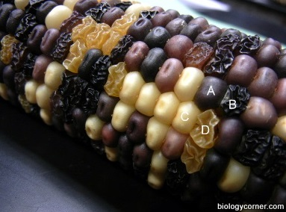

Corn specimen C is the result of a cross between two plants that are **heterozygous for both seed coat** **and seed texture**. You may want to look back at the other activities to remind yourself of the genes involved in the control of color and texture of seed coats.

This experiment will test to see if the corn is really the result of a heterozygous dihybrid cross. Make a prediction for the phenotypic ratios that should be seen from the result of the above cross.

Cross (parent genotypes): __________x ___________

Punnett square:

|  |  |  |  |
| --- | --- | --- | --- |
|  |  |  |  |
|  |  |  |  |
|  |  |  |  |
|  |  |  |  |

Predicted phenotypic ratio:

_____ purple smooth: _______ purple wrinkled: ______ white smooth: ______ white wrinkled

**Procedure:**

1. Use an ear of corn labeled “C”
2. Place a rubber band around a specimen lengthways so that it separates the corn into two equal long halves.
3. Count the kernels that have one phenotype on one half of the ear and then the other half. Record your counts on the data table below.
4. Count the kernels of the other phenotypes on one half of the ear and then the other half. Record your counts on the data table below.
5. Caculate the percentage of each phenotype by dividing the number of kernels for a phenotype on an ear by the total number of kernels on the ear.

**Data:**

|  |  |  |
| --- | --- | --- |
| **Phenotype** | **Number Counted** | **Percentage** |
| **purple smooth** |  |  |
|  |  |  |
|  |  |  |
|  |  |  |
|  | **total:** | **100%** |

Did you obtain a 9:3:3:1 ratio? To determine if the deviations from your observed data are due to chance alone or if the data is significantly different, you need to use a chi square test. The table below will help you make the calculations.

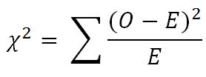

|  |  |  |  |
| --- | --- | --- | --- |
|  | Expected Number | Observed Number | (O – E)2 ÷ E |
| Purple & Smooth | Total x 9/16 = |  |  |
| Purple & Wrinkled |  |  |  |
| Yellow & Smooth |  |  |  |
| Yellow & Wrinkled |  |  |  |
|  |  | *X*2 value  (add the numbers from  the rows above) | |

Now determine if your chi square value is a good fit with your data. Your degrees of freedom (df) is the number of possible phenotypes minus 1. In your case, 4 - 1 = 3. Find the number in that row that is closest to your chi square value. **Circle that number on the chart below.**

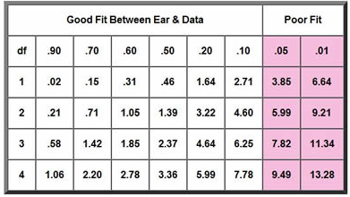

**Analysis:**

1) Does your chi square analysis of real corn data support the hypothesis that the parental generation was PpSs x PpSs?

2) In your own words, explain independent assortment.

3) If both of these genes were on the same chromosome what phenotype(s) would you see in the resulting generation?

**Chi Square Practice Problem Set**

**1. Problem:** A large ear of corn has a total of 216 grains, including 135 Purple & starchy, 36 Purple & sweet, 32 Yellow & starchy, and 13 Yellow & sweet.

**Your Null Hypothesis:** This ear of corn was produced by a dihybrid cross  
(PpSs x PpSs) involving two pairs of heterozygous genes resulting in a theoretical (expected) ratio of 9:3:3:1.

**Objective:** Test your hypothesis using **chi square** and **probability** values.

**2. Problem:**In a certain species of bird, eyes can be either black or yellow. Two black eyed birds are crossed, and the result is 144 black eyed lizards, and 56 yellow-eyed lizards.

**Your Hypothesis**: The black eyed parents were Bb x Bb.

**Objective**: Test your hypothesis using chi square analysis. In this set, because only two values (traits) are examined, the degrees of freedom (*df*) is 1. **SHOW ALL WORK!**

**3. Problem:**A sample of rats (all from the same parents) shows116 Black hair, black eyes | 32 Black hair, red eyes | 38 White hair, black eyes | 15 White hair, red eyes

**Your hypothesis: (what are the parents?)__________________________________  
Objective**: Use a chi square analysis to support your hypothesis

1. Adapted from : *Corn Genetics Student Guide*, Carolina Biological Supply