Name:_______________________________________ Period: ________
Observation of HeLa Chromosomes: Cytogenetics*
Learning Goals:
- How to affix, stain and visualize human chromosomes mounted on microscope slides.
- To use the microscope and appropriate focusing techniques to see human chromosomes at high (400x) magnification.
- To recognize various chromosomal features; sister chromatids, centromeres.
- To scan the microscope field so as to recognize an ideal chromosome spread void of overlapping chromosomes of the same or adjacent cells.
- To recognize that cancer cells have different numbers of chromosomes than normal human cells.

Background Information:

Every normal human cell contains 23 pairs of homologous chromosomes for a total of 46 chromosomes. Each set of homologous chromosomes can be recognized by a number of factors including size and centromere location.
Each chromosome in a cell is composed of two main parts: DNA, which contains the information in its sequence of nucleotides; and proteins called histones, which have the DNA tightly spooled around them.
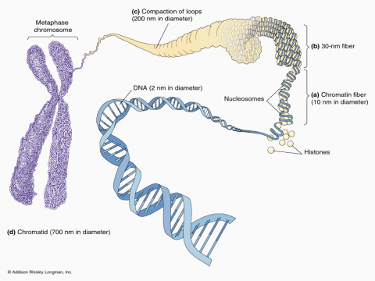

Technicians and scientists known as cytogeneticists spend a lot of time looking at these chromosomes to detect problems with the chromosomes which can lead to a number of diseases. A normal human’s 46 chromosomes consist of 22 pairs of autosomes and 1 pair of sex chromosomes. Any difference from this number is called an aneuploidy and is considered abnormal. Some diseases you may have heard of that are aneuploidies include
- Down’s Syndrome- characterized by an extra chromosome #21
- Cri du Chat – characterized by a deletion of the short arm of chromosome #5
- Turner’s Syndrome – characterized by the absence of one X chromosome (one of the sex chromosomes); these females only have 45 chromosomes
- Many forms of cancer which develop numerous and varied changes from the normal 46 chromosomes

The technique that cytogenecists use to see these chromosomes is called karyotyping that they produce by making chromosome spreads or cell smears. This lab will take you through the procedure of making a chromosome spread so you can see how the numbers of chromosomes in HeLa cells compares to the number of chromosomes in normal human cells.
A normal karyotype looks like this:
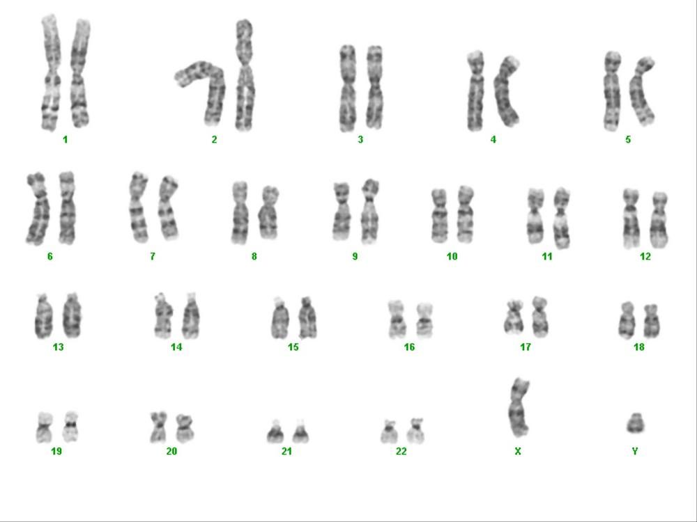
Because HeLa cells are aneuploidy, the karyotype might look like this:
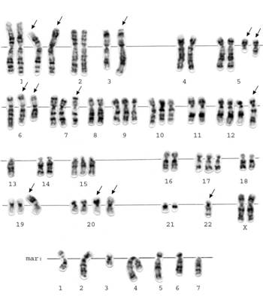

The HeLa cells you will use have been prepared in the following way:
- Live HeLa cells actively undergoing mitosis were treated with colchicine. Colchicine works by stopping dividing cells in metaphase when the chromosomes are in their most condensed form.
- The HeLa cells that are frozen in metaphase were then placed in a hypotonic solution.
- A fixative, or preservative, that locks the cell structures in place is then added and the cells are ready for you to use.
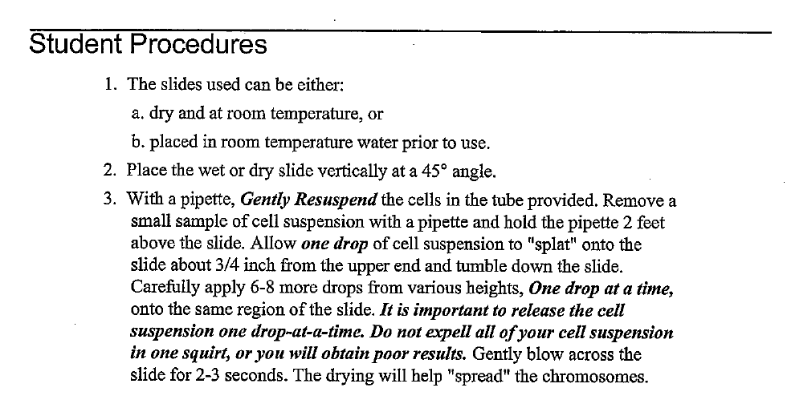
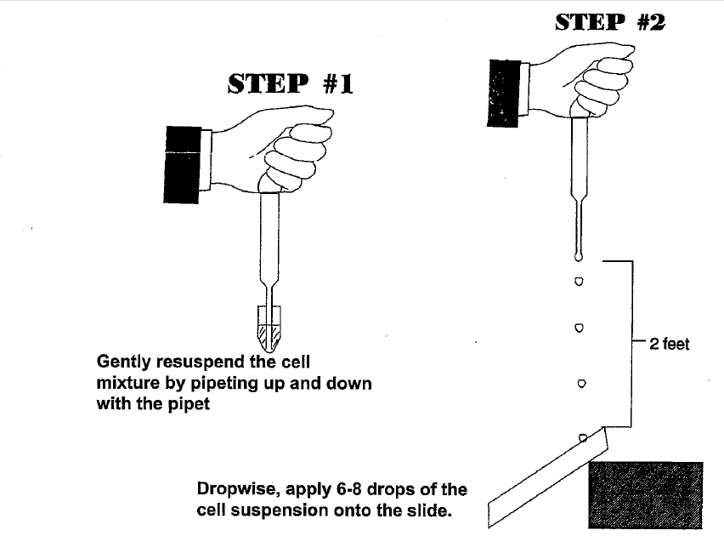
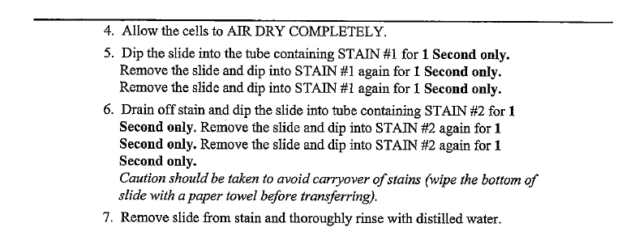
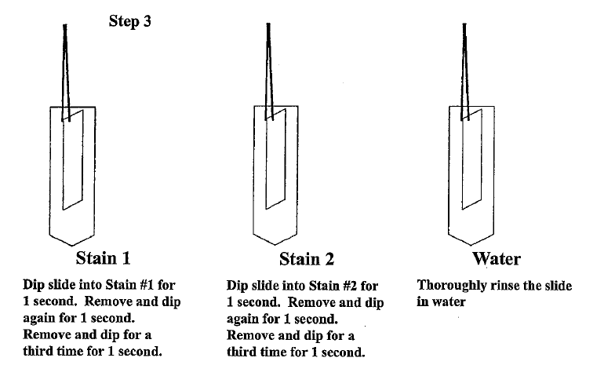
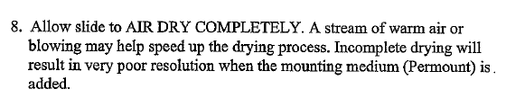
9. Place 2 drops of Permount on the stained area of your slide and place a glass coverslip over the Permount. Apply gentle pressure to the coverslip to spread the Permount evenly under the coverslip.
10. Under scanning (4X) power on your microscope scan your spread for cells which appear to have ruptured and released their chromosomes. Shift to high power (400X) to examine your spread more carefully. An ideal chromosomes spread will contain chromosomes which appear distinct, do not overlap with adjacent chromosomes, and whose sister chromatids are separate and distinct. This exercise requires careful observation so take your time when viewing.

Data: Draw and color your microscopic image into your lab notebook.
Specimen: ______________________________

Total magnification: ___________

Count the number of chromosomes in each of 3 cells. Remember that HeLa cells are aneupoloid and each cell will likely contain a slightly different number of chromosomes. What is the average number of chromosomes? _____________
Discussion Questions: Write the answers in complete sentences into your notebooks.
1. Draw a chromosome in metaphase below; label the centromere and each chromatid.
2. The cells you used were prepared by soaking them in a hypotonic solution. What was the purpose of doing this?
3. Define the role of histones in the chromosomes.
4. Explain the difference between an aneuploidy and a diploid cell.
5. During which stage of mitosis are the chromosomes in their most condensed state and thus best suited for karyotyping?
6. Most human cancer cells have some sort of aneuploidy. Why do you think this is true (relate this to specific happenings in mitosis and the cell cycle)?
7. HeLa cells have been one of the most important tools in biological research since their discovery. Briefly describe one discovery or current research project that involves HeLa cells. Provide an APA citation for where you find the information (REMEMBER, ONLY .edu OR .gov)

