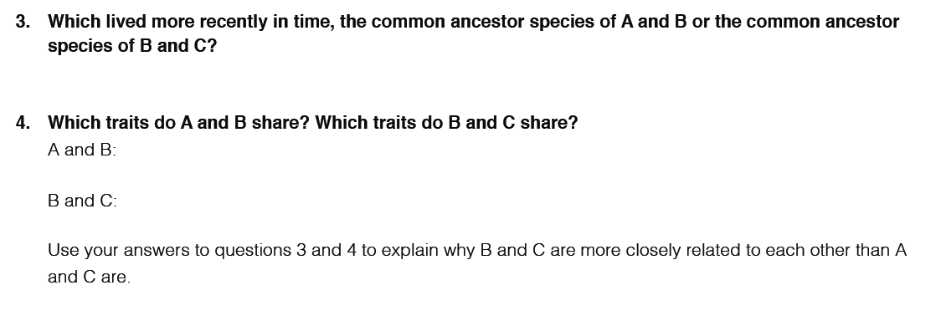
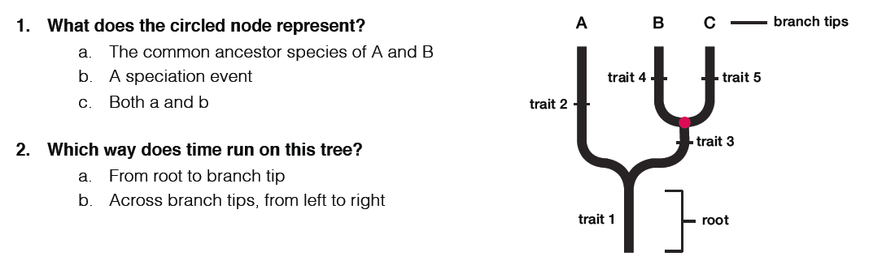
Evolution and Phylogenetic Trees Lab Name ____________________________________________

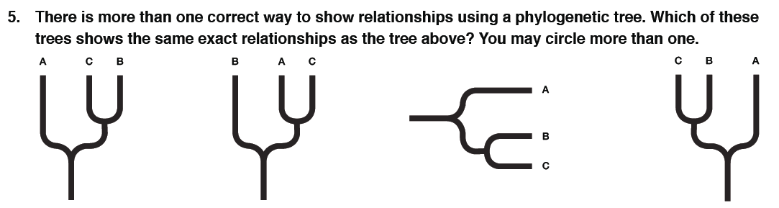

Go to the following website: http://www.pbs.org/wgbh/nova/labs/lab/evolution/
You will be completing 3 missions – Training Trees, Fossils Rocking the Earth, and DNA Spells Evolution
There are 3 subunits to each mission. You will make the phylogenetic trees, add the traits, and answer one question for each subunit.

Mission 1 – Training Trees
Part 1 - Red, Green, and Gecko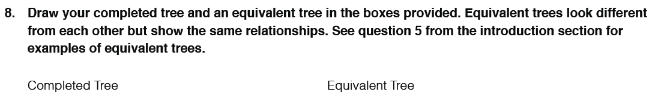

Part 2 of Mission 1 – Familiar Faces
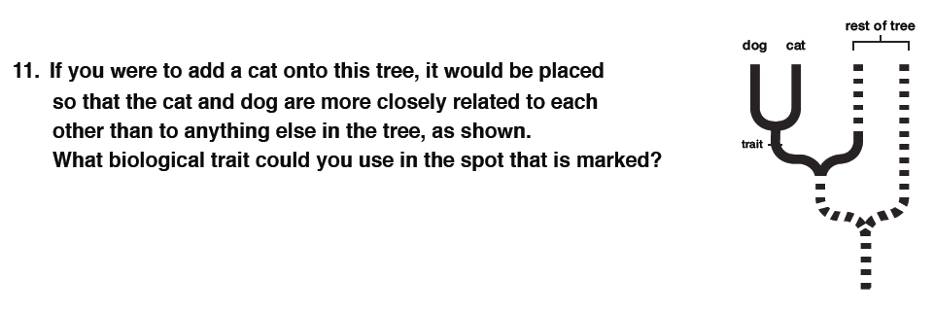
Part 3 – Tree of Life Vegetarian Edition
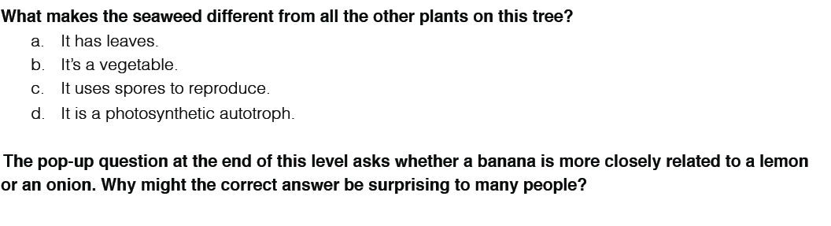

Mission 2 – Fossils: Rocking the Earth
Part 1 – Eating Dinosaurs for Dinner
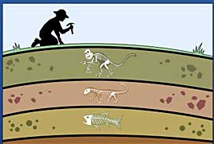
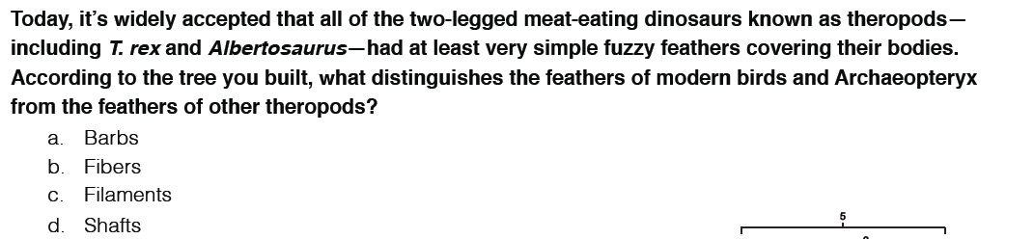
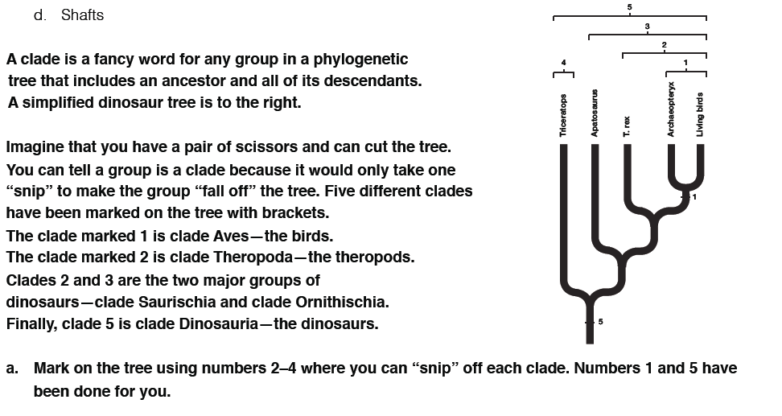
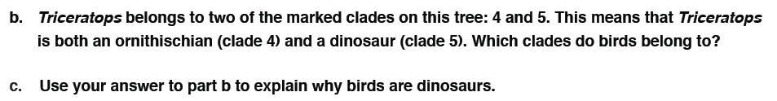

Part 2 – One Small Step
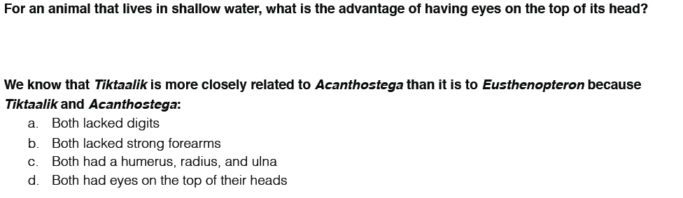
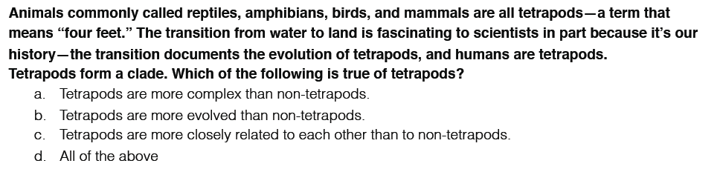
Part 3 – Origin of Whales
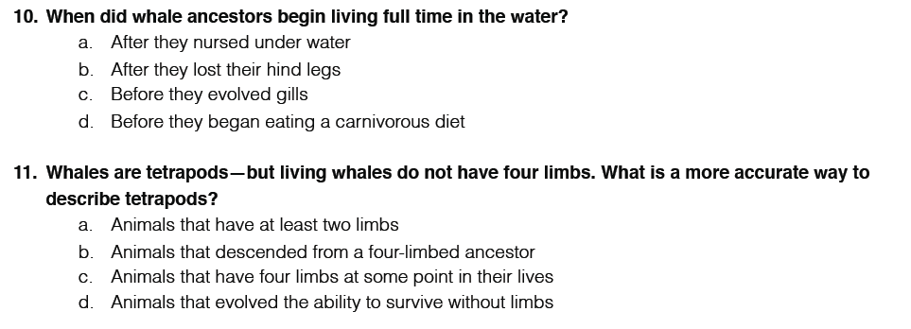
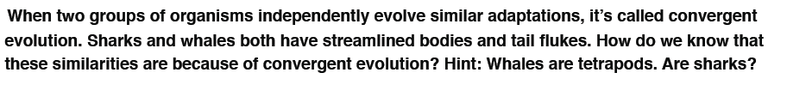

Mission 3 – DNA Spells Evolution
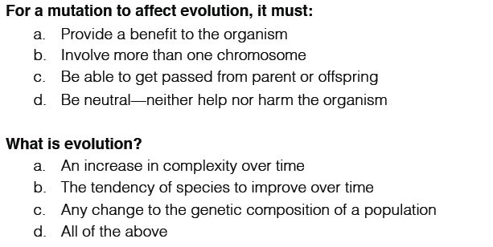
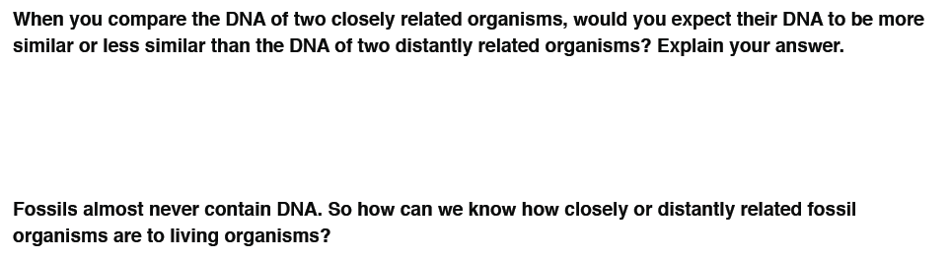

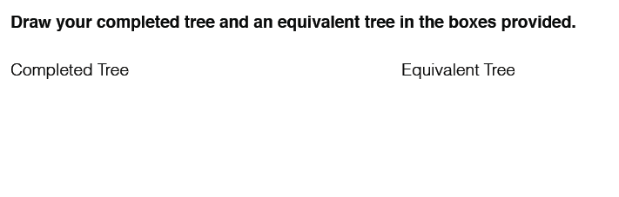
Part 1 –Frog Legs and Fish Eggs

Part 2 – One Fish, Two Fish, Red Fish, Lungfish

Part 3 –Were the Tiny Wild Things Are
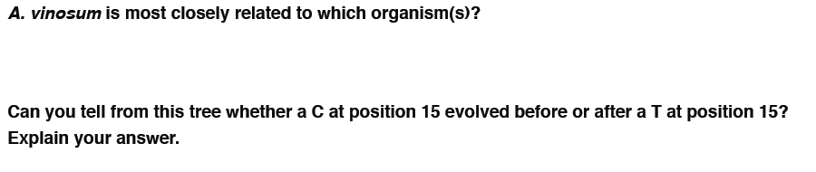

Bonus challenge: The more we learn about viruses, the stranger they seem. They are not quite considered an “organism” because they can’t reproduce outside of a host. But viruses are EVERYWHERE. Contrary to what most people think, most viruses are completely harmless to us, and some are even helpful. HIV, however, is very harmful to humans. Where did it come from? Figuring that out is your job in this question. Based on the genetic information in the chart below, complete the rest of the phylogenetic tree that shows how these viruses evolved then answer the question that follows.
