17.2 pages 488-489, Mechanisms of Evolution:
Define the following terms

1. stabilizing selection _______________________________________________________
_________________________________________________________________________

2. directional selection _______________________________________________________
_________________________________________________________________________

3. disruptive selection ____________________________________________
__________________________________________________________

Label each graph according to the type of natural selection on polygenic traits from the 3 above:
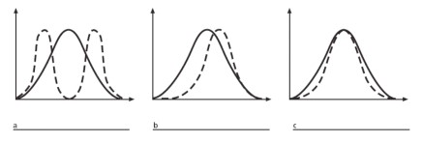
Which mechanism of selection is each:
A. Starlings produce an average of five eggs in each clutch. If there are more than five, the parents cannot adequately feed the young. If there are fewer than five, predators may destroy the entire clutch.
_________________________
B. The occurrence of large or small beak sizes among seed crackers in the absence of medium-sized beaks. _________________

C. A group of peccaries (pig-like herbivores) eat only the cacti with very few spines. ____________________________

