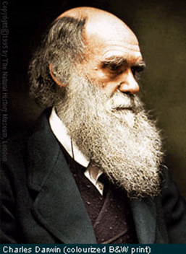
Chpt 16-19 : Evolution
Daily Warm Ups

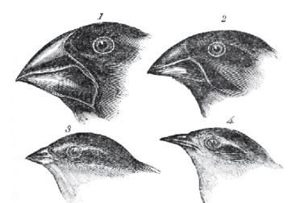

The very first thing that you will do every day when you walk into class is a science warm up. This will usually be a question that will either get you thinking about what we will be learning that day or will help you think about what we learned during the day before. You should first try to answer the question from your own memory and using your own thoughts but, if you are having difficulty, you may look for the answer outside the class (book, internet, etc).
You can change your answers at any time prior to when it is graded (in fact, it is encouraged! Learning is a process). See me if you don’t understand or need help with any of these topics. If you ever miss a day, it is your responsibility to make-up the warm ups for the day you missed.

Warm Up questions are worth 4 points each. I will be looking for any misconceptions you might have, how thoroughly you answer a question, how much you used resources available to you, and even how well a particular Warm Up question is constructed.
Scoring Rubric:
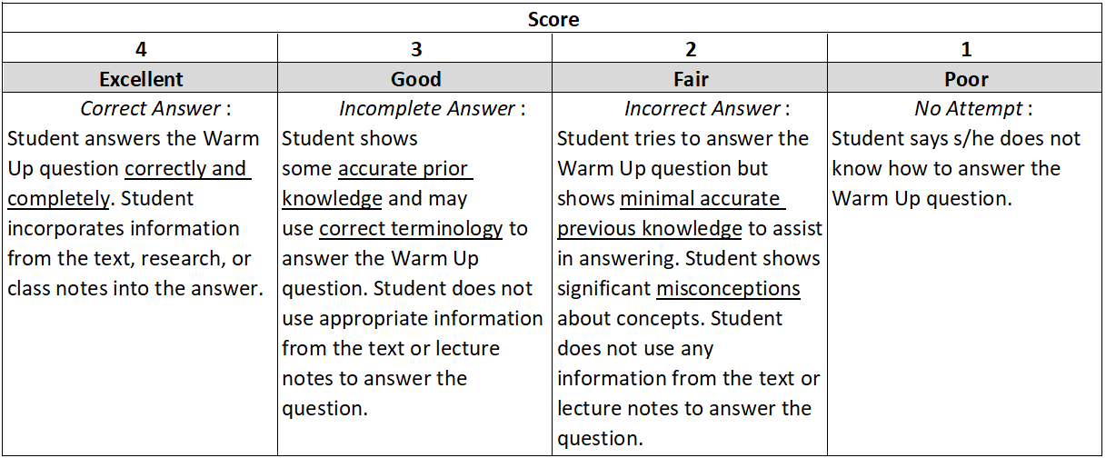

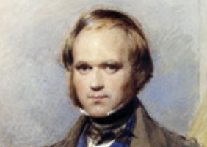
Date __________
Concept covered: Theories of Evolution; 16.2, pg 454-458

Match each person to their contribution to the Theory of Evolution
A. Developed theory of plate tectonics and how formation of sedimentary rock indicates that Earth is billions of years old.
B. Inheritance of acquired characteristics – an incorrect proposal
C. Factors limit population sizes
D. Currently accepted model of natural selection as outlined in the book The Origin of Species
E. Geologic proof that Earth is older than 6,000 years; processes like volcanoes continue to change the Earth
F. Natural selection also occurred in Malay Archipelago (famous for explaining marsupials in Australasia)
Malthus _______

Lyell _______

Wallace _______

Darwin _______

Lamarck _______

Hutton _______

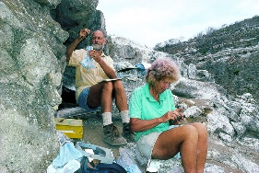
Date _________

Concept Covered: Evidence for Evolution; 16.3-16.4, pg461-465

After watching the video Beak of the Finch, explain how the data the Grants collected about the Galapagos finches shows evidence for evolution and natural selection.

Date _________

Concept Covered: Molecular Evidence for Evolution; 16.4, pg 470-471

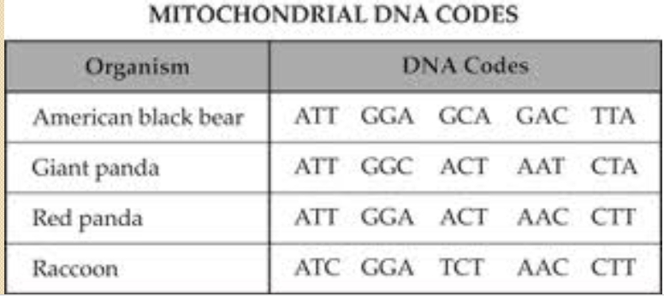

Which species is the most closely related to the black bear according to the DNA evidence in the chart? ___________________________ Explain how you know this. ________________
___________________________________________________________________________

Which 2 species listed in the chart are the most closely related? How do you know? ___________________________________________________________________________

Date _________
Concept Covered: Evidence for Evolution – Body Structures; 16.4, pg 468-469

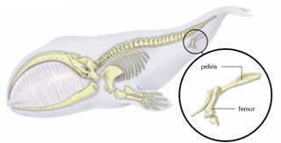
A. What evidence of evolution is being shown in the image below? (pelvis and leg bone – femur- in a whale) _____________________________

B. Explain how the image of the bones at the left gives evidence for evolution.
__________________________________
__________________________________
__________________________________
__________________________________
__________________________________

Date _________

Concept Covered: Isolating Mechanisms 17.3, pages 494 - 495

For each example write the first letter of the isolation type that is being described on the line to the left.
R = reproductive B = behavioral G = geographic T = temporal
_____1. A group of bears was separated when the landmass on which they were living split up (continental drift/plate tectonics). One group eventually became black and brown bears, the other, polar bears.
_____2. Two species of butterflies are found in northern Michigan, but one species is found only near rivers and streams, the other near lakes.
_____3. Fireflies have a unique lighting pattern. The frequency of lighting (speed of flashing) is species specific. Fireflies in the same area will not mate with those having a different lighting frequency.
_____4. Horse and donkeys produce mules, but they are sterile.
_____5. Two closely related species of plants live in the same area and are capable of interbreeding, but one releases pollen in March and the other in April.
_____6. In fruitflies, when sperm from one species enters the other species, the sperm is immobilized and unable to fertilize the egg.
_____7. The Albert’s squirrel and Kaibab squirrel are distinct subspecies of differing colors that live on opposite sides of the Grand Canyon.
_____8. The eastern and western meadowlarks have overlapping habitats, but will not mate because of the different songs used to attract mates. Eastern meadowlarks will not respond to the song of the western meadowlark and vice versa.

Date _________
Concept Covered: Mechanisms of Evolution 17.2, pg 488-489

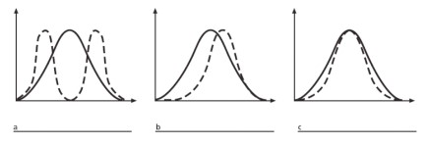

Label each graph as showing either stabilizing, directional, or disruptive selection. The straight line is the normal distribution, the dashed line is the natural selection.
Date _________

Concept Covered: Mechanisms of Evolution 2; 17.2, pg 489

Label each as stabilizing, directional, or disruptive selection:
A. Starlings produce an average of five eggs in each clutch. If there are more than five, the parents cannot adequately feed the young. If there are fewer than five, predators may destroy the entire clutch. _________________________
B. The occurrence of large or small beak sizes among seed crackers in the absence of medium-sized beaks. _________________

C. A group of peccaries (pig-like herbivores) eat only the cacti with very few spines. ____________________________

D. Large, dominant alpha males obtain mates by brute force, while small males can sneak in for furtive copulations with the females in an alpha male’s territory. ______________________________
Date _________
Concept Covered: Genetic Drift; 17.1, pg 490
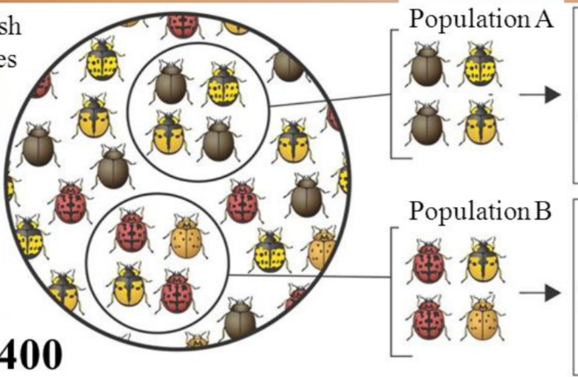
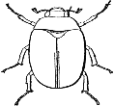
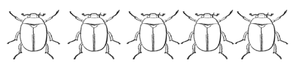

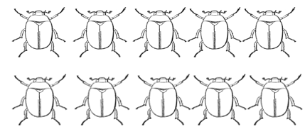

Draw what 12 descendants of each population might look like in the space to the right.
Give an example of what could cause a genetic bottleneck in these populations: _____________________________________________________________________________
If a genetic bottleneck occurred, what might we see in future generations, and why? ____________________________________________________________________________
____________________________________________________________________________

Date _________
Concept Covered: Allele Frequency; 17.1, pg 483
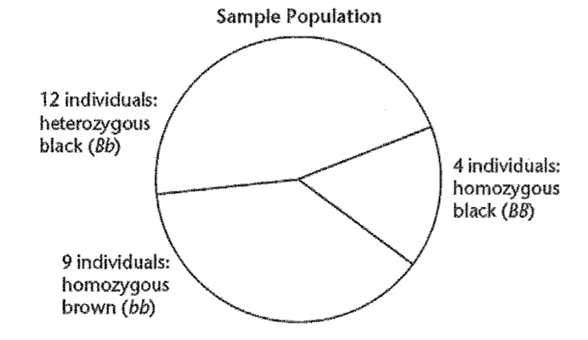

A. The total number of individuals in this population is ________. The total number of alleles is ____________.
B. How many alleles for black fur are in the sample population and what percentage of allele frequency does that represent? ______________________________________________________________________________________________________
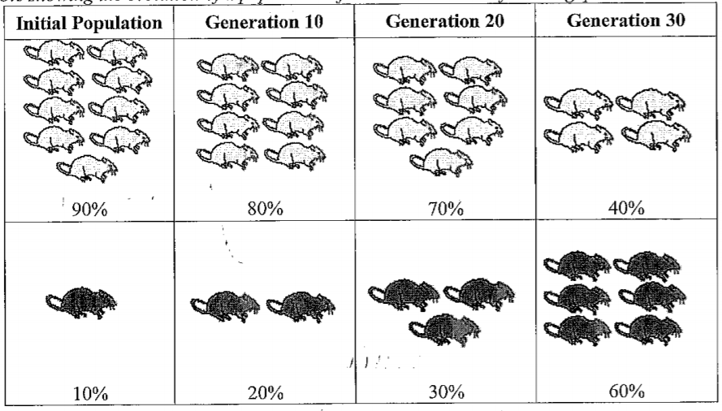

C. Describe how the allele frequency is changing in the mouse population above and propose one explanation for this change. ____________________________________________________________________________
_________________________________________________________________________________________
_________________________________________________________________________________________
_________________________________________________________________________________________

Date _________
Concept Covered: Cladograms, 18.2, pg 517-519
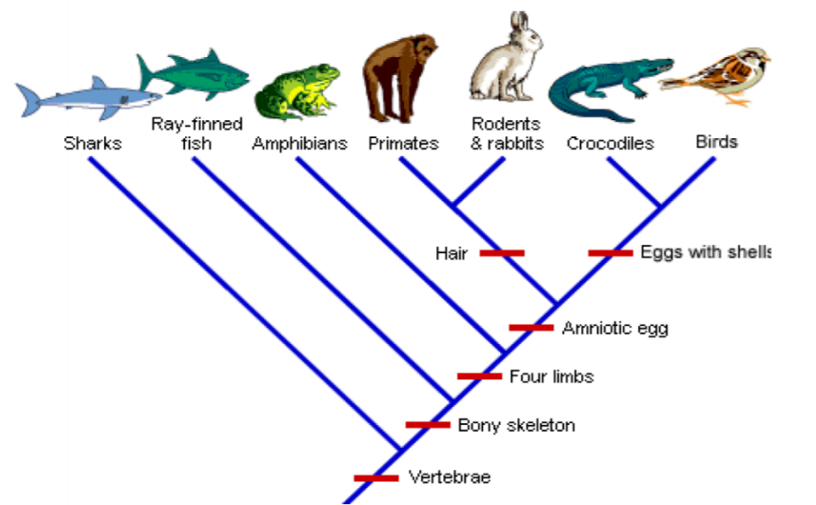

A. Which organism is most closely related to rodents and rabbits in this diagram? _______________
B. Which came first, the chicken or the egg? How do you know? ______________________________________
______________________________________
______________________________________

Date _________
Concept Covered: Evolutionary Relationships 18.2, pg 518-519
Derived Characters in Organisms
Organism | Derived Character
 | Backbone | Legs | Hair
Earthworm | Absent | Absent | Absent
Trout | Present | Absent | Absent
Lizard | Present | Present | Absent
Human | Present | Present | Present

1. What trait separates the least closely related animal from the other animals? ____________
2. Use the information in the chart to construct a cladogram of these animals. Include the traits.

3. Place a “star” on the cladogram where a frog should be placed.
Date _________
Concept Covered: Relative Dating, 19.1, pg 540

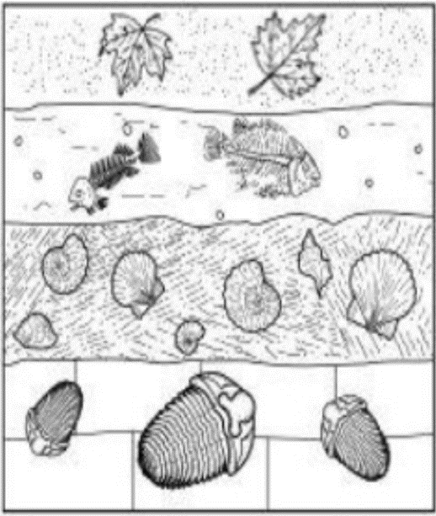
The diagram shows an undisturbed section of sedimentary rock.
1. Which of the following statements is best summarizes the history of this area?
A. The area was once a forest and was replaced by a freshwater lake.
B. The area was once a freshwater lake and was replaced by a saltwater ocean.
C. The area was once a saltwater sea and was replaced by a forest.

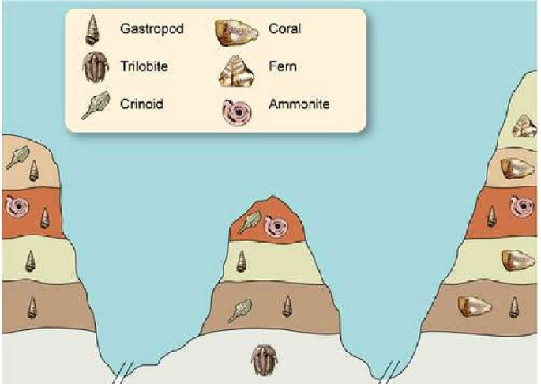

Use the diagram of the rock layers above to number the fossils in order. The oldest fossil will be labeled #1.
Trilobite _____ Fern ______ Ammonite _____ Coral _____
Date _________
Concept Covered: Radiometric Dating, 19.1, pg 540-541

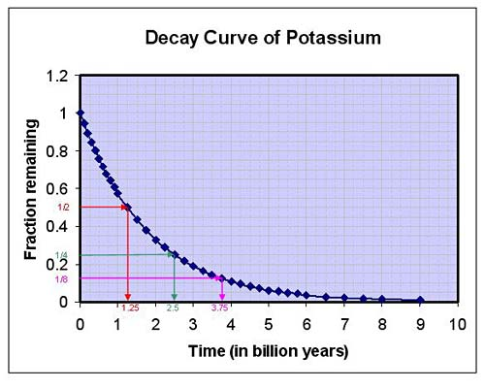
1. What is the half-life of Potassium-40? _________________
2. A microscopic fossil is found embedded in a rock. The rock sample is found to contain ¼ the K-40. Approximately how old is the fossil? _____________________ What type of organism is the fossil likely to be from? _____________________________
3. Why do scientists not use K-40 to date the age of Egyptian mummies? ________________
____________________________________________________________________________
4. A fossilized tree killed by a volcano is studied. It had 6.25 percent the amount of carbon-14 found in a sample the same size from a tree that is alive today. The half life of C-14 is 5,730 years. When did the volcanic eruption take place? Show your work.

Date _________
Concept Covered: Patterns of Evolution, 19.2, pg 551

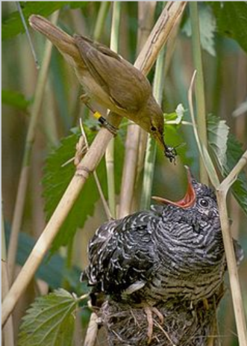
On the blank line, identify each animal pairing as an example of coevolution or convergent evolution.
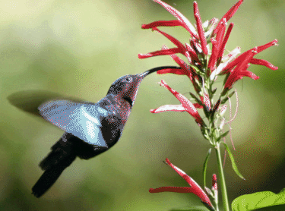

A. Hummingbird and flower B. Warbler unknowingly raises a cuckoo baby
_______________________ ____________________________
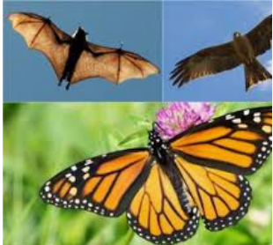
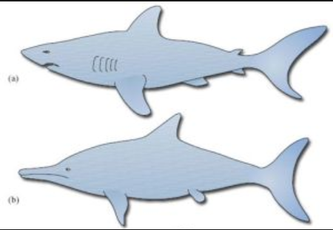
C. Shark and dolphin D. Bat, bird, and butterfly
______________________ ___________________________
Date _________

Concept Covered: Primate Evolution 26.3, pg 765-772

1. List 3 adaptations that all primates share and that have helped them gain an evolutionary advantage in their environment.
_____________________________________________________________________________

2. A human’s most closely related living relative is the ______________________________.

3. Which early hominine bones changed shape over time, allowing later hominids to walk upright? ________________________________________________________________

4. List 2 ways a modern human’s skull differs from an ancient hominid, like Australopithecus.
____________________________________________________________________________

