Name:_____________________________________ Period __________
Cancer Gene Detection Lab
The TP53 gene is called a tumor suppressor gene and is responsible for making proteins that either repair damaged cells or cause damaged cells to die (apoptosis). When this gene is not working due to a mutation, these proteins are not produced, and abnormal cells are allowed to divide and grow. A simple way to look at the TP53 gene would be to picture yourself as the TP53 gene, and a plumber as one of the proteins that fixes damaged cells and that you can control. If you have a water leak and you are “functioning properly”, you would be able to make a phone call to the plumber. The plumber could then come to your home and either repair the leaky faucet, or remove it completely to stop the leak. If you were unable to make the call (you are a faulty TP53 gene), the plumber would not be called and the leak would continue (cancer cells dividing) and eventually flood your home.

A mutation in the TP53 gene, located on chromosome 17, is the most common mutation found in cancer cells, and is present in over 50% of cancers. We will be studying Li-Fraumeni syndrome. People that inherit only one copy of the TP53 gene (Li-Fraumeni syndrome) are predisposed to developing cancer in childhood or early adulthood if the gene becomes mutated by smoking, virus, environmental factors, etc.
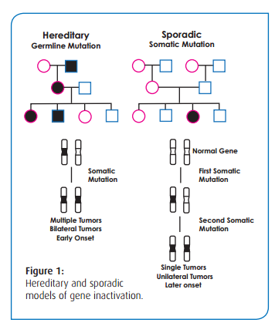Figure 1: The “two hit hypothesis”
Constructing a Pedigree
A first step in the search and diagnosis of LFS is to establish the family pedigree of the patient. This is done by the family physician, oncologist, and genetic counselor. The pedigree information that you will develop is for a young woman who is suspected to have the LFS.

Upon monthly breast self-examination, Valerie Brown, age 36, found a small irregular mass. She was concerned because she knew that her mother had a mastectomy when she was I her late thirties. Valerie made an appointment with her physician, who referred her to a specialist at a local cancer center, where she was diagnosed with breast cancer. As part of the medical work-up, the oncologist had inquired about her family history of cancer. Upon consultation with her mother, Valerie learned that her father and his family appeared to be free of cancer, However, in Valerie’s mother’s family, several cases of cancer have occurred.

With the information given below chart the family pedigree. Include each person’s name, age, and cross it out if they are deceased. Fill in the circle or square if they had cancer.

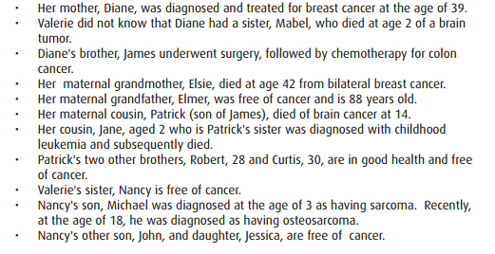
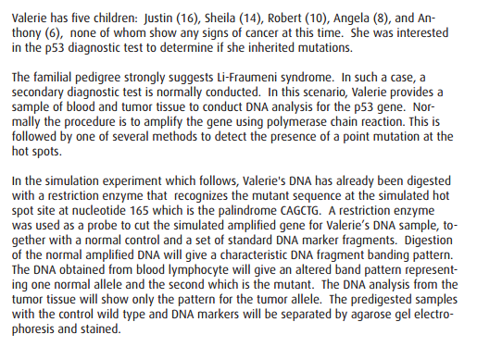

Cancer Gene Detection from Gel Electrophoresis
What is the theory behind detecting a mutation in TP53 gene using a restriction enzyme? Many times genes that are highly conserved, like TP53, will not be prone to mutations except for some “hot-spots”. These hot spots, for some reason are prone to mutations and many times these mutations are predictable in disorders. TP53 has such a hot spot about 1/3 of the way through its gene where there is not usually a restriction site. The restriction enzyme PvuII (which cuts at 5’ –CAGCTG-3’) will cut the mutated, dysfunctional, TP53 DNA.

This is the region where the hot spot for p53 protein is found:

CTGGCGATTAGCCGATCTCAACTGCCCCGGACTTTACGGGGCCTATCGGCCAATTCCCCGGG

Analyze the above sequence and circle the region where the mutation is likely to happen (hint: a single nucleotide is changed – missense point mutation), write the mutated sequence below.

Now cut the mutated DNA above with PvuII and run it on the gel below:

Control - Normal TP53gene
Mutated TP53 gene
Standard

400bp
360
320
280
240
200
160
120
80
40
10bp

Recall that you ran 5 different samples yesterday. What was the purpose of each sample?
1. Standard DNA fragments:
2. Control (normal p53) DNA:
3. Patient Peripheral blood DNA:
4. Patient Breast Tumor DNA:
5. Patient Normal Breast Tissue DNA:
Draw the gel how you think it will appear tomorrow, label the lanes. Remember that a “normal” individual has 2 copies of the TP53 gene – one on each inherited chromosome 17.

Hypothesis: Propose a hypothesis predicting if Valarie will show Li-Fraumeni syndrome by viewing your gel tomorrow. Make sure to use a prediction directly related to what you will observe on the gel.

**Lab performed is EDVOTEK Cancer Gene Detection Experiment 115 (http://www.edvotek.com/115?category=1793)
It includes a pedigree analysis of patient Valerie as part of the pre-lab.
Name:______________________________________ Per # ____________
Post-Lab Analysis of Cancer Detection Lab
Purpose: What was the overall purpose of this lab?

Hypothesis: Rewrite your hypothesis from the Pre-Lab:

Data: Draw the gel below with labeled wells

Data Analysis: What does each well show with regards to the TP53 gene?
Lane 1:
Lane 2:
Lane 3:
Lane 4:
Lane 5:
Discussion: Compare your prediction to what you actually observed. Does Valarie have Li-Fraumeni syndrome? How do you know? Was your prediction accurate with regards to how each lane would appear or were there differences. What is indicated by the appearance of each lane? Why does Valerie’s tumor DNA sample have fewer bands than the blood sample? Can a physician proceed with diagnosis based on this molecular data?

