Issue: August 2005

Doggy Double: Korean Scientists Create First Canine Clone

by Sarah Taber
In Seoul, South Korea, a puppy named Snuppy plays: healthy, happy and, to all appearances, totally normal. But though Snuppy (short for Seoul National University puppy) may look like your average dog, in reality he is anything but. Snuppy is the first canine clone, created by scientist Hwang Woo Suk and his colleagues after nearly three years of research and more than 1,000 failed attempts. Cloning dogs—a feat described by many as more difficult than cloning a human being—may allow scientists to generate better research models to help cure human diseases. Hwang's research was published in the August 4, 2005 issue of Nature.
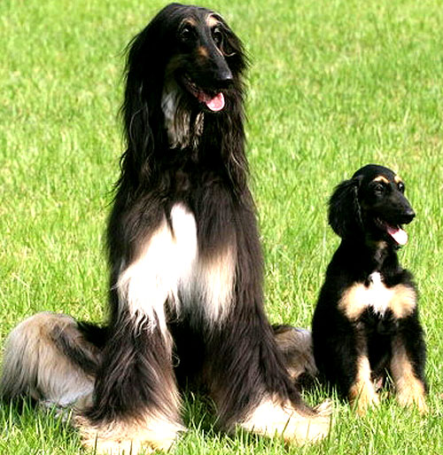
Hwang Woo Suk/Seoul National University
Snuppy the puppy with Tai, his genetic double. Scientists in Seoul cloned Snuppy from one of Tai's skin cells.
Hwang and his colleagues are not the first to attempt to clone dogs—Mark E. Westhusin of Texas A&M University, the first person to successfully clone a cat [See Cloned Cat Causes Controversy, February 2002], tried for three years before giving up. As Westhusin told News@Nature.com, "It's a logistical nightmare to work with this species." George Seidel of Colorado State University, who refused to even have a go at the project because of its difficulty, told the New York Times that Hwang's accomplishment was "simply a heroic effort, a brute force heroic effort."
So what makes canine cloning so doggone difficult? In standard cloning procedure, scientists begin by removing a mature egg from the ovary of an animal. They then take out the egg's genetic material, and add the nucleus of a cell from the animal that they are trying to clone. The egg receives a chemical shock which causes it to start dividing and to form an early embryo. After letting the embryo grow for a few days, the scientists transfer it to the uterus of a surrogate mother, where it (hopefully) gestates normally before being born. Unfortunately, with dogs, almost every one of those steps is more complicated than it is with many other animals.
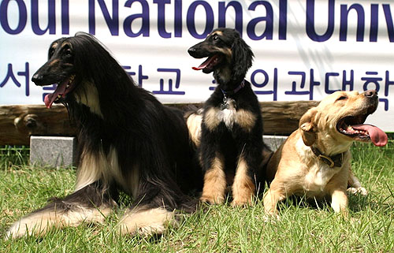
Hwang Woo Suk/Seoul National University
Snuppy with his "parents": the Afghan hound he was cloned from and the yellow Labrador retriever who was his surrogate mother.
First, female dogs ovulate only once or twice a year, and unlike many other animals (humans included), they cannot be stimulated by hormone therapy to ovulate more often. Dogs are also unique in that their eggs mature in their oviducts (the tubes leading from the ovary to the uterus) rather than in the ovaries themselves. This makes harvesting mature canine eggs far more difficult. Finally, for unknown reasons, dog embryos are not able to survive in the laboratory; scientists were therefore unable to grow them for the customary several days before implantation.
Despite these setbacks, Hwang and his colleagues refused to be deterred. In order to determine when each of their 123 potential egg donors was ovulating, they monitored the dogs' blood every day for spikes in progesterone. Once they were able to reliably predict when the dogs were fertile, they faced the much trickier problem of extracting the eggs from the oviduct—a tube about two inches (five centimeters) long and only a twentieth of an inch in diameter.
Hwang and his team developed a novel surgical approach to harvesting the eggs. After first anesthetizing the dog, the researchers made a small incision in its torso, and tied a knot at the bottom of one of its oviducts. They flushed the oviduct with saline, and then drew out the liquid (which contained the mature eggs). After the eggs were collected, the researchers snipped the knot to reopen the oviduct.
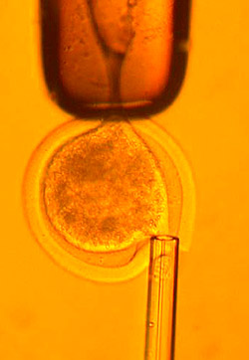
Getty Images
Snuppy nestled happily in the arms of his creator, Hwang Woo Suk (left). The result of an egg fused with the nucleus of cell from the Afghan hound, Tai (right).
Once the egg was fused with the nucleus of a cell from the dog they were trying to clone, Hwang and his team had less than four hours to implant it inside a surrogate mother. This made timing crucial—and highly difficult. After more than 1,000 attempts involving eggs from more than 100 dogs, Hwang managed to produce three pregnancies. One abruptly ended when the surrogate mother miscarried. One went to term, but the resulting puppy died of respiratory failure only a few days after birth. And one produced Snuppy.

Snuppy Family Tree
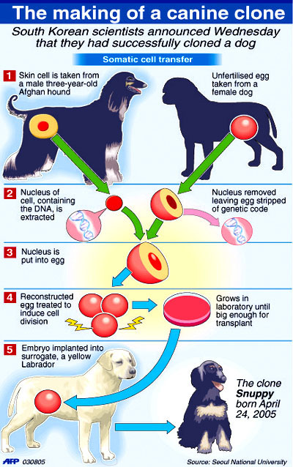
Martin Magino/AFP
Hwang and his colleagues believe that cloning dogs will provide a new way to study many of the diseases that afflict both canines and humans, including cancer, diabetes, hypertension and heart defects. Therapies utilizing stem cells from cloned canine embryos could be tested on dogs before similar techniques are tried on humans. As Gerald Schatten, a medical researcher at the University of Pittsburgh who collaborated on the study, told Reuters, "By learning whether [therapeutic stem cell treatment] is safe and effective in our companions, we may also know whether it is safe and effective for our loved ones."
Some scientists feel that Hwang and his team should have let sleeping dogs lie. In an interview with the Associated Press, Ian Wilmut, the reproductive biologist who produced Dolly the sheep [See Adult Mammal Cloned for First Time, April 1997], cautioned "successful cloning of an increasing number of species confirms the general impression that it would be possible to clone any mammalian species, including humans." Lee Chang-young, a member of the Bioethics Committee of Catholic Bishops' Conference of Korea, agreed, telling the Reuters News Service, "The more animals are cloned, the more possibilities there are of creating a cloned human." Hwang, for his part, "firmly reject[s] the term human cloning," and, as his team stated at a news conference in Seoul, believes it to be both "unsafe and inefficient."
As for Snuppy the puppy, though he may now be the most renowned dog in history, he apparently hasn't let fame go to his head. "If you come here, if you meet him," the proud Hwang told news@nature.com, "You may fall in love with him."

Bibliography
"Cloned Dog Raises Ethical Questions of Its Science." Reuters, (August 4, 2005) [accessed August 5, 2005]: www.nytimes.com/ reuters/ politics/ politics- science- cloning- ethics.html?.
Herskovitz, Jon. "S. Korean Scientists Create World's First Cloned Dog." Reuters, (August 3, 2005) [accessed August 5, 2005]: www.nytimes.com/ reuters.news.news- science- cloning- dogs.html.
Kolata, Gina. "Beating Hurdles, Scientists Clone a Dog for a First." New York Times, August 4, 2005, page A1.
Lee, Byeong Chun et al. "Dogs Cloned From Adult Somatic Cells." Nature, August 4, 2005, page 641.
Marris, Emma. "Snuppy Rewards Dogged Approach." news@nature.com, (August 3, 2005) [accessed August 5, 2005]: www.nature.com/ news/ 2005/ 050801/ full/ 050801-7.html.
"South Korean Stem Cell Pioneer Clones Dog." Associated Press, (August 4, 2005) [accessed August 5, 2005]: www.nytimes.com/ aponline/ science/ AP-Dog-Clone.html.
Vogel, Gretchen. "First Dog Cloned." ScienceNow, (August 3, 2005) [accessed August 5, 2005]: sciencenow.sciencemag.org/ cgi/ content/ full/ 2005/ 803/1.

Keywords
dog, clone, Snuppy, Seoul National University,Hwang Woo Suk
© 2011 Facts On File News Services

Citation:
Tabor, Sarah. "Doggy Double: Korean Scientists Create First Canine Clone." Today’s Science On File: n. pag. Today’s Science. Facts On File News Services, 31 Aug. 2005. Web. 9 Mar. 2011. <http://www.2facts.com/article/s1300947>.

HOMEWORK: Biotechnology - Cloning
Background Reading
Cloning Article: Snuppy the Puppy
Text: Chapter 15.2, particularly the section on Transgenic Organisms, p427

Discussion Questions

1. Briefly describe the cloning process.
_______________________________________________________________________________________________________________________________________________________________________________________________________________________________________________________________________________________________________________________________________________________________________________________________________________________________________________________________________

2. Brainstorm possible advantages and disadvantages of cloning plants and animals.
Advantages | Disadvantages
3. Thus far, we have been able to successfully clone sheep, dogs, frogs, zebra fish, cattle, and monkey embryos. Scientists in Japan are even looking into cloning wooly mammoths.
- With reasoning, discuss whether you believe it is right for humans to clone organisms.
- Where do you think a line should be drawn between what is acceptable and what is unacceptable?

___________________________________________________________________________________________________________________________________________________________________________________________________________________________________________________________________________________________________________________________________________________________________________________________________________________________________________________________________________________________________________________________________________________________________________________________________________________________________________________________________________________________________________________________________________________________________________________________________________________________________________________
___________________________________________________________________________________________________________________________________________________________________________________________________________________________________________________________________________________________________________________________________________________________________________________________________________________________________________________________________________________________________________________________________________________________________________________________________________________________________________________________________________________________________________________________________________________________________________________________________________________________________________________
__________________________________________________________________________________________________________________________________________________________________________________________________________________________________________________________________________________________________________________________________________________________________________________________________________________________________________________________________________________________________________________________________________________________________________________________________________________________________________________________

P.S. In 2008, Snuppy became a dad! He was bred with a cloned female dog and they had nine puppies, one of whom died. The remaining eight were healthy. This is normal for dog litters.

