Name _________________________________________________
1. A. Original DNA:
CCTAT ATCTC TCTAT ATCTC TCATA CTGTG TGTCT CTATA
Complementary DNA:__________________________________________________________
B. Make identical strands of DNA
CCTAT ATCTC TCTAT ATCTC TCATA CTGTG TGTCT CTATA (original)
________________________________________________________ (new)

_________________________________________________________ (new)
_________________________________________________________ (compl. From 1A)
2. A. Original DNA: CCGGA TTTTA ATTAG CTACT ATCGT ACTAC GTTGG TGCTA
Complementary DNA: ______________________________________________________________

B. Make identical strands of DNA
CCGGA TTTTA ATTAG CTACT ATCGT ACTAC GTTGG TGCTA (original)
________________________________________________________ (new)
_________________________________________________________ (new)
________________________________________________________ (compl. from 2A)
3. Explain how replicating DNA in this manner is considered “semi-conservative”.
______________________________________________________________
______________________________________________________________
Part B
4. Why does DNA need to replicate? _______________________________
5. How do base-pairing rules make DNA replication possible and accurate?
______________________________________________________________
_____________________________________________________________
6. Explain 3 main steps in the process of DNA replication. Name the enzymes that go with each step (HINT: There are 4 main enzymes, 2 of them go with the second step).
a. ___________________________________________________________
_____________________________________________________________
b. ___________________________________________________________
_____________________________________________________________
c ___________________________________________________________
_____________________________________________________________
d. ___________________________________________________________
_____________________________________________________________
7. What are Okazaki fragments? Why are they needed?
_____________________________________________________________
_____________________________________________________________
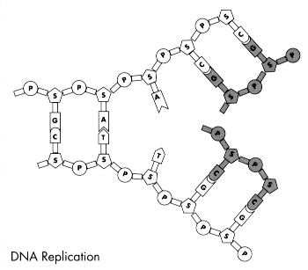
7. Label the 5’ and 3’ ends of the original template strands of DNA (the white ones) in the above image.
8. Label the 5’ and 3’ ends of the newly formed strands of DNA (the gray) in the above image.
9. Add arrows to indicate the direction in which the new nucleotides are being added.
10. Label each gray strand as Leading or Lagging.
10. Draw in a “circular-shaped” helicase using a highlighter or colored pencil in the correct location. What is the function of helicase? _________________________________________________

