Chapter 13: RNA & Protein Synthesis
Daily Warm Ups

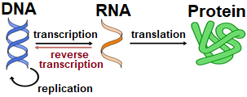
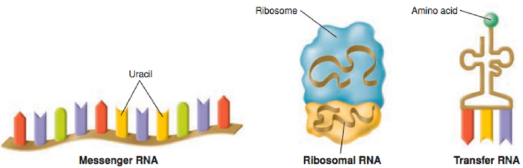

The very first thing that you will do every day when you walk into class is a science warm up. This will usually be a question that will either get you thinking about what we will be learning that day or will help you think about what we learned during the day before. You should first try to answer the question from your own memory and using your own thoughts but, if you are having difficulty, you may look for the answer outside the class (book, internet, etc).
This booklet will be glued into your BILL and graded on test day. You can change your answers at any time prior to when it is graded (in fact, it is encouraged! Learning is a process). See me for help if you need it. If you ever miss a day, it is your responsibility to make-up the warm ups for the day you missed.

Warm Up questions are worth 4 points each. I will be looking for any misconceptions you might have, how thoroughly you answer a question, how much you used resources available to you, and even how well a particular Warm Up question is constructed.
Scoring Rubric:
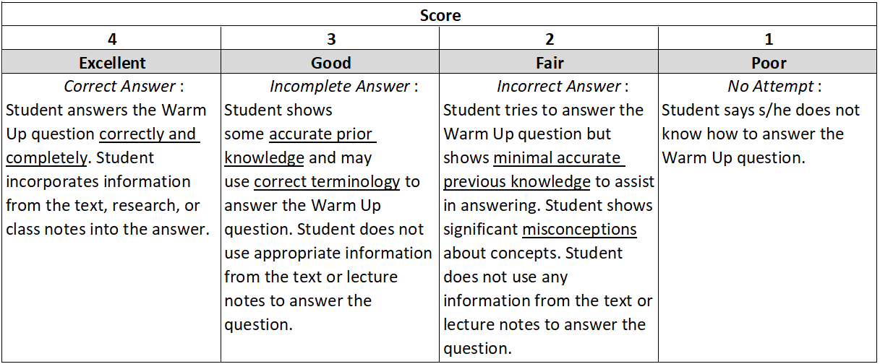

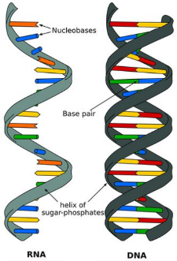
Date _________
Concept Covered: DNA and RNA Comparison (pg 362)

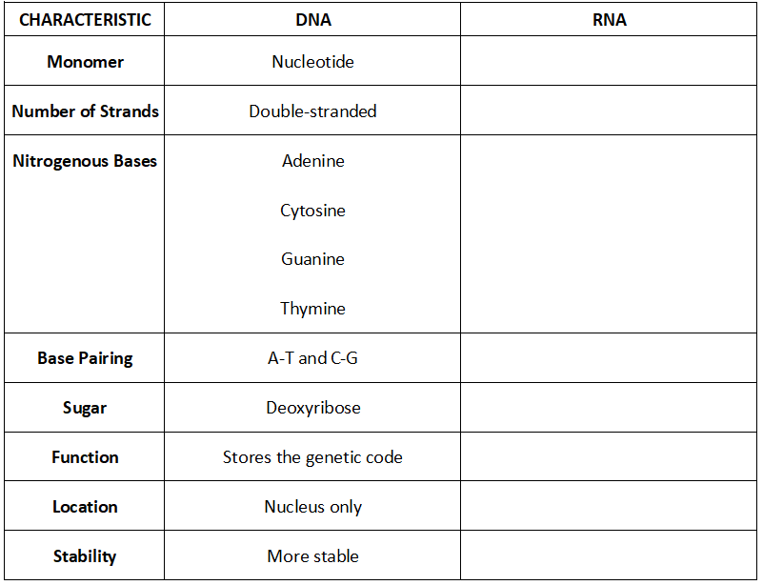
Compare and contrast the structures of DNA and RNA by completing the table.

Date _________
Concept Covered: RNA (pg 363)

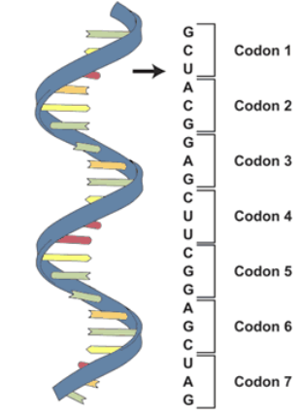
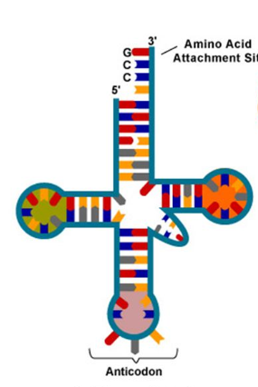
Identify each image as mRNA, tRNA, or rRNA. Then identify its location as either nucleus, cytoplasm, or both.

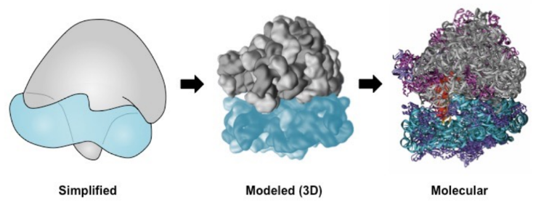

Date _________

Concept Covered: mRNA Editing (pg 365)

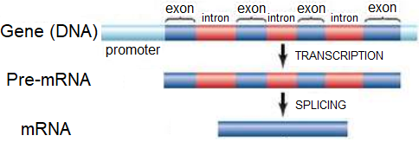

- Which regions of the mRNA are removed during editing? _________________________
- Which regions of the mRNA are spliced back together? __________________________
- How does RNA polymerase know where to attach to begin transcription?
________________________________________________________________________
- How would the protein product be altered if editing did not occur?
________________________________________________________________________________________________________________________________________________________________________________________________________________________

Date _________

Concept Covered: Codons (pg 366-367)

- What is the START codon? ______________
- What are the three STOP codons? ____________________________________________
- Use the codon chart to determine the amino acid sequence for which this mRNA strand codes.

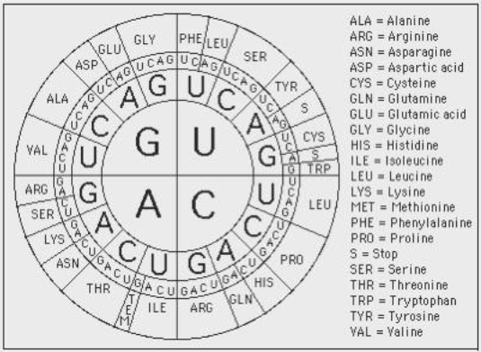

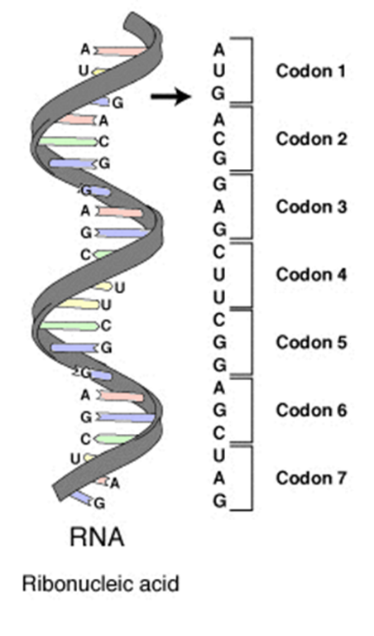
____________________________________________
____________________________________________
____________________________________________
____________________________________________
____________________________________________
____________________________________________
____________________________________________

Date _________

Concept Covered: Translation (pg 368-369)

Use the following terms to label the diagram of translation.

Amino acid Polypeptide chain A site E site P site
Codon Anticodon tRNA mRNA Ribosome

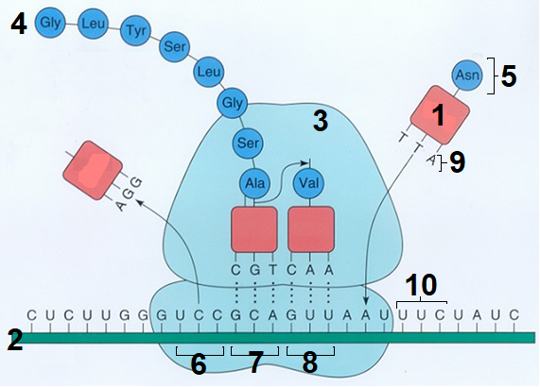

- ______________________________
- ______________________________
- ______________________________
- ______________________________
- ______________________________
- ______________________________
- ______________________________
- ______________________________
- ______________________________
- ______________________________

Date _________

Concept Covered: Gene Mutations (pg 372-374)

Identify the gene mutations shown below. Use the terms frameshift, substitution, insertion, deletion, sense, missense, nonsense where they apply. Each image will have 2 terms.
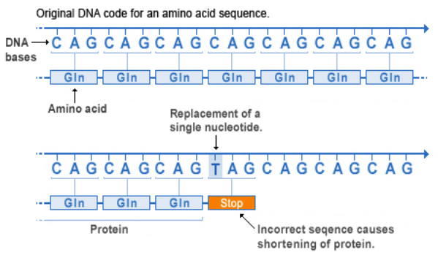

- ______________________________
______________________________

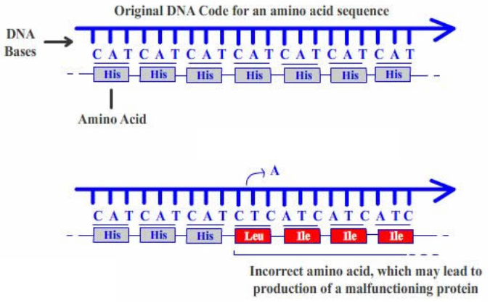

- _______________________________
_______________________________

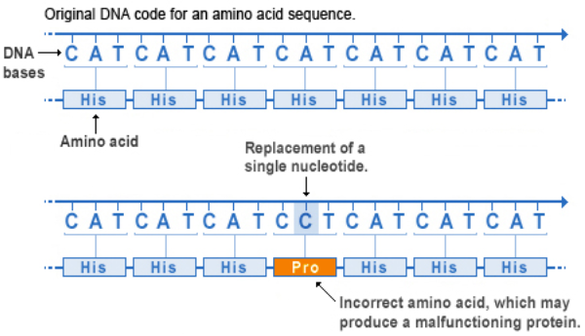

- ______________________________
______________________________

Date _________

Concept Covered: Gene Mutations (pg 372-373)

Describe the gene mutations found in the following human genetic disorders.
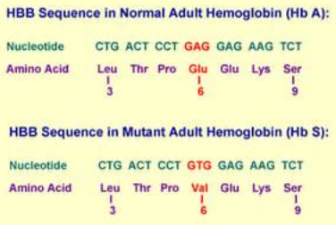
Sickle Cell Disease
___________________________________
___________________________________
___________________________________

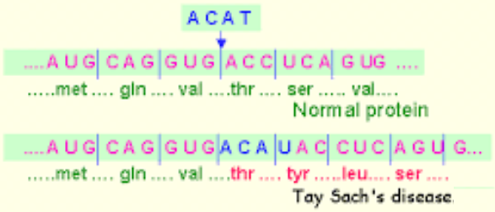
Tay Sachs Disease
___________________________________
___________________________________
___________________________________

Cystic Fibrosis
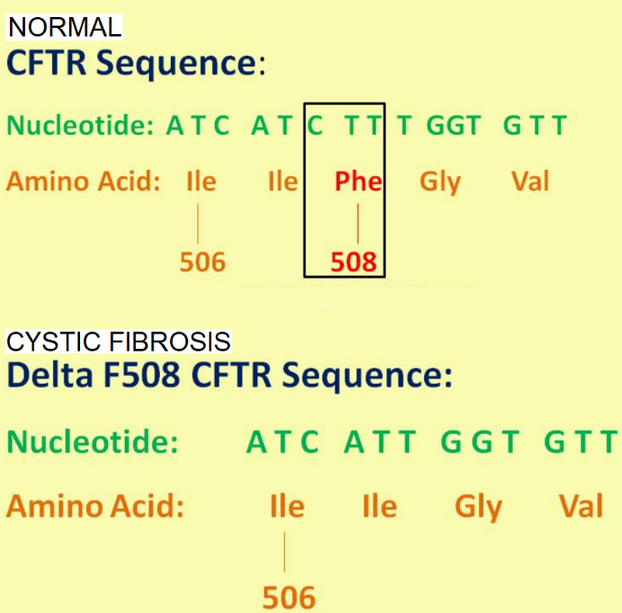
___________________________________________
___________________________________________
___________________________________________

Date _________
Concept Covered: Not All Mutations Are Bad (pg 375-376)
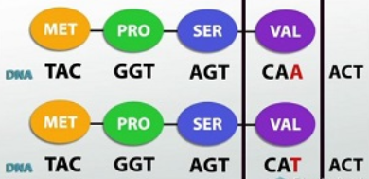

- What is a silent mutation? ___________________________
___________________________________________________
2. What are symptoms of sickle cell disease? ______________________________________
___________________________________________________________________________
3. Someone heterozygous for sickle cell trait has a protective advantage from what other deadly disease? _________________
4. Ryan Clark, former NFL player, was a carrier of sickle cell. Although considered “normal phenotype” and not having sickle cell disease, he had a serious sickle cell crisis while playing in Denver, nearly died and lost his spleen. How can you explain this? ____________________
____________________________________________________________________________
____________________________________________________________________________
Date _________

Concept Covered: Operon (pg 377-378)
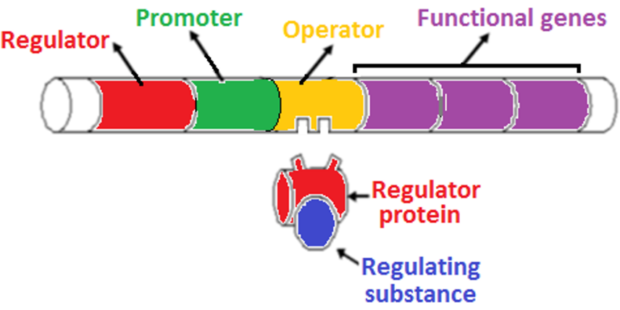

Briefly describe the functions of each of the parts of an operon.

Regulator: ____________________________________________________________________
Promoter: ____________________________________________________________________
Operator: ____________________________________________________________________
Functional genes: ______________________________________________________________
Regulator protein: ______________________________________________________________
Regulating substance: ___________________________________________________________
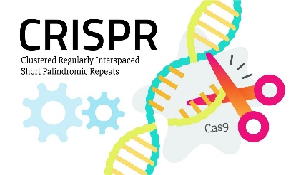
Date _________

Concept Covered: CRISPR/cas9 gene editing

CRISPR-Cas9 is a genome-editing tool that is creating a buzz in the science world. It is faster, cheaper, and more accurate than previous techniques of editing DNA and has a wide range of potential applications. Once a specific DNA sequence has been identified by the guide RNA (gRNA), the enzyme called Cas9 cuts through both strands of DNA at a particular location.
Read the following article and write a 1 paragraph reflection about your thoughts. Potential of this technology? Bad? Good?

First Gene-Edited Dogs Reported in China

An extra-muscular beagle has been created through genome engineering. Are we on our way to customizing the DNA of our pets?
- by Antonio Regalado
- October 19, 2015
Genetic engineering of animals will open up remarkable possibilities in medicine and agriculture but also could lead to new ethical dilemmas.
Man’s best friend is now his newest genetic engineering project.
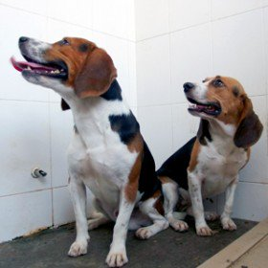
Beagles named Hercules, at left, and Tiangou are the world’s first gene-edited dogs.
Scientists in China say they are the first to use gene editing to produce customized dogs. They created a beagle with double the amount of muscle mass by deleting a gene called myostatin.
The dogs have “more muscles and are expected to have stronger running ability, which is good for hunting, police (military) applications,” Liangxue Lai, a researcher with the Key Laboratory of Regenerative Biology at the Guangzhou Institutes of Biomedicine and Health, said in an e-mail.
Lai and 28 colleagues reported their results last week in the Journal of Molecular Cell Biology, saying they intend to create dogs with other DNA mutations, including ones that mimic human diseases such as Parkinson’s and muscular dystrophy. “The goal of the research is to explore an approach to the generation of new disease dog models for biomedical research,” says Lai. “Dogs are very close to humans in terms of metabolic, physiological, and anatomical characteristics.”
Lai said his group had no plans breed to breed the extra-muscular beagles as pets. Other teams, however, could move quickly to commercialize gene-altered dogs, potentially editing their DNA to change their size, enhance their intelligence, or correct genetic illnesses. A different Chinese Institute, BGI, said in September it had begun selling miniature pigs, created via gene editing, for $1,600 each as novelty pets.
The Chinese beagle project was led by Lai and Gao Xiang, a specialist in genetic engineering of mice at Nanjing University. The dogs are being kept at the Guangzhou General Pharmaceutical Research Institute, which says on its website that it breeds more than 2,000 beagles a yearfor research. Beagles are commonly used in biomedical research in both China and the U.S.
Genome editing refers to newly developed techniques that let scientists easily disable genes or rearrange their DNA letters. The method used to change the beagles, known as CRISPR-Cas9, is particularly inexpensive and precise (see “10 Breakthrough Technologies 2014: Genome Editing”).
Last month, Duanqing Pei, a representative of the Chinese Academy of Sciences, highlighted Lai’s work as part of what he called a large Chinese effort to modify animals using CRISPR. The list of animals already engineered using gene editing in China includes goats, rabbits, rats, and monkeys. Pei described the efforts as a national scientific priority and part of China’s effort to establish world-class research.
The ease with which gene-editing can be carried out has raised worries that humans could be next (see “Engineering the Perfect Baby”). Those fears were stoked in April when another Chinese team reported altering human embryos in the laboratory in an attempt to correct a genetic defect that causes beta-thalassemia (see “Chinese Team Reports Gene-Editing Human Embryos”).
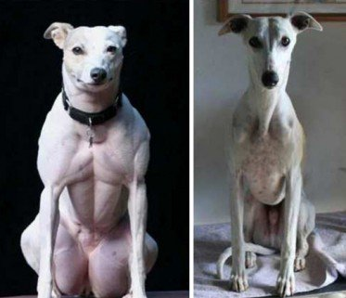
A naturally occurring DNA mutation in the myostatin gene leads to highly muscled whippets, at left, as reported in the journal Neuromuscular Disorders. Scientists in China say they can now engineer the same change into other dogs.
The dog researchers took much the same approach, directly introducing the gene-editing chemicals—a DNA snipping enzyme, Cas9, and a guide molecule that zeroes in to a particular stretch of DNA—into more than 60 dog embryos. Their objective was to damage, or knock out, both copies of the myostatin gene so that the beagles’ bodies would not produce any of the muscle-inhibiting protein that the gene manufactures.
In the end, of 65 embryos they edited, 27 puppies were born, but only two, a female and a male, had disruptions in both copies of the myostatin gene. They named the female Tiangou, after the “heaven dog” in Chinese myth. They named the male Hercules.
Lai and his colleagues reported that in Hercules, the gene editing was incomplete, and that a percentage of the dog’s muscle cells were still producing myostatin. But in Tiangou, the disruption of myostatin was complete and the beagle “displayed obvious muscular phenotype,” or characteristics. For example, her thigh muscles were large compared to those of her littermates.
The effects of losing the myostatin gene are well known from nature. One breed of ultra-beefy cattle called Belgian Blues normally lack the gene and grow to hulking size. Among dogs, the mutation occurs naturally only in whippets, says Eva Engvall, a retired scientist and whippet breeder who in 2007 helped identify the mutation affecting that breed. The double-muscled dogs are called “bully whippets.”
In rare cases, a person can also be born without any working copy of myostatin. In 2004 doctors reported a newborn who “appeared extraordinarily muscular, with protruding muscles in his thighs and upper arms.” They confirmed he was missing the myostatin gene and noted that by four and a half years of age, the boy could extend his arms while holding three-kilogram dumbbells.
Because the myostatin gene is well-studied—and because double-muscling isn’t known to have obvious drawbacks—it is frequently cited in debates over hypothetical future “gene-doping” among athletes. U.S. doctors are already attempting to block myostatin in gene-therapy experiments that seek to slow muscle loss in boys suffering from Duchenne muscular dystrophy.
Engvall says she was impressed by the Chinese work, which she says shows how gene editing might also be used to correct genetic illnesses that affect some dog breeds. “The point of this work was not to re-create myostatin knockouts,” says Engvall, “The point was to use the CRISPR technology in dogs. And in this project, the authors overcame some obstacles, in that dogs are a bit tricky when it comes to manipulating embryos.”
However, Eliane Ostrander, a scientist at the National Institutes of Health who has studied myostatin in dogs, says it remains unclear to her, based on the publication, whether the beagles were displaying extremely noticeable increases in muscle mass, as is seen in whippets. “The number of dogs is still small,” she says. “It will be interesting to see what types of variation come up as more dogs undergo the process.”
When DNA alterations are introduced at the embryo stage, they can affect every cell in an animals’ body, including sperm and egg, the cells of the “germline.” Lai’s team says it checked Hercules’s sperm and found that, if he was bred, he would pass the myostatin mutation onward. “The favorable traits that result from gene editing can pass generation by generation,” says Lai, and it will be possible to breed large numbers of gene-edited dogs “which can be commercialized.”
People have been influencing the genetics of dogs for millennia. By at least 36,000 years ago, early humans had already started to tame wolves and shape the companions we have today. Charles Darwin frequently cited dog breeding in The Origin of Species to demonstrate how evolution gradually occurs by a process of selection. With CRISPR, however, evolution is no longer gradual or subject to chance. It is immediate and under human control.
It is precisely that power that is stirring wide debate and concern over CRISPR. Yet at least some researchers think that gene-edited dogs could put a furry, friendly face on the technology. In an interview this month, George Church, a professor at Harvard University who leads a large effort to employ CRISPR editing, said he thinks it will be possible to augment dogs by using DNA edits to make them live longer or simply make them smarter.
Church said he also believed the alteration of dogs and other large animals could open a path to eventual gene editing of people. “Germline editing of pigs or dogs offers a line into it,” he said. “People might say, ‘Hey, it works.’ ”
Reflection Paragraph:

