Unit 6: DNA & DNA Replication
Daily Warm Ups

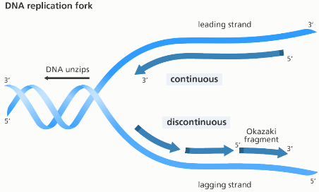
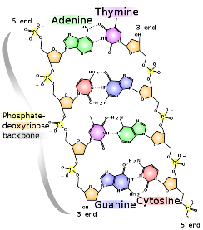

The very first thing that you will do every day when you walk into class is a science warm up. This will usually be a question that will either get you thinking about what we will be learning that day or will help you think about what we learned during the day before. You should first try to answer the question from your own memory and using your own thoughts but, if you are having difficulty, you may look for the answer outside the class (book, internet, etc).
This booklet will be glued into your BILL and graded on test day. You can change your answers at any time prior to when it is graded (in fact, it is encouraged! Learning is a process). See me for help if you need it. If you ever miss a day, it is your responsibility to make-up the warm ups for the day you missed.

Warm Up questions are worth 4 points each. I will be looking for any misconceptions you might have, how thoroughly you answer a question, how much you used resources available to you, and even how well a particular Warm Up question is constructed.
Scoring Rubric:
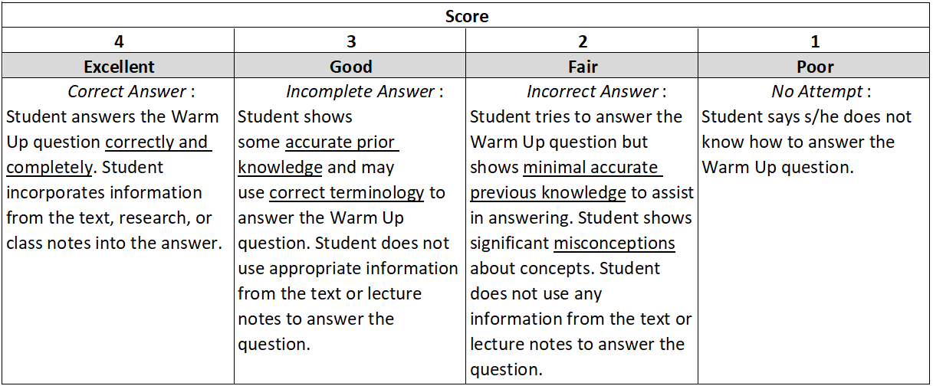

Date _________

Concept Covered: DNA Structure (book reference pg 344-345)

Label each of the following on the DNA diagram below:
Deoxyribose sugar Pyrimidines Hydrogen bonds Phosphate group
Purines 3’ end 5’ end Nucleotide Nitrogenous base

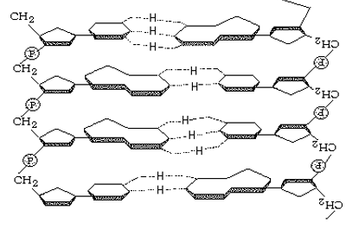

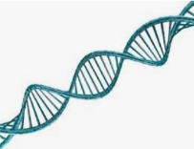
Date _________

Concept Covered: Discovering DNA’s Structure (book reference pg 345-347)

- What was Chargaff’s contribution to the discovery of DNA’s structure?

- Explain the role of x-ray crystallography/diffraction in the discovery. Who contributed this understanding?

- What was Watson & Crick’s proposal for DNA’s structure?

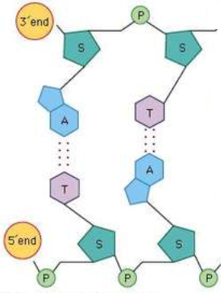
Date _________

Concept Covered: DNA Structure (book reference pg 348)

- Why are the DNA strands described as ‘antiparallel?’

- Why are hydrogen bonds so important to the structure of DNA?

- Adenine and guanine (purines) are longer than thymine and cytosine (pyrimidines). What would happen to the parallel strands if adenine was paired with guanine?

Date _________

Concept Covered: DNA Function

Label the diagram of the Central Dogma of molecular biology.
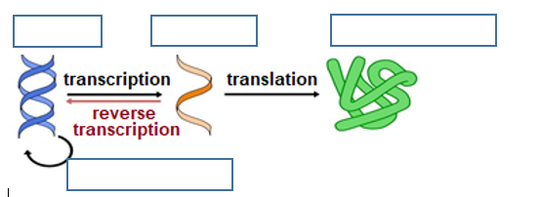

Date _________

Concept Covered: Transformation (book reference pg 338-339)

In your own words, describe the results of Griffiths’ experiments and their importance to his discovery that genetic information can be passed from one bacterial strain to another.

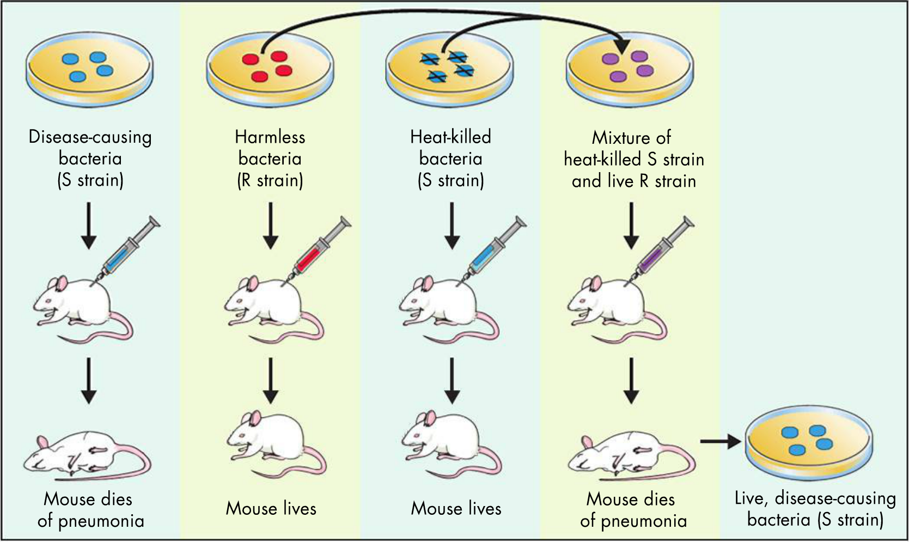

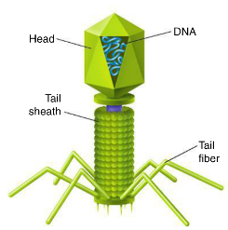
Date _________

Concept Covered: Discovering DNA Carries Genetic Information
(book reference pg 340-341)

- How did Avery and his team investigate which organic molecule (carboyhydrates, lipids, proteins, nucleic acids) was responsible for carrying the genetic code?

- How did Hershey & Chase confirm that genetic material was a nucleic acid?

Date _________

Concept Covered: DNA Replication Enzymes

Unscramble the following to identify the enzymes that enable DNA replication to occur.

- SEACHILE – Separates double-stranded DNA by breaking the ____________________
hydrogen bonds between the two strands, allowing
each to be copied
- LEASERTOME – Maintains the length of the telomeres by ____________________
adding repetitive nucleotide sequences to the 3’ends
of eukaryotic chromosomes

- MARYLOPSEEAND – Adds nucleotides in the 3’-5’ direction to ____________________
build new DNA strands and repairs copying errors

- AGILES – Joins Okazaki fragments on the discontinuous lagging ____________________
strand
Date _________

Concept Covered: DNA Replication (book reference pg 351-352)

There are many enzymes involved in replicating DNA. Consider how the process would be altered if each of these enzymes was absent. If each was removed, how do you think it would change the replication process and the resulting cell(s)?

- Helicase

- DNA Polymerase

- Ligase

- Telomerase

Date _________

Concept Covered: DNA Replication (book reference pg 351)

- Use the following terms to label the replication fork below (one term will be used twice):
DNA Polymerase Helicase Lagging strand
Leading strand Ligase Okazaki fragment

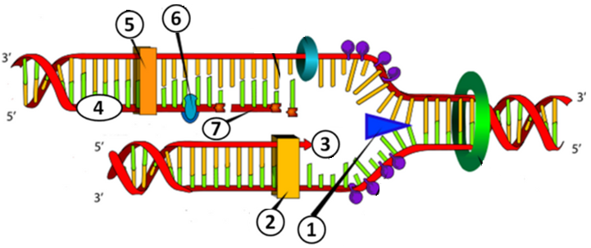

- _________________________________
- _________________________________
- _________________________________
- _________________________________
- _________________________________
- _________________________________
- _________________________________

- On the diagram, draw two arrows that show the direction in which the DNA polymerase enzymes are moving.

Date _________

Concept Covered: DNA Replication – Evaluating an Analogy

When you are studying with a friend, he tells you that DNA replication is like photocopying a page of a book. Think of the original materials, the copying process, and the final products. Explain how the two processes are alike and identify major differences.

Date _________

Concept Covered: Errors in Replication

A scientist determined the number of copying errors made after exposing DNA to various ultraviolet light rays, shown in the graph below.
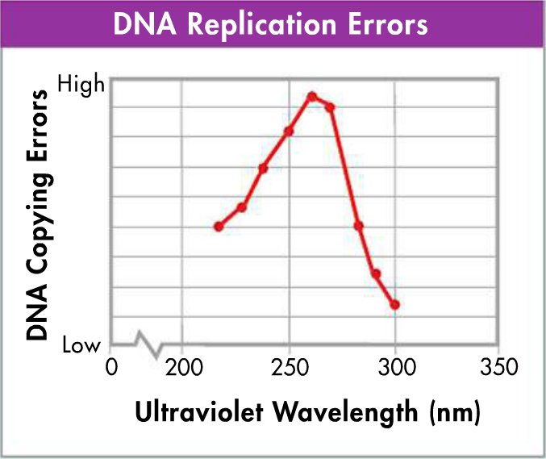
- At what wavelength do the most damaging effects occur?

- What conclusion would you draw from the graph about the effect of UV rays on living organisms?

Date _________

Concept Covered: CRISPR-Cas9 and DNA Repair

CRISPR-Cas9 is a genome-editing tool that is creating a buzz in the science world. It is faster, cheaper, and more accurate than previous techniques of editing DNA and has a wide range of potential applications. Once a specific DNA sequence has been identified by the guide RNA (gRNA), the enzyme called Cas9 cuts through both strands of DNA at a particular location.
Hypothesize how the CRISPR-Cas9 process may utilize the existing DNA repair mechanisms already in the cells.

Date _________

Concept Covered: Comparing Eukaryotic and Prokaryotic Replication
(book reference pg 353)

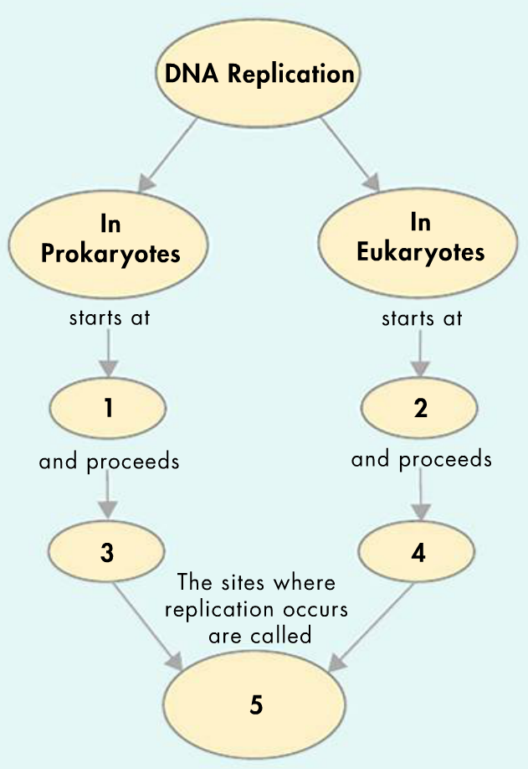
Compare and contrast eukaryotic and prokaryotic replication by filling in the numbered blanks.
1.________________________________________
2.________________________________________
3.________________________________________
4.________________________________________
5.________________________________________

Date _________

Concept Covered:

Date _________

Concept Covered:

