Paternity Test – the Genetics of Blood Type
Name ___________________________________________
Pre-Lab:
1. Complete the following tables:
Allele | Codes for a protein that is
 | A version of the enzyme that puts Type A carbohydrate molecules on the surface of red blood cells
 | A version of the enzyme that puts Type B carbohydrate molecules on the surface of red blood cells
i

Genotype | This person’s cell make | Blood Type
I^{A}I^{A} | The version of the enzyme that puts Type A _________________ molecules on the surface of ____________ blood cells
 | The inactive protein
 | A version of the enzyme that puts both Type A and Type B carbohydrate molecules on the surface of red blood cells

2. Define Antigen ________________________________________
3. Define Antibody ____________________________________________
4. Complete the blanks within the following table:
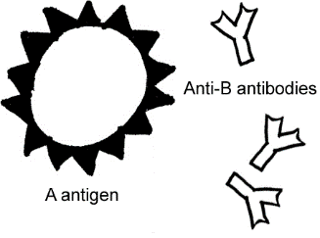 | Blood group A  If you belong to the blood group A, you have A antigens on the surface of your red blood cells and ________ antibodies in your blood.
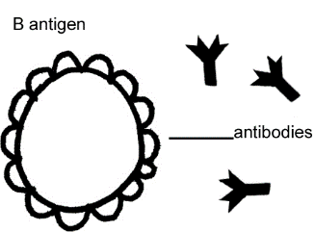 | Blood group B  If you belong to the blood group B, you have B antigens on the surface of your red blood cells and ________ antibodies in your blood.
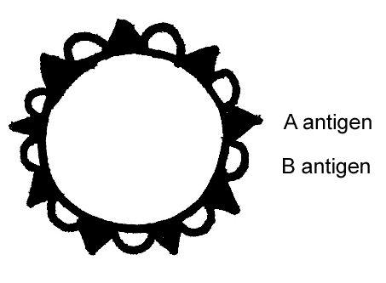 | Blood group AB  If you belong to the blood group AB, you have both A and B antigens on the surface of your red blood cells and no anti-A or  anti-B antibodies in your blood.
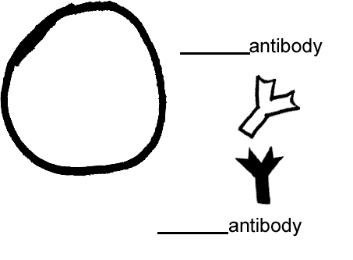 | Blood group O  If you belong to the blood group O, you have neither A nor B antigens on the surface of your red blood cells, but you have both  ________ and ________ antibodies in your blood.
5. Blood Transfusions:
If you are given a blood transfusion that does not match your blood type, antibodies present in your blood can react with the antigens present on the donated red blood cells. For example, if a person who has Type A blood is given a Type B blood transfusion, then this person's anti-B antibodies will react with the Type B antigens on the donated red blood cells and cause a harmful reaction. This transfusion reaction can cause the donated red blood cells to burst and/or clump together (called agglutination) and block blood vessels.
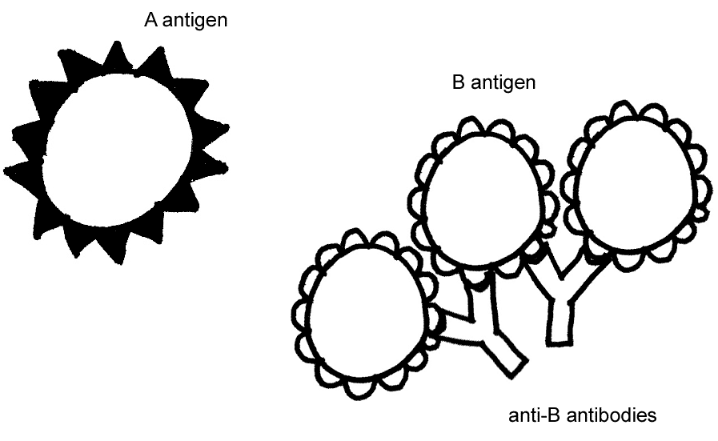
Test your understanding of blood groups by completing the following table:
Blood Group | Antigens on red blood cells | Antibodies in blood plasma | Can receive blood from | Can donate blood to
A
B
AB
O
+
-

6. Which blood type is considered the universal donor? _______________
7. Someone who is B- can receive blood from what other blood types? ______________________________________

Background: In this investigation, you will determine the blood groups of the mother (June), her natural daughter (Andrea), and 4 possible fathers. Use the data to decide who should not and who should pay June child support.

Procedure:
1. Using the dropper vial, place a drop of the synthetic blood sample in each well of the blood typing slide. Use the same person for all three wells of the slide. Use a new slide for each individual you need to test. To prevent cross-contamination, always replace the cap on one vial before opening another vial.
2. Add a drop of synthetic anti-A serum (blue) to the well labeled A. DO NOT touch the vial to the blood on the slide. Replace the cap.
3. Add a drop of synthetic anti-B serum (yellow) to the well labeled B. Replace the cap.
4. Add a drop of synthetic anti-Rh serum (clear) to the well labeled Rh. *Sometimes this is labeled D instead of Rh. Replace the cap.
5. Using a different toothpick for each well to prevent cross-contamination, gently stir the synthetic blood and anti-sera for about 15 seconds. You might need to wait about 15-30 seconds for any agglutination to happen.
6. Carefully examine the thin films of liquid mixtures. If the mixture looks uniform in appearance, there is no agglutination. If the sample appears granular or has solid particles in it, agglutination has occurred. The agglutination in each well might look different. In the Data Table below, answer “yes” or “no” as to whether agglutination occurred. Be sure to record the data in the correct column.
7. Thoroughly rinse the blood typing slides and scrub lightly with a test tube brush.
Data Table 1: Agglutination Results of Paternity Test – Write “clot” or “no”
 |  |  | Possible Fathers
 | Mother (June) | Child  (Andrea) | #1 | #2 | #3
Anti-A
Anti-B
Anti-Rh (D)

Data Table 2: Blood Type Determination
 |  |  | Possible Fathers
 | Mother (June) | Child (Andrea) | #1 | #2 | #3
ABO group
Rh (D) group

8. Duplication of lab test is important; therefore, compare agglutination results with another group. You might need to retest some of the samples! When you are satisfied that both tables are accurate and complete, answer the questions below independently.

Analysis:
1. As shown by your tests, baby Andrea is blood group _________ (A, B, AB, or O?). What allele did Andrea receive from her mother June? _________________________ (I^{A}, I^{B}, or i)
2. What allele must have come to Andrea from her father? __________________(I^{A}, I^{B}, or i)
3. Which of the fathers, if any, is genetically excluded by your ABO data from being Andrea’s father? _______________
Why?

4. The dominant allele D must be present for a person to be Rh+. An Rh+ person is either Dd or DD.
a. An Rh negative person has what genotype? _________
b. What is June’s genotype for the Rh factor? ___________
c. What Rh allele must come from Andrea to her father? __________ (either D or d)
d. What is Andrea’s genotype for the Rh factor? __________
5. Which of the possible father or fathers are genetically excluded by the Rh factor data from being Andrea’s father? _______________________________________________________________________
6. Which possible father is a good candidate for paying child support for Andrea? _______________
Extension:
1. Jane is blood type A and her husband is blood type B. Jane is puzzled because their daughter is type O. Explain how the daughter inherited a blood type that neither parent has. Then show the Punnett square of this cross.

2. If Jane and her husband (from #1) were both type AB, could they have a type O daughter? Explain.

3. An archeologist discovers an unopened tomb in Egypt. Inside she finds the mummies of 2 adults and 2 children. Inscriptions identify the 2 adults as the Chief Scribe and his wife. The inscriptions describe how their son and his best friend drowned in the Nile River when their boat overturned. The mummies are so well preserved that lab technicians can type the blood of the 4 individuals. Both adults are type B. Child 1 is type A, Child 2 is type B. Which child is NOT the son and how do you know?

4. On the basis of blood type, you know that one of the children could not have been the son of the 2 adults. Why does this not definitively prove that the other child is their son?

5. Jim is blood type A- and his mother is blood type O-. What is/are the possible blood type(s) of Jim’s father? ___________________
6. Jim (from #5) has a sister who is blood type O+. Now what do you think the father’s blood type is? _____________
7. After graduating from high school, Cindy decides to join the Navy. She knows that her father’s blood type is B and her mother’s is O. Cindy’s blood is typed as part of her physical exam, and she is blood type A. Cindy returns home and asks her parents if she is adopted. Why?

8. Describe how blood type is an example of both codominance and multiple alleles.

9. Research Rh incompatibility. Write about what you learned.

