History of DNA WebQuest

1. Friedrich (Fritz) Miescher
http://www.dnai.org/timeline/index.html
Find Miescher on the timeline and click on the bucket with the Red Cross to watch the animation. In 1869, he extracted a substance from white blood cells that he called nuclein. What do you think he was actually extracting?
__________________

2. Frederick Griffith
https://www.dnalc.org/view/16375-animation-17-a-gene-is-made-of-dna-.html

Frederick Griffith’s famous experiment was conducted in 1928. In his experiment, ______________ smooth virulent bacteria plus live rough ______________ bacteria killed mice. His experiment demonstrated that DNA was the _______________ material.

Griffith’s Famous Experiment: Transformation
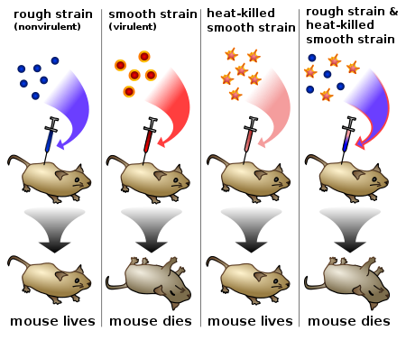

3. Oswald Avery
http://www.dnai.org/timeline/index.html
Click on the “Transforming Factor” animation
In 1944, what did he discover that DNA is responsible for?
______________________________________________

4. Alfred Hershey and Martha Chase
http://www.dnai.org/timeline/index.html
Click on the “Blender Experiment”
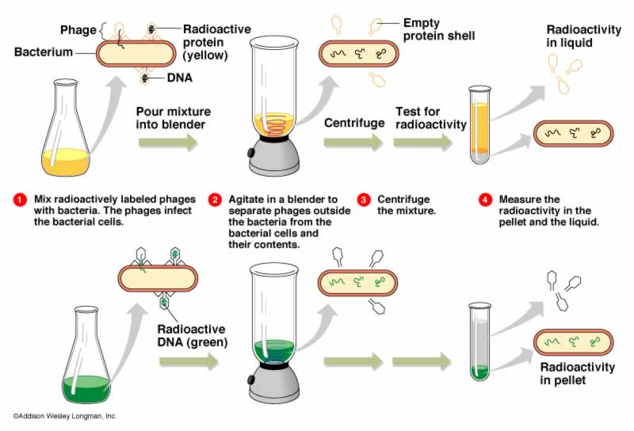
a. In 1952, their experiments showed that ______ is the genetic material instead of ____________.

5. Erwin Chargaff
http://www.dnai.org/timeline/index.html
Watch “Chargaff’s Ratios.” Chargaff used relative proportions of bases in DNA to come up with his rules for base pairing. What are four sources of DNA that he used?
_____________________________________________

http://fig.cox.miami.edu/~cmallery/150/gene/chargaff.htm
Adenine (A) pairs with _____________
Guanine (G) pairs with _____________
The bases that are purines include ___________ & ____________.
The bases that are pyrimidines include ___________ & ______________.
6. Rosalind Franklin.
http://www.accessexcellence.org/RC/AB/BC/Rosalind_Franklin.php
http://www.dnai.org/timeline/index.html - Watch Franklin’s X-ray diffraction pattern.
What is X-ray crystallography (a.k.a. X-ray diffraction)?
_____________________________________________
What did she discover about the shape of DNA?
_____________________________________________
7. Linus Pauling
http://www.dnai.org/timeline/index.html - Watch the animation.
Linus Pauling proposed a structure for DNA that was incorrect. Describe or draw it below:

8. Maurice Wilkins
http://www.nzedge.com/heroes/wilkins.html
His research, with the help from ________________, led to the discovery of the DNA molecule structure. This discovery was made by American biologist, ________________, and British physicist, ________________.

9. James Watson and Francis Crick.
http://www.dnai.org/timeline/index.html
a. What did they receive the Nobel Prize for in 1962?
____________________________________________
b. What is the difference between Pauling’s structure and the actual structure of DNA?
_______________________________________________
10. DNA Game
http://nobelprize.org/educational_games/medicine/dna_double_helix/
Play the game and record what three organisms you had:
1.
2.
3.

