Topic: Prokaryotes
Homework the previous night: 5 minutes
Students, draw a vertical line down the middle of your paper (left side of notebook). Make a list of prokaryotes on the left side of your paper (Ex: Streptococcus pneumonias, Escherichia coli, etc.) and name the parts of a prokaryotic cell on the right side (Ex: DNA, ribosomes).

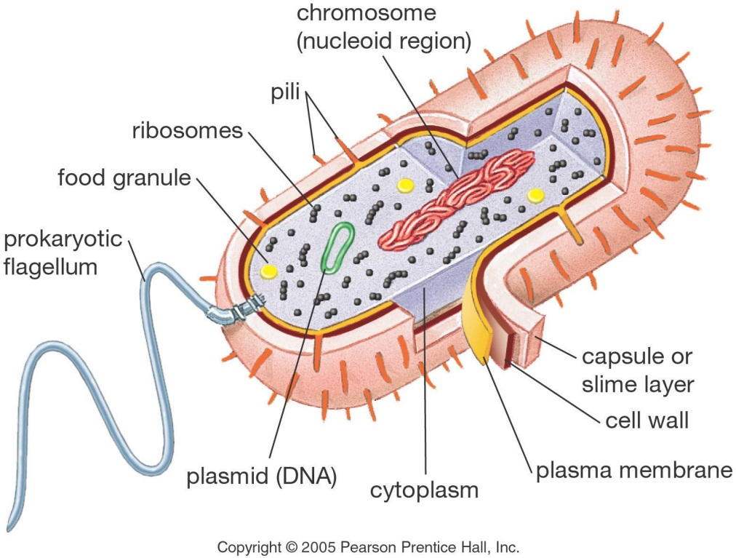

Activity One: Prokaryote structure 20 minutes
Learning Objectives:
a) The learner will (TLW) identify common prokaryotes.
b) TLW make a model of a prokaryotic cell to facilitate memorization of the cellular components.

Materials:
For each student: 1 empty, fill-it-yourself gel capsule, size 00 (these can be purchased at any health food or vitamin store; store them in the refrigerator so they do not melt or become deformed). http://www.amazon.com/Solaray-Empty-Gel-Caps-capsules/dp/B000OQ4AJM

For each lab group: 2 spools of thread; 1 tube of glitter glue; 1 small container of petroleum jelly; 1 cotton ball; waxed paper; 1 meter stick; 1 pair of scissors.

Procedure:
1. Prior to class, refrigerate the gel capsules and the glitter glue.

2. In class, begin a discussion of answers to homework. Ask for volunteers to put their answers on the board. Ask the students if they agree with all example organisms that have been written on the board. Ask the students to eliminate those organisms that are not correct or ask for support on those that they are not sure about. Add other organisms to the board or give quick stories about an organism or two. If you have time, research stories of famous people affected by prokaryotes to make a few of the example organisms memorable (ex: Van Gogh died of syphilis; virulent strains of E. coli have caused death in people who ate contaminated fast food; bacteria cultures are used to make blue cheese and yogurt, etc.). Remind the students that not all prokaryotes are pathogenic (in fact, most are not), but because the benign ones are invisible to the naked eye, most people do not hear or think much about them (ex: soil bacteria that fix or denitrify nitrogen).
3. Ask if everyone agrees with the cell parts listed on the board. Play devil’s advocate to fish for support for each of the parts listed, or to help the students think of missing cell parts. Keep reminding the students to provide support for their comments and responses (OK to use computer).

4. After the students have completed a list of cell parts, tell them they are each going to make a prokaryotic cell model. Tell the students that the DNA inside a prokaryotic cell is approximately 500 times the length of the cell itself. Hold up a size-00, fill-it-yourself capsule and a ruler and tell the students the approximate length of the capsule. Ask each person to calculate how long the DNA would be for this “cell.” Pass out spools of thread and meter sticks (or tell them the length of the room, or the size of the floor tiles, etc.) so they can spool off enough thread to represent the DNA for their cell.

5. Tell the students they may use the supplies at their lab table to represent the components of a prokaryotic cell in any way they choose, but they must be able to justify their representations. (For example: glue – cytoplasm; glitter – ribosomes; thread – DNA; capsule – cell wall; petroleum jelly – capsule coating; two or three fibers from a cotton ball or short segment of thread– flagella, cotton fibers for pili.)

6. Warn the students that the gel capsule will melt if handled too much so they must work quickly. The capsule can be coated with petroleum jelly once it is closed and then add a flagellum and pili. As soon as the prokaryotes are made, they should be left on a piece of waxed paper in the refrigerator to dry and harden. (The gel capsules will deform slightly with the glue and the warmth of the students’ hands, but once they are dried in the refrigerator they can be handled or sent home in a plastic bag.)

Possible homework: “Find and explain 2 examples of symbiotic relationships”
Activity Two: Mitochondria - Bacterial Symbionts (can be done as a “flipped lesson” depending upon time) 20 minutes
Learning Objectives:
a) TLW identify the cell components that distinguish a prokaryote from a eukaryote.
b) TLW predict the characteristics that mitochondria and chloroplasts should have if they had a prokaryotic origin.

Materials:
For the class: several images from textbooks or the Internet of prokaryotic cells, with their component parts labeled or depicted (electron micrographs and other real-life images are preferable to illustrations); several images of mitochondria and chloroplasts inside plant and animal cells; a projection screen; a projector; a computer.

Procedure:

1. Show the students some of the images of prokaryotic cells and point out, or ask the students to identify, the component parts.

2. Ask the students to write, on their own sheet of paper, a list of the organelles found in all prokaryotic cells. Directly across from that list ask the students to write a list of the organelles found in eukaryotic cells. Then answer: What cell structures do mitochondria and chloroplasts have in common with prokaryotes? (This can be a homework assignment the night before if there is little time the day before.)

3. Tell the students about the endosymbiont theory—the hypothesis that mitochondria and chloroplasts were once independent prokaryotic organisms that were engulfed by a larger cell, where they lived in a symbiotic relationship within the cell. If your students have not heard of symbiotic relationships in which one organism lives inside another, give some examples: bacteria that live in mammalian intestines to help the mammal break down fiber and produce vitamin D and K; photosynthetic algae that live inside each species of coral to give these animals their bright colors and source of glucose, etc.

4. Ask the students to work in pairs to make a list of what features the mitochondria and chloroplast would or would not have if they in fact had once been independent prokaryotic organisms. Let the students know that over time the independent organisms would become more and more interdependent, so some features that once distinguished these organelles as prokaryotes might have been lost, but there still should be some remaining signs of prokaryotic features.

5. Ask the students to share their lists with another pair of students and then share their combined lists with the rest of the class. Ask one student to take notes on the board of all the features that are shared. Some features that mitochondria and chloroplasts have that reveal their prokaryotic origins might include: DNA that is circular rather than linear, additional circular plasmids of DNA, ribosomes, no membrane-bound organelle inside the mitochondria or chloroplasts, plasma membrane proteins that are most similar to those of prokaryotes, etc.

HW: Ask the students to read the parts of their textbook that cover prokaryotes and the endosymbiont theory.
Good site to use for information: http://exploringorigins.org/protocell.html
Ask the students to follow up on one of the prokaryotic characteristics that mitochondria and chloroplasts have that may reveal their evolutionary relationship with prokaryotes by writing a summary of the Endosymbiotic Theory in 3 sentences or less.

