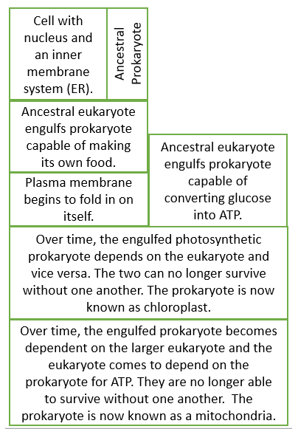

When did the first prokaryotic cells evolve?______________________________

When did the first eukaryotic cells evolve?______________________________

What are 5 pieces of evidence that support endosymbiosis?

1.

2.

3.

4.

5.

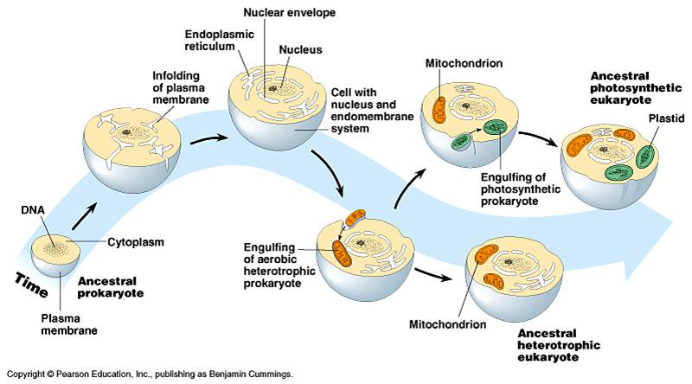

What is the Endosymbiotic Theory? ____________________________________________  
____________________________________________________________________________________________________________________________________________________

The Endosymbiotic Theory