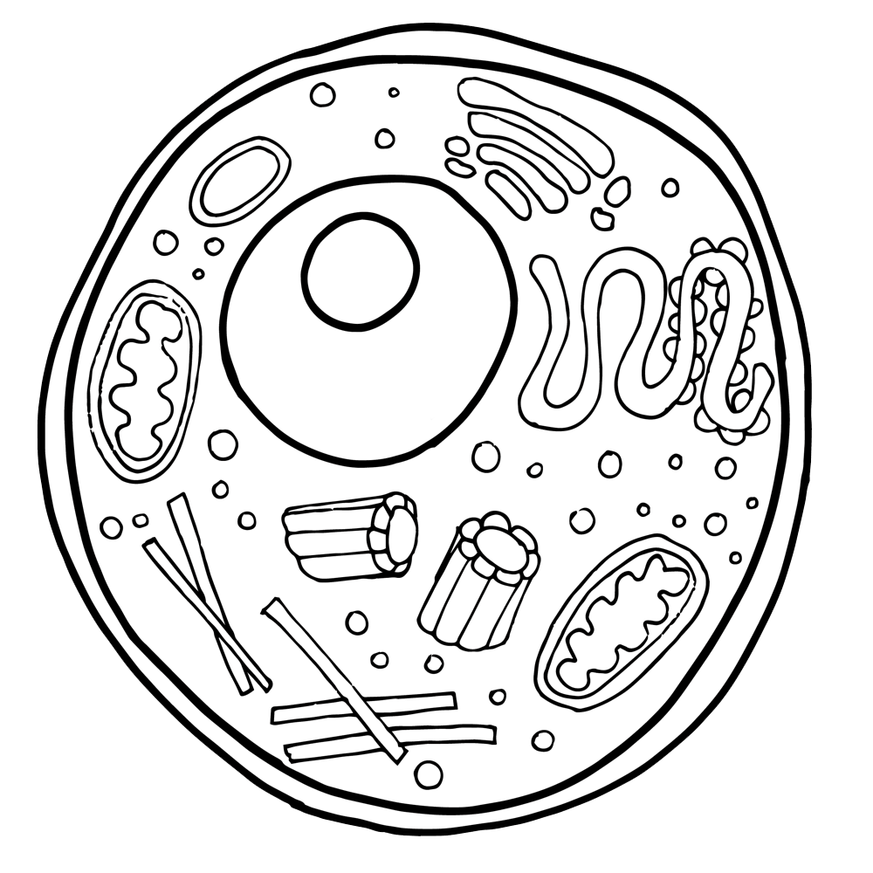

Cell

Cell

What is the

What is the

Matthias Schleiden

Rudolf Virchow

Theodor Schwann

Robert Hooke

Anton van   
 Leeuwenhoek

1665

1673

1839

1838

1855

Theory?

Matthias Schleiden

Rudolf Virchow

Theodor Schwann

Robert Hooke

Anton van   
 Leeuwenhoek

1665

1673

1839

1838

1855

Theory?

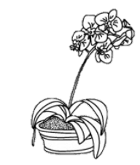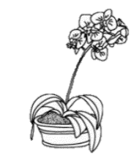

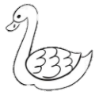

<https://www.youtube.com/watch?v=4OpBylwH9DU>

<https://www.youtube.com/watch?v=4OpBylwH9DU>

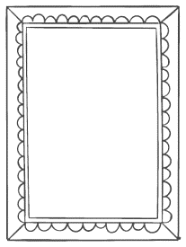

What are the components of the cell theory?

1.

2.

3.



What are the components of the cell theory?

1.

2.

3.

How do you think the invention of the microscope influenced the cell theory?

How do you think the invention of the microscope influenced the cell theory?