*____________________: diffusion of ___________________ through a selectively permeable membrane

*Type of facilitated diffusion

*Water moves from ___________ to ___________ concentrations through protein channels called __________________________.

**\*Facilitated Diffusion:** diffusion of ________________ particles through transport _________________ found in the membrane.

*Transport proteins are _____________; they allow only certain molecules to cross the membrane

*Transports _____________ or _____________ molecules

*Ex:

Two Types of Proteins

1. Carrier proteins: _________________ _____________ to move specific molecules in or out of the cell

Ex:

2. __________________ proteins: have a tunnel that allows _____________ molecules to move in or out of the cell

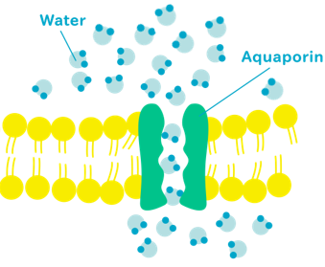

**In the diagram below, label the side with the high concentration (HIGH) and the low concentration (LOW). Then draw an arrow (🡪) showing the direction the solution will move through the membrane.**

Osmosis

­

**In the diagram below, label the side with the high concentration (HIGH) and the low concentration (LOW). Then draw an arrow (🡪) showing the direction the solution will move through the membrane.**

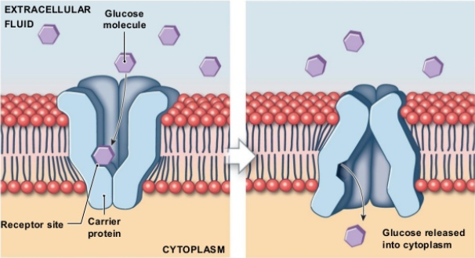

Facilitated Diffusion

**\*Diffusion**: ________________ movement of particles from an area of _________ concentration to an area of ___________ concentration

*Once the concentration of the substance on both sides of the cell membrane is the same, _________________ is reached.

*Even when equilibrium is reached molecules continue to move in both directions, but there is ___________ _______________________________.

*Molecules that can move through the membrane are ___________ and ___________, like ______ and _______.

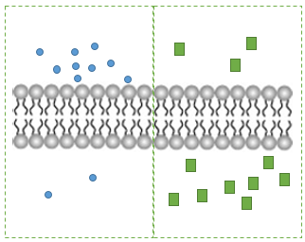

**In the diagrams below, label the side with the high concentration (HIGH) and the low concentration (LOW). Then draw an arrow (🡪) showing the direction the solution will move through the membrane.**

Diffusion

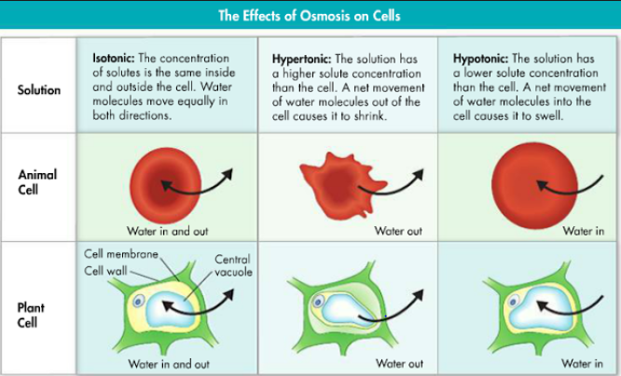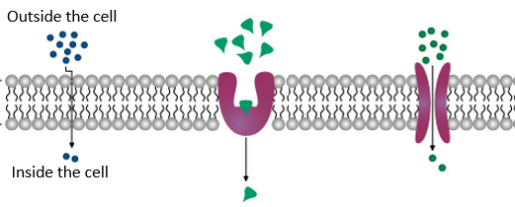

* Cell uses __________ energy
* Molecules move _________________
* Molecules move from areas of __________ concentration to areas of ___________concentration
* **HIGH** 🡪 **LOW (Particles move down or with the concentration gradient)**

Types of Passive Transport