Name ______________________________________ **Dialysis Lab**

**Reference Page – Diffusion, Osmosis, and Semi-Permeable Membranes**

1. Molecules (like perfume or water) will ALWAYS try to move from a place where they are closely packed together (a **GREATER CONCENTRATION**) to a place where they are not packed together and are spread out (**LESS CONCENTRATED**).

**A A A A A**

**A A A A A** Let’s move over here. **A**

**A A A** It’s less crowded!!!

Greater Concentration Less Concentration

2. The molecules will move from Greater concentration to Less Concentration until there are equal numbers on both places. This is called **EQUILIBRIUM**.

This is much more comfortable!!

Equilibrium

**A A A A A A A A**

**A A A** **A A A**

3. The actual movement of the molecules from Greater to Less Concentration is called **DIFFUSION**.

**B B B B**

**B B**  Let’s **DIFFUSE** over here. **B B B**

**B** It’s less crowded!!  **B B B B**

Less Concentration Greater Concentration

4. When water molecules move from Greater to Less Concentration it’s given a special name – **OSMOSIS**.

**H2O H2O H2O**

**H2O H2O H2O** Come on – let’s move by

**H2O H2O H2O OSMOSIS** to where it’s less crowded! **H2O H2O H2O H2O**

Greater Concentration Less Concentration

5. Look closely at this example of a cell in an environment.

Water will move OUT of the cell (by Osmosis) to reach Equilibrium. Salt will move IN to the cell (by Diffusion) to reach Equilibrium. *Note: in most living cells, salt is unable to move across the lipid bilayer without the input of energy because of its strong ionic charges. Water moves through protein channels without the use of energy.*

**H2O Salt**

**Salt Salt**

**Salt H2O**

**H2O Salt**

6. Cells are surrounded by a **SEMI-PERMEABLE MEMBRANE**. This means that some molecules can pass through the membrane and other molecules can’t. Think of the cell membrane like the screens on you windows at home. Small things, like air molecules and rain, can get through, but large things like bugs and basketballs, can’t make it through the small holes. With a cell membrane, small molecules like water and oxygen can easily pass through. Larger molecules, like protein, are too big to squeeze through the tiny spaces in the membrane. Separating molecules by size across a membrane is called **DIALYSIS**.

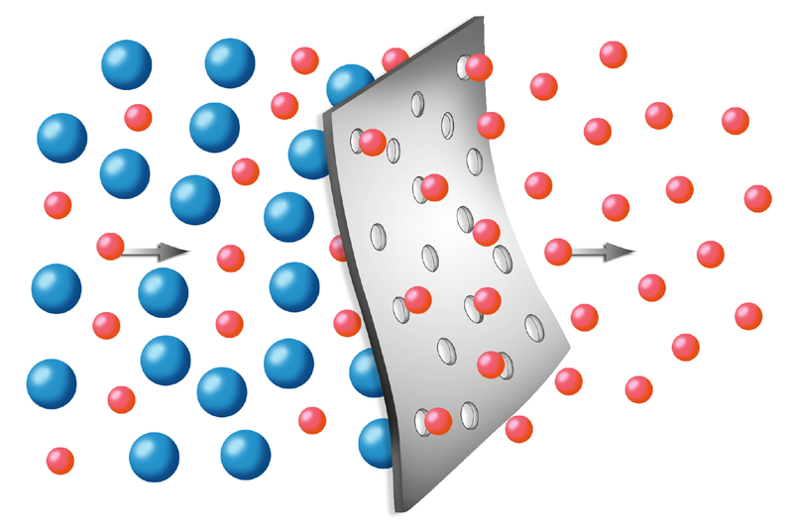

**water**

**protein**

7. Look closely at the example below of a cell in an environment.

Protein Protein

Protein Protein

H2O

H2O Protein Protein

Protein

Water will move OUT of the cell by Osmosis until it reaches Equilibrium. The protein really wants to move IN to the cell by Diffusion, but it can’t due to its large size. The protein will never reach equilibrium, so the water continues to move across in an effort to equalize the concentrations. *Note: this might happen for a living cell, but may not for all membranes. Some membranes have different sized holes*.

**Pre-Lab Questions:**

1. List the following substances from largest to smallest: protein, water, red blood cell, iodine, glucose, starch

Largest: ___________________________

Highlight the substances at left that would be small enough to fit through the holes in dialysis tubing.

___________________________

___________________________

___________________________

___________________________

Smallest: __________________________

Iodine added

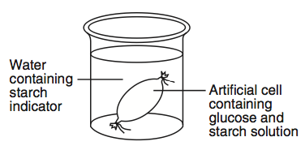

1. You set up an experiment that looks like the image at the right and let it set for 24 hours. The next day you add Iodine indicator to the “environment container” to test for starch, but must leave the room for several minutes before checking the results. When you return, you are surprised to see that, somehow, the liquid inside the “cell” has turned a blackish-purple color! Explain what happened to cause the liquid in the “cell” to mysteriously change colors.

Starch solutionr

Water

__________________________________________________________________________________________________

__________________________________________________________________________________________________

1. ****Look at the experiment shown at the right. Will the human red blood cells be able to diffuse through the dialysis membrane and enter the “cell”? EXPLAIN your answer.

Human blood cells

**______________________________________________________**

Water



1. The experiment shown at the left was left to sit for 24 hours. How could you show that the protein did or did not cross from the “environment” into the “cell”? ______________________

Water

Protein solution

__________________________________________________

How could you test if the water moved out of the “cell”? _________

__________________________________________________________

1. If the experiment in #3 had the protein solution replaced with Glucose solution instead, how could you test to see if the glucose has moved into the cell?____________________________

_____________________________________________________________________________



**St. Jean de Brebeuf Hospital**

DIVISION OF DIALYSIS

Indianapolis, Indiana

Dear Braves Technologies,

Our division works exclusively with dialysis patients and the development of more efficient kidney dialysis machines. The patients we treat have kidney disease and must use our dialysis machines to filter the waste chemicals from their blood.

To receive dialysis treatment, a patient is first connected to a dialysis machine by an IV. Inside the dialysis machine is a long piece of semi-permeable dialysis tubing that passses through an environment container filled with a watery liquid. The patient’s blood enters the machine and flows through the dialysis tubing. The high concentration of waste molecules in the blood move out of the dialysis tubing by diffusion and enter the watery environment, which has a very low concnetration of waste molecules – and the blood is cleaned! The semi-permeable dialysis tubing is important because it allows the smaller waste molecules to pass through, but won’t let the larger blood cells and other important molecules to diffuse out of the blood and into the watery environment.

Our research team has recently been working on the development of a new dialysis tubing for our machines. For this new dialysis tubing to work properly, it must be permeable to water and allow water molecules to pass through from the watery environment (where there is a great concentration of water) into the dialysis tubing filled with blood (where there is a less concentration of water). We are very excited about our new dialysis tubing, as it should work more efficiently in our dialysis machines. However, our research and development team is not yet sure if water can actually move through the semi-permeable membrane and enter the dialysis tubing as required. Nor do we know if it allows other molecules like glucose and protein to move across the membrane. Knowing if these moleucles can cross will help us with quality control.

Before our new tubing can be used with patients, its permeability to water, glucose, starch, and protein must be tested and proven. Unfortunately, we don’t have the expertise needed to complete these important tests. We are sending samples of our new dialysis tubing to you and ask that your research teams complete the necessarey tests to see if those molecules can indeed pass through the semi-permeable dialysis tubing membrane.

We are anxious to receive your results ans our new tubing could be saving lives!

Thank you,



Dr. Christina McCarter

Research and Development

Division of Dialysis

St. Jean de Brebeuf Hospital

Brave Technologies, Inc.



**DEPARTMENT MEMO**

TO: All Research Teams

I have spoken with Dr. McCarter and she is sending us dialysis tubing for our experiments. She also added that if water does cross the membrane, she needs to know at what **RATE** it moves through. Therefore, I need for you to answer THREE questions for Dr. McCarter:

1. Will water move from an environment, through the dialysis tubing membrane, and into the dialysis tubing?

2. If the dialysis tubing *is* permeable to water, at what **RATE** does it move? (you should report the speed that the water enters the tubing as **grams of water/minute**)

3. Will the tubing allow glucose and protein to cross the membrane?

You will be supplied with all necessary supplies, but if you require additional supplies for a very unique experiment, I will get them for you. Remember, you are on a budget – everything costs money!

I want you to **set up TWO of your experiments** (2 trials) **at the same time** so you can average your data for more accurate results. You should let your “cells” stay in their water environments for at least **20 minutes** so the molecules have plenty of time to move. Use the following formula to calculate the Water’s Rate of Movement into the Dialysis Tubing (if it moves through the membrane):

Change in mass of the cell (grams)

Rate of water movement (grams of water/minute) =

Total time the cell was in the water (minutes)

You will need to complete the following items to mail back to Dr. McCarter:

* A neat, professional letter that answers Dr. McCarter’s 3 questions.
* A neat, completely labeled and titled Data Table that shows all the data you collected.
* A large, neatly labeled drawing/diagram that will illustrate to Dr. McCarter how you set up your experiment and how it worked to prove that water, glucose, and protein could or could not move through the tubing.

In addition to your normal salary, you will receive a payment whose amount will be determined by how pleased Dr. McCarter is with your work. I will send the attached Evaluation Form to Dr. McCarter to fill out on your work.



Evaluation Form

Research Team Members:______________________________

_______________________________

_______________________________

|  |  |  |
| --- | --- | --- |
| **Letter** | **YES** | **NO** |
| The letter is neat |  |  |
| The letter is properly constructed –  Introductory paragraph/Body/Closing/Letterhead |  |  |
| Describes if water does or does not move into the tubing, and how you know |  |  |
| Describes if glucose moves across the membrane, and how you know |  |  |
| Describes if protein moves across the membrane, and how you know |  |  |
| Letter states at what rate water moves into the tubing in g/min  (assuming water does move into the tubing) |  |  |
| Letter accurately explains that the tubing should or should not be used, and why. |  |  |

_______________________________

|  |  |  |
| --- | --- | --- |
| **Data Tables and Diagrams** | **YES** | **NO** |
| Data table is neat, correctly labeled, and titled |  |  |
| Data table illustrates ALL data collected and is easy to understand and follow |  |  |
| Experimental design illustrations are neatly constructed and labeled |  |  |
| Experimental design illustrations make it clear how the experiment was set up and how it was used to determine if water, glucose, and protein can move across the membrane |  |  |
|  | | |
| The information received did not meet our deadline and was late | |  |
| **Total Score** | | /40 |

Comments: