FOOD CHAINS AND ENERGY PYRAMIDS
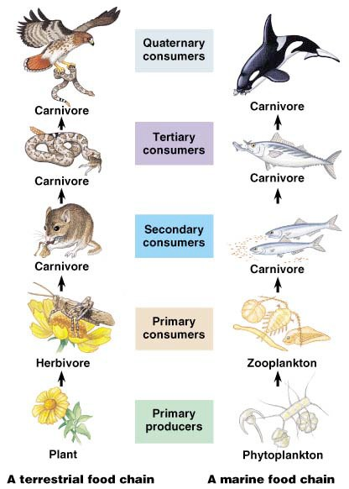

All organisms need an input of energy and nutrients to live. For animals, both of these come from the food they eat. For plants the source of energy is the sun — they produce their own food through photosynthesis — and their source of nutrients is the soil.

The feeding relationships between organisms forms a food chain. Producers (plants, or autotrophs) capture the sun’s energy and absorb nutrients from the soil to make their own food. Primary consumers (animals, heterotrophs, or herbivores) eat the plants and capture their energy and nutrients. Secondary consumers (animals, heterotrophs, or carnivores) eat the herbivores and capture their energy and nutrients. Third and fourth level consumers continue this chain by eating the lower level carnivores. Then finally decomposers break down waste and dead organisms recycling the nutrients back into the ecosystem, so they are available for another generation of plants and animals.

When a consumer eats another organism, only a small fraction of the energy taken in is used for growth. About 50% of the food is not digested or absorbed and is passed out as waste. About 40% of

The different levels of organisms in a food chain are called trophic levels.

the energy of the food is lost from as heat or used by the organism for cellular respiration — making energy for daily life. Only about 10% of the food eaten is used for growth and is therefore available as energy to the next trophic level in the food chain. This produces a pyramid of energy and a pyramid of numbers in an ecosystem. The greatest amount of energy and the largest population is at the base of the pyramid with the producers. The least amount of energy and the smallest population is at the top of the pyramid in the top level consumers.
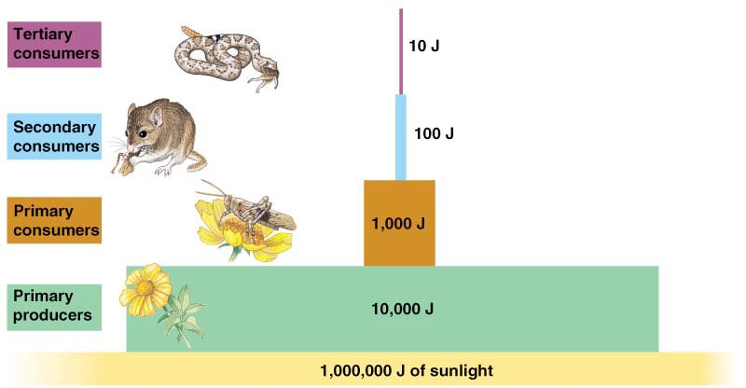

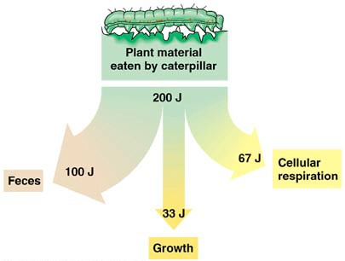

Only about 10% of the energy from the food eaten is used for growth.

Because of the loss of energy moving up the food chain, each trophic level can support fewer organisms.

PROCEDURE

1. | O  ▪ | n the accompanying sheets is a collection of organisms from a food chain:  grass
 | ▪ | grasshoppers
 | ▪ | mice
 | ▪  ▪ | snakes  hawks

2. You also have been provided with a food chain pyramid chart. Glue this pyramid into your notebook.

3. Cut out the organisms and organize them at the appropriate trophic level. Start by gluing all the grass (10,000 blades of grass) onto your ecosystem pyramid.

4. Now calculate the correct amount of each of the animals that can be supported at their trophic level, given the following rules:

▪  It takes 10,000 blades of grass to feed ________ grasshoppers.

▪  It takes ________ grasshoppers to feed ________ mice.

▪  It takes _______ mice to feed _______ snakes.

▪  It takes ________ snakes to feed 1 hawk.

5. Glue the correct number of animals onto the food chain pyramid at their proper trophic level.

6. Record the number of organisms at each trophic level.

7. Correctly label each trophic level:

▪  producer

▪  primary consumer

▪  secondary consumer
▪  tertiary (3rd level) consumer
▪  quaternary (4th level) consumer

8. Give your pyramid color so it stands out and is easy to remember.

9. Answer the Summary Questions then glue those pages into your notebook.

SUMMARY QUESTIONS

1. In the chart below record the number of organisms at each trophic level and calculate the ratio of predators to prey.

Trophic level | Name of organisms | Number of organisms | Ratio  (predator : prey)
Producers
Primary consumers |  |  | 1 :
Secondary consumers |  |  | 1 :
Tertiary consumers |  |  | 1 :
Quaternary consumers |  |  | 1 :

2. Explain why none of the ratios are 1:1. In other words, why does it take more than one prey to feed one predator?

3. What trophic level is not represented in your pyramid?

4. What energy source used by this ecosystem is not shown in the pyramid?

5. One day the people living in houses on the edge of this ecosystem spray a general purpose insecticide to kill a wide range of insects on their property. The wind carries the insecticide onto the field and it kills many of the grasshoppers. Discuss the possible effects on this ecosystem from the loss of the grasshoppers.

6. Even though all of the grasshoppers weren’t killed, they all were exposed to the insecticide, so when the mice eat them, they are also ingesting pesticide.

a. How much pesticide will each mouse take in compared to each grasshopper? Explain.

b. How much pesticide will each snake take in compared to each grasshopper? Explain.

c. How much pesticide will each hawk take in compared to each grasshopper? Explain.

d. Considering your answers to the previous questions, explain what happens to environmental poisons as you move up the food chain.

7. The grass necessary to support this ecosystem needs 10 acres to grow. But this field has been reduced to 5 acres because a developer has built houses on the other 5 acres. Explain what the result of this development will be on each of the trophic levels in this ecosystem.

8. Assume the pyramid you just completed was a pyramid of biomass.
a. If one hawk has a mass of 1.4 kg, how many kilograms of grass must exist in that area? __________

b. If each mouse has a mass of about 19.3 grams, how many hawks can live in the area if 100 mice are living there? Show your work in the space below __________
ENERGY I POPULATION SIZE PYRAMID

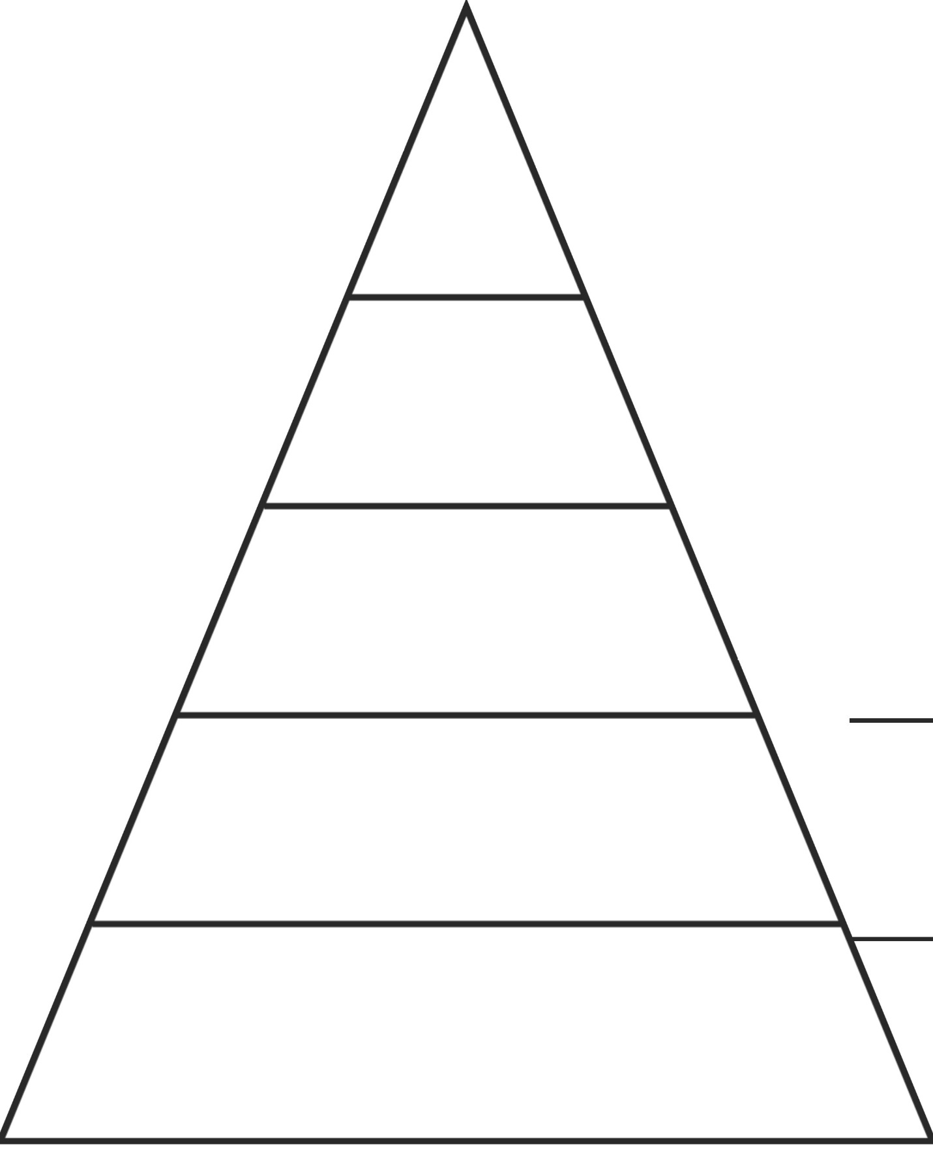

POPULATION SIZE
___________

____________

THIS PAGE INTENTIONALLY LEFT BLANK

