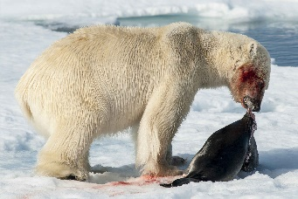
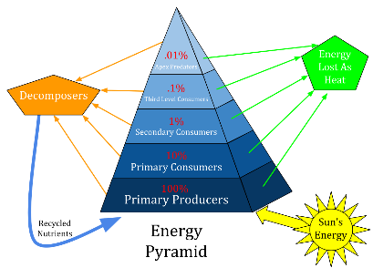
Chpts 3-6 : Ecology
Daily Warm Ups

The very first thing that you will do every day when you walk into class is a science warm up. This will usually be a question that will either get you thinking about what we will be learning that day or will help you think about what we learned during the day before. You should first try to answer the question from your own memory and using your own thoughts but, if you are having difficulty, you may look for the answer outside the class (book, internet, etc).
You can change your answers at any time prior to when it is graded (in fact, it is encouraged! Learning is a process). See me if you don’t understand or need help with any of these topics. If you ever miss a day, it is your responsibility to make-up the warm ups for the day you missed.

Warm Up questions are worth 4 points each. I will be looking for any misconceptions you might have, how thoroughly you answer a question, how much you used resources available to you, and even how well a particular Warm Up question is constructed.
Scoring Rubric:
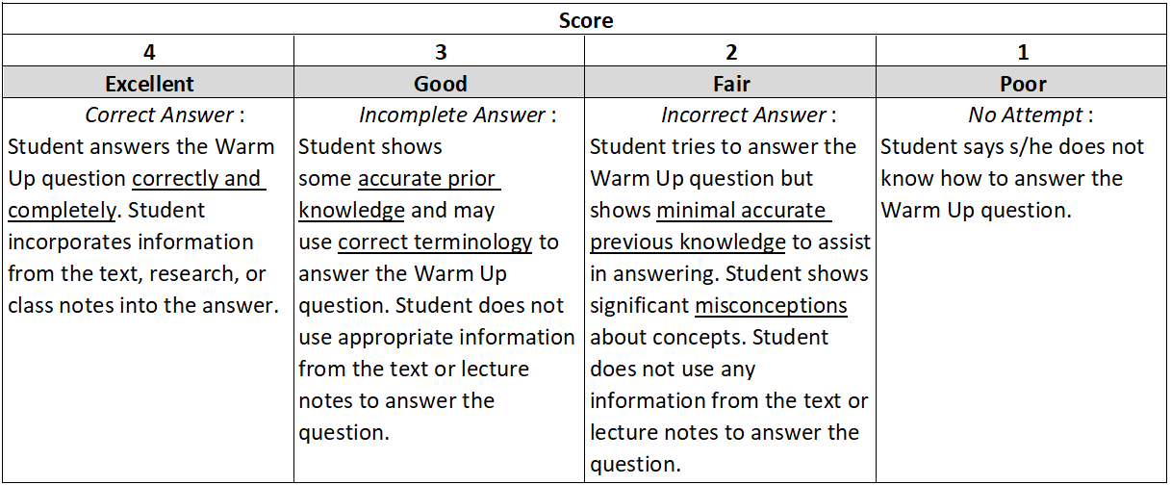

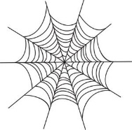
Date __________
Concept covered: Food Chains and Food Webs, pg 69-76
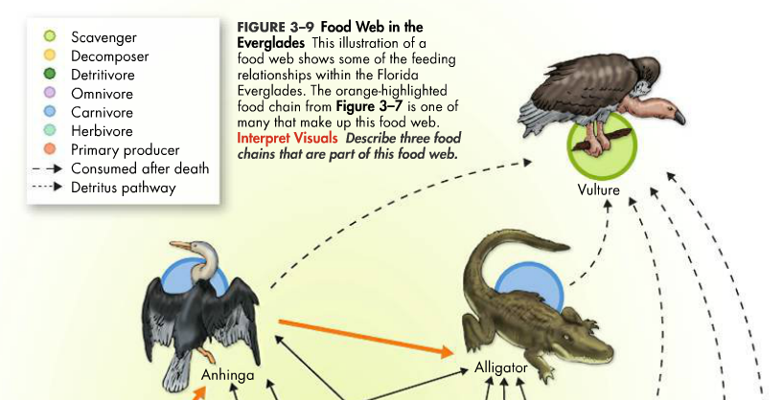

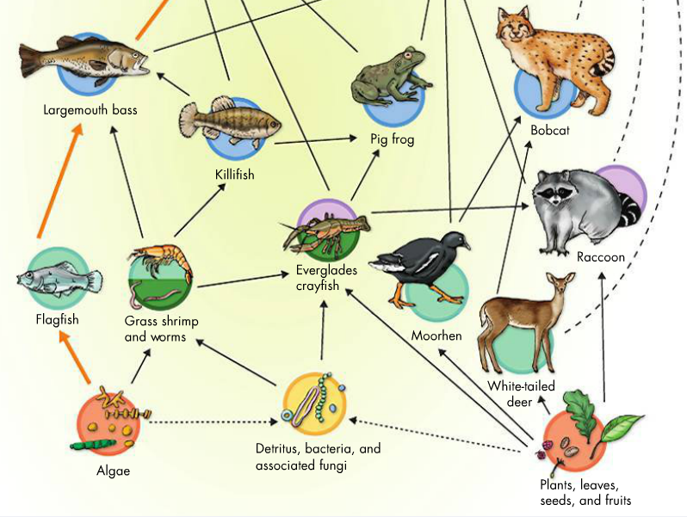

1. Circle 3 food chains that are part of this food web.
2. Why are the arrows pointing “up” and not down? _______________________________________________
3. What do ecologists mean when they say that alligators depend upon plants, leaves, seeds, and fruits for survival? _________________________________________________________________________________
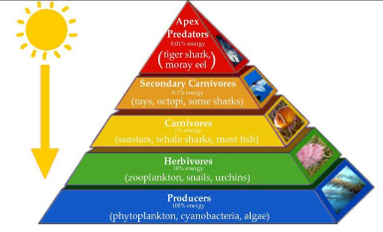
Date _________

Concept Covered: Ecological Pyramids, pg 77-78

1. Design a pyramid of numbers for this food chain: 200 caterpillars, 1 oak tree, 5 robins

2. Draw what the same food chain would look like as a pyramid of biomass.

3. If there are 10 robins living in an area and each robin weighs 70 grams, how many 2000kg oak trees must also live in that same area to maintain a healthy ecosystem? Show your work.

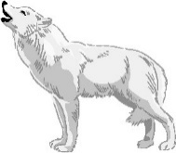
Date _________

Concept Covered: Keystone Species, pg 102

Watch the video “How Wolves Change Rivers” (4:35). Then answer the questions below.
https://www.youtube.com/watch?time_continue=67&v=ysa5OBhXz-Q

1. Many people opposed the reintroduction of the wolves to Yellowstone, and it was very controversial. A similar problem is happening on Isle Royale in Lake Superior. There are only 2 main species living on the remote island, wolves and moose. There used to be an “ice bridge” that would form in Lake Superior every winter allowing wolves from Canada, Michigan and Minnesota to cross back and forth onto and off of the island, therefore increasing the genetic diversity. With climate change, this ice bridge hasn’t formed in many years, and as of this January only 1 wolf remained alive on IR. What evidence could you provide from the video shows that reintroducing wolves would likely be beneficial to the ecosystem?

2. How did reintroducing wolves cause a change in the abiotic factors of Yellowstone?

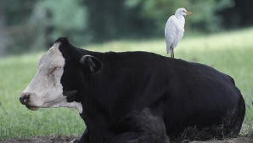
Date _________

Concept Covered: Symbiosis, pg 103-104

Label each of the following interactions as:
P = parasitism C = commensalism M = mutualism
_____1. The barnacles attached to the skin of a whale are feeding on food in the water that passes over them as the whale swims. The whale rarely notices they are there.
_____2. The whale barnacles grow too numerous and cause “drag” on the swimming whale.
_____3. A crocodile lies on the riverbank with its mouth open waiting for an Egyptian plover (bird) to eat the bits of decaying meat between its teeth.
_____4. A spider builds its web on a tree.
_____5. Tapeworms live in the intestines of animals and feed on the nutrients eaten by the animal.
_____6. Dogs will herd sheep and cattle for humans.
_____7. Humans have several species of bacteria living in the gut that we call “microflora”. The bacteria will produce vitamin B, further digest plant material the person can’t digest, and even provide an immune function.
_____8. A brown leech is feeding on the blood of its host, human.

Date _________
Concept Covered: Ecological Succession, pg 106-109

Cut out the pictures Mrs. McCarter hands to you. Arrange them in order. Glue onto the table.
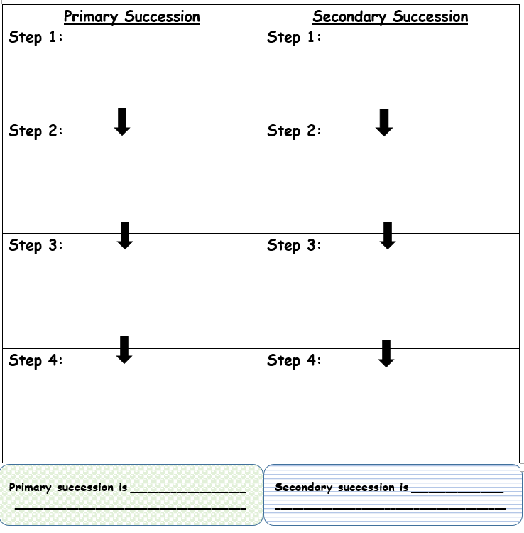

Date _________

Concept Covered: Population Graphs, pg 132-135

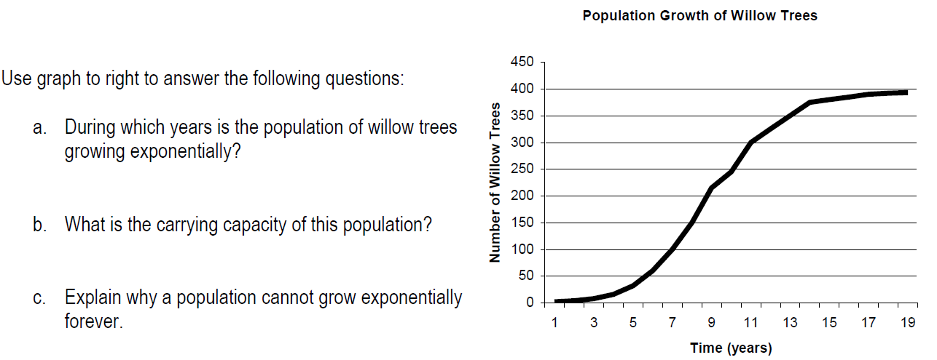

.
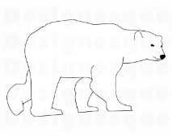
Date _________

Concept Covered: Climate Change, pg 173-179

Watch the video clip “State of the Planet's Wildlife: Climate Change May be a Death Sentence for Polar Bears”. Then answer the questions below.
https://www.youtube.com/watch?v=O_HyqPZdN5s
1. Refer to the graph on the next page. When did the downward trend in mean global sea ice begin? _____________
2. When did the upward trend in CO₂ levels begin? ___________
3. Why are scientists looking at CO₂ levels (in other words, why not look at N₂ levels)?

4. What are the possible effects for towns and cities along the coasts of the US in terms of water levels and polar bear activity?

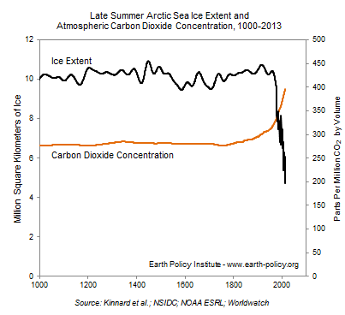

.

Date _________
Concept Covered:

