Chapter 3 Vocab
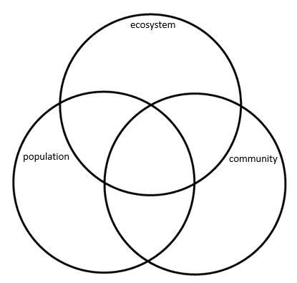
Food chain

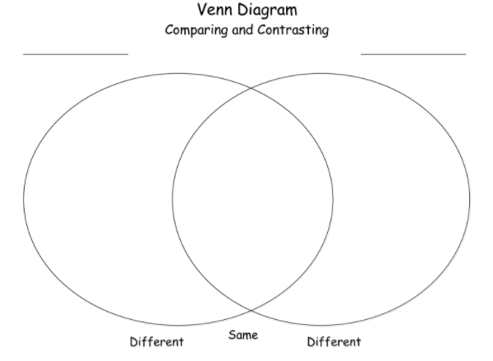

Food web

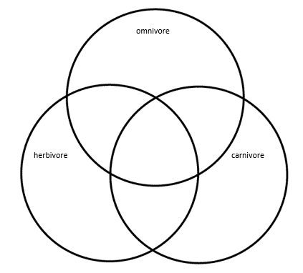
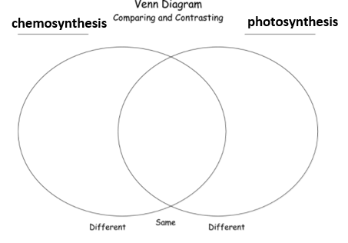

community

Chapter 3.1 -3.3 The Biosphere | ecology | Chapter 3.3--3.4 Energy Flow and Cycles of Matter, 4-2 Community Interactions | Ecological pyramid
 | biome |  | 10% rule
 | Biotic factor |  | biomass
 | Abiotic factor |  | biomagnification
 | autotroph |  | Biogeochemical cycle
 | Primary producer |  | transpiration
 | heterotroph |  | Nitrogen fixation
 | decomposer |  | denitrification
 | detritivore |  | Limiting nutrient
 | phytoplankton |  | eutrophication
 | zooplankton |  | habitat
 | saprotroph |  | niche
 | Trophic level |  | Competitive exclusion principle

Chapter 4-2 Community Interactions; 4-3 Succession; 5-1 Populations | predation | Chapter 5-2, 6-1 Limits to Growth | Density-dependent limiting factor
 | Keystone species |  | Density-independent limiting factor
 | symbiosis |  | Invasive species
 | Pioneer species |  | monoculture
 | Ecological succession |  | biodiversity
 | Primary succession
 | Secondary succession
 | Population density
 | emigration
 | Exponential growth
 | Logistic growth
 | Carrying capacity

