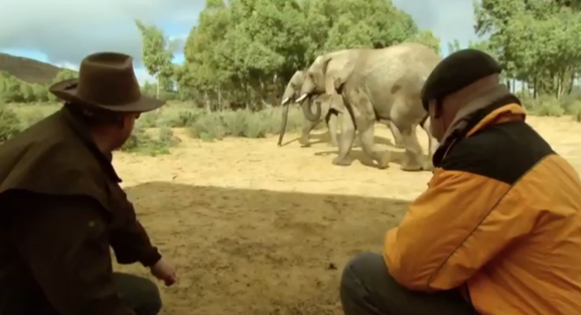
Scientific Method –
Are Elephants afraid of mice? Mythbusters

https://www.youtube.com/watch?v=7oA77tVNKtc&list=PLEtJLOC0O65zmOzJT8p4PPnmghTrBkt5u&index=1&feature=plpp_video

- State the question that Jamie and Adam are attempting to answer?

- What is the independent variable?

- What is the dependent variable?

4. What is their original hypothesis?

5. Why did the guys need to revise their original methods?

6. What were the final conclusions?

7. Explain one thing the guys could have done differently to make the experiment better?

8. Describe or way the scientific method is used by a professional in his/her job.

