Name:_______________ Date:__________ Period:______

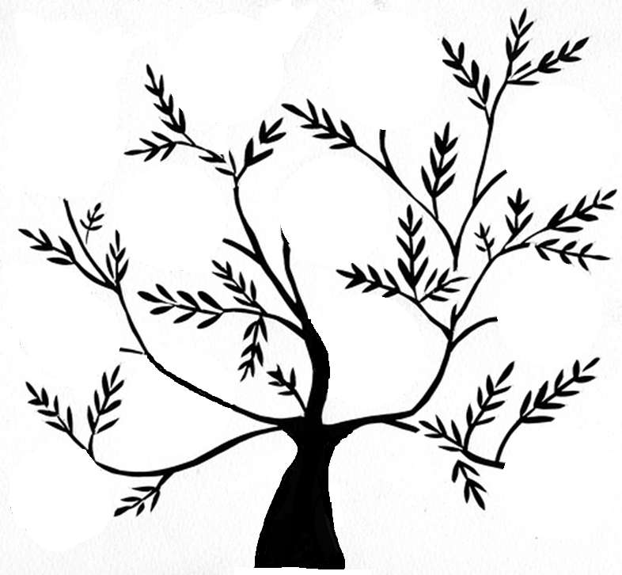

R___________________

D______

G_______________________

* Take in _____________ and ______________
* Sexual:_________________________________________
* Asexual:____________________________________________
* Groups of _______________ ____________ OR _______________________
* Evidence from:

H____________________

* One or more ________

**Characteristics of Life**