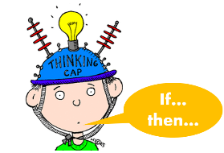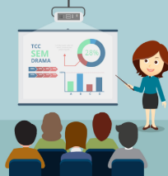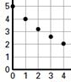

A procedure that is created in which only one variable is changed to test the hypothesis.

Results are shared with the scientific community through published papers.

A testable statement about what might happen.

Use the data to support or not support the hypothesis.

The process of noticing events and then generating ideas or problems based off of those events.

Collect & Analyze Data

Infer & Hypothesize

Draw Conclusions

Design Controlled Experiment

Observations & Questions

Information is gathered through detailed records of what is observed during an experiment.

Communicate Results/Peer Review

Cut out the boxes below, sort, and glue into categories of the scientific method.

Scientific Method

**Icon**

**Definition**

**Steps**