Why An Interactive Notebook?

You will also be spending a lot of time with something called BILL. In our Biology course, students keep an interactive student notebook (ISN), where you will document your learning and interact with course content. You will also take notes from the book and from videos you watch in this notebook. Our ISN is called a Biology Interactive Learning Log, and we will use it daily.

On any given day, we could be doing one of the following things in our notebook:
- Solving practice problems
- Answering practice questions
- Interpreting graphs or diagrams
- Building models and answering questions about them
- Creating graphic organizers or concept maps about biology content
- Writing practice free response questions

The activities we will do in our BILL are meant to allow you to interact with the biology content of our class in various ways. The more ways you interact with biological concepts, the more likely you will be able to apply them to new situations, whether it is a test or a lab investigation.

You will be asked to color code, highlight, ask questions and interact with your notebook on a daily basis, so it is important to bring it to class each day and to keep up with it every day. Keeping the items inside in order is important in helping you to organize your learning and keeping the flow of course content in a logical order. This will become even more important when you are reviewing for the final exams each semester.

To create your BILL, you will need a composition notebook, NOT a spiral-bound notebook. I have found the composition notebooks to be much more durable and less likely to have pages lost than the spiral-bound notebooks. This is important because by the end of the year, you will have a homemade study guide and you need it to be all in one piece! Because your BILLs get a lot of use, they need to be durable and sturdy, and the composition books fit this description.

You will need to decorate the cover of your BILL with a collage of some sort. Anything that is school appropriate is fair game. Make sure your name is clearly visible on the front. This is your opportunity to personalize your notebook and really make it yours. I do not expect you to be artists--this is not art class! I recommend that you cover the front of your notebook with clear packing tape once you have completed the cover to add durability, but also to protect the collage you make.

We will go over how to set up the inside of the BILL in class on the second or third day of class so be sure you have at least one composition notebook with you in class so that you can get it set up.

It is important that you keep up with your BILL on a daily basis, since this learning log is the physical representation of your processing of course concepts. We will use this notebook in class on a daily basis to catalog all the learning that you do both inside and outside the classroom, so it is important that you have it with them each day. Below are some collages that illustrate a little bit about what a BILL is, and how it might appear.

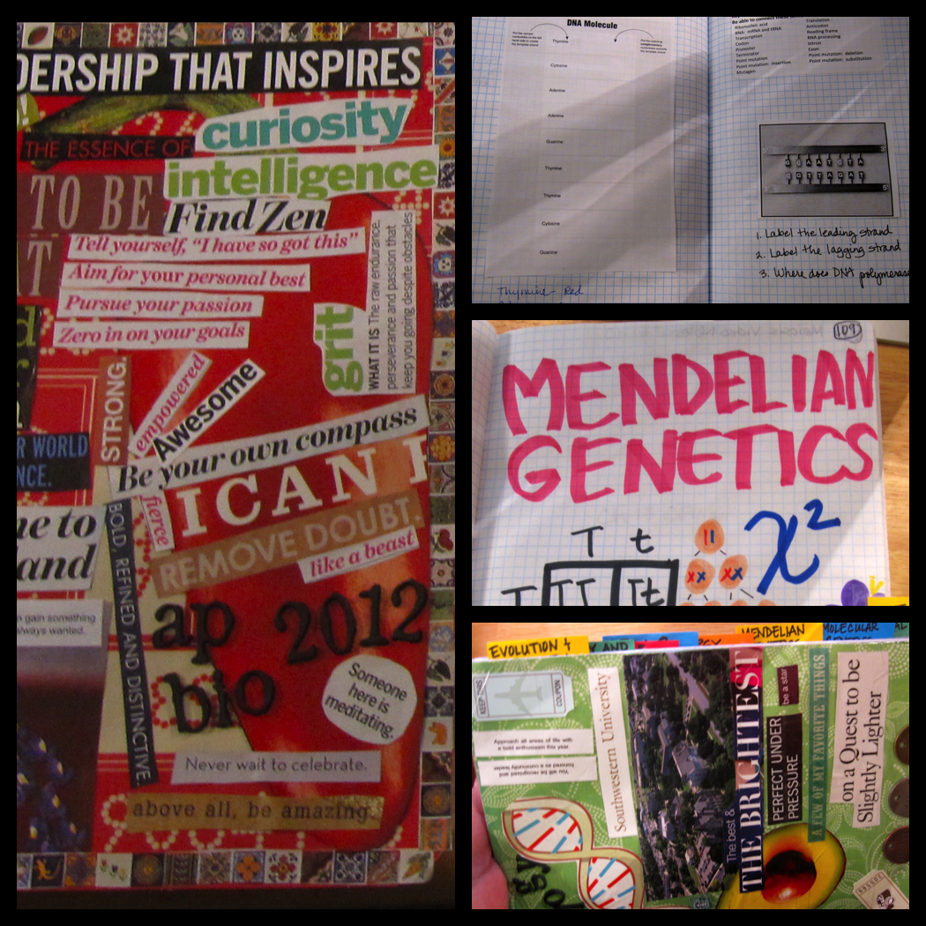
Here is what the cover and a cover page might look like. Personalize your notebook and make it your own.

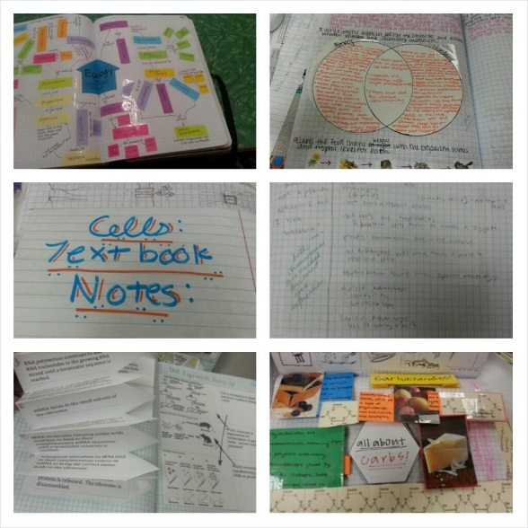
Here are some examples of activities you might be asked to do in your notebook. There are graphic organizers, concept maps, foldable activities, and models. These are just a few examples of things we will do in our notebooks that help you to learn the course content we will cover.

Why You Should Color Code Your BILL, and How to Do It

Color-coding and highlighting your learning log can help you organize information.
How often have you taken notes over several chapters and then gone back to review them, only to discover that you aren’t able to pick apart what’s important from what’s not? By using a color-coding or highlighting system, you can help yourself distinguish what information is truly important from what is not as important. For example, as you read this tip sheet, you are probably noticing that the headers for each paragraph are in boldface type and in red. The information in boldface red type is the key information, while the information that is highlighted in orange-yellow represents supporting information.

Color-coding and highlighting your learning log can help retain more information.
Research indicates that color coding is beneficial because it causes the learner’s eyes to track more often over material, and fixate on the color-coded items less frequently, but for a longer period of time. The fixation of the eyes on the color-coded items for a longer period of time leads to more information processing in the brain, which leads to more learning. Students who read information that had been color-coded were better able to retain information since their eyes would immediately track to what had been marked as important. Additionally, this led to improved performance on tests.

So how do you begin using a color coding system? Let’s talk about the HOW.
- Choose a color coding or highlighting scheme. For example, you may choose to identify key concepts in one color, and supporting concepts in another, and key terms in another. Whatever colors you choose is up to you, as long as you identify what information belongs to what color. Another way you can do this when taking notes is this:
  - Highlight or underline information you thoroughly understand in green.
  - Highlight or underline information you still are unsure about or have questions about in yellow.
  - Highlight or underline information you truly do not understand in red.
- The number of colors you use matter. If you narrow down the number of colors you plan to use, this will reduce confusion for you when you go back to study later on. Also, realize that not every piece of information you gather from viewing lectures or reading your text is important. How you decide to color code/highlight will determine how many colors you end up using.
- The colors you use must make sense to you. In the end, it will not matter to me what the colors you choose to use mean, but only that you are implementing some sort of color coding scheme to organize your studies. Additionally, the colors you choose must make some sort of organizational sense for you. If you feel that all key terms should be circled in blue, then by all means, do that!
- Color coding connections between units of study is also helpful. For example, if you color code by themes, you could choose a color to represent all the things we study that relate to evolution, or to cellular processes. This will enable you to see the connections between units, and prevent you from viewing them as isolated topics. Biology is all about interrelationships and connections! This practice will help you see how all the things we study are related to one another.
- Use colored symbols to identify items that require further review or study or to identify items you are confident you know. When you are going back over your notes after you have taken then, it is a good idea to identify those items that you need to ask questions about, or need further instruction about. If you color code them or use a colored symbol to denote these things, it will make it easier to identify what you need help with. For example, you could put a red star by the things that you need more help with. Conversely, you could use a green star to note the concepts and ideas you are confident you understand.

With these tips, you will be on your way to becoming an organized learner who will see more success in retaining information you have learned.

