Sea Urchin Fertilization Lab

Prelab: http://virtualurchin.stanford.edu/fertlab.htm
- Do the interactive tutorials about “fertilization and development” and “anatomy”. The above link brings you directly to the “fertilization and anatomy”, then you click on the hyperlink on the left sidebar to get to “anatomy”.
- Read the background below and answer the 4 questions after it.
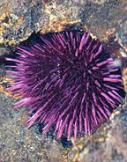
BACKGROUND
Though urchins inhabit ocean waters all around the globe, and their eggs are eaten in many parts of the world, their use in biological experiments began by chance.
The era of modern biology started in the 1870s, when scientists realized that organisms are composed of cells. Improvements in microscopes were also letting researchers see new things. At the time, German scientists led the way in biological research and established a station for studying marine organisms near Naples, Italy. Needing samples to study, they plumbed the local waters. When they noticed fishermen dining on urchin eggs, biologists brought the eggs back to their labs.

Under the microscope, scientists found cells so transparent they could easily see what was happening inside them. That quality, along with the incredible abundance of eggs from just one urchin, made the sea creature a lab favorite. And as researchers watched the see-through eggs, they witnessed profound events still of interest to scientists today.
The aha moment
When the urchin began its life in science, just 130 years ago, scientists couldn’t yet answer the question "where do babies come from?" They knew male sperm needed to enter a female’s body—but some thought a tiny human, or homunculus, lived in the sperm, waiting to grow once it was inside a female.
Then, in 1875, German biologist Oskar Hertwig watched as an urchin sperm entered an urchin egg. The sperm nucleus then fused with the egg nucleus, triggering a chain of events that caused the cell to divide. This was it—fertilization. The beginning of a new organism. The aha moment. The long sought-after explanation of sexual reproduction.
The urchin’s unique contribution to this revelation was the transparency of its eggs. Hertwig could see the nucleus of the sperm, a darkish circle against the lighter background of the egg cell, grow when it entered the egg and move toward the egg’s nucleus. He watched as the two small circles met and slowly became one. Today, researchers still observe this activity, searching for clues to treat certain forms of infertility. In fact, many of the methods used in modern human fertility research can be traced back to early work done using urchins.

http://www.exploratorium.edu/imaging_station/research/urchin/story_urchin1.php

Many other living things are used today as “model organisms” to study biological processes. For instance, Gregor Mendel used peas, Charles Darwin used finches, fruit flies are used to study inheritance of genes, and roundworms like C. elegans are commonly used in many labs to study genetics and cell function. Model organisms are used to research human diseases, genetics, etc. where using actual humans would be considered unethical or dangerous. The sea urchin is one such model organism that has proved to be very useful in gaining insights into fertilization and embryology.
The type of sea urchin we will be using today is called a Lytechinus variegatus, or green urchin. They are collected from calm, clear waters off the coast of Florida. They feed mainly on seagrass. There is no quick and easy way to tell a male urchin from a female. The color of the gametes is the best way. Sperm is white and eggs are yellowish-orange in color.

PRE-LAB QUESTIONS
1) What does it mean when we refer to something as a “model organism”?

2) Why is reproduction is important?

3) How do organisms develop after fertilization?
4.) How do you tell a male sea urchin from a female?

Please wash your hands with warm water before handling the urchins but NO SOAP as they are very sensitive to the detergents found in hand soaps.

OBJECTIVE: To examine the external structures of live adult sea urchins, to induce sea urchins to release gametes; to witness fertilization and early development of the sea urchin.

MATERIALS :
Light Microscope Sea Water 100mL
Concavity slides Graduated cylinder
Plastic cup Cover slips
Syringe with needle Pipettes
1.5mL of 0.5M potassium chloride (KCl) solution

PROCEDURE:
1. Load the syringe with 1.5mL of the KCl solution. Carefully insert the needle through the soft tissue surrounding the urchin’s mouth and inject the solution into the central cavity. Swirl the urchin gently to mix the solution inside. Within 10 minutes, gametes will release from the top of the urchin.

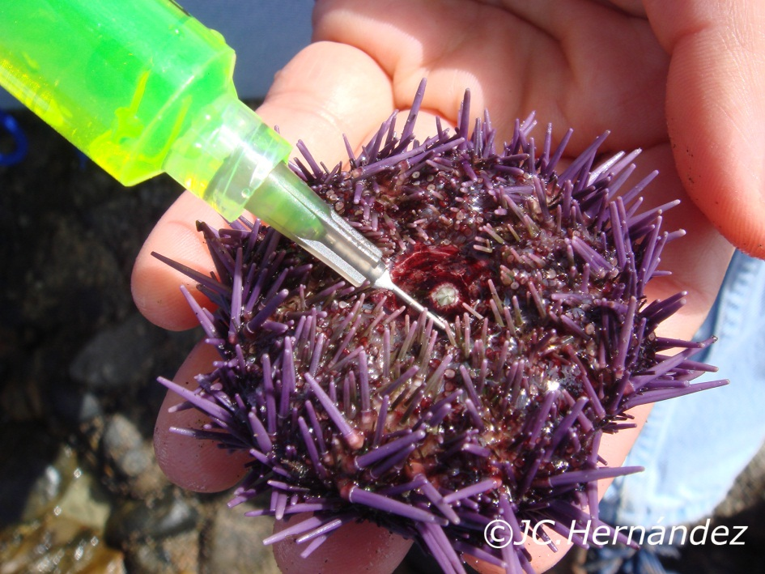
http://www23.homepage.villanova.edu/josecarlos.hernandez/urchin%20web/overview%20growth.html

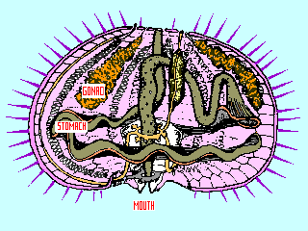

2. You will be able to differentiate male and female urchins when you see the gametes. Eggs are yellow or orange and sperm is white. The sperm should be collected “dry” and the eggs need to be collected in seawater. To do this, turn over the urchin on a plastic cup and wait to hear the “plop” of cells dropping into the cup. If it is egg cells, then fill the cup with about 50mL of seawater.

There will be enough sperm and eggs for the whole class from one set of “parents”.

3. To witness fertilization, place a drop of eggs on a concavity slide and focus on it with your microscope. You may need to turn down the light using the diaphragm to best see the cells. Add a drop of diluted sperm (one drop of sperm to 75mL of seawater just before use.) Using full-strength sperm suspension would likely cause polyspermy, or more than one sperm fertilizing one egg, followed by abnormal development of the zygote. Quickly add a coverslip and observe.

Fertilization should occur within 1-2 minutes of adding the sperm to the eggs. You will confirm fertilization by identifying a halo like membrane around the egg.

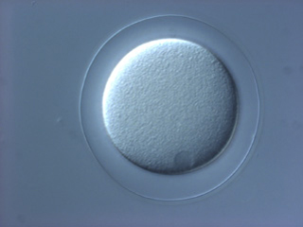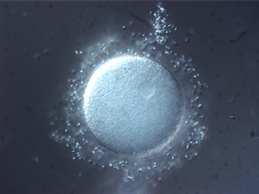

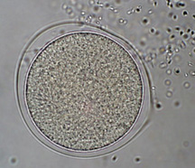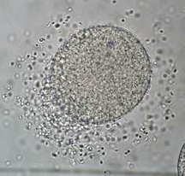

ANALYSIS:
1.) Why do you use a depression slide to view the eggs?

2.) What is the purpose of the halo?

3.) What SPECIFICALLY would happen if multiple sperm were able to fertilize one egg?

