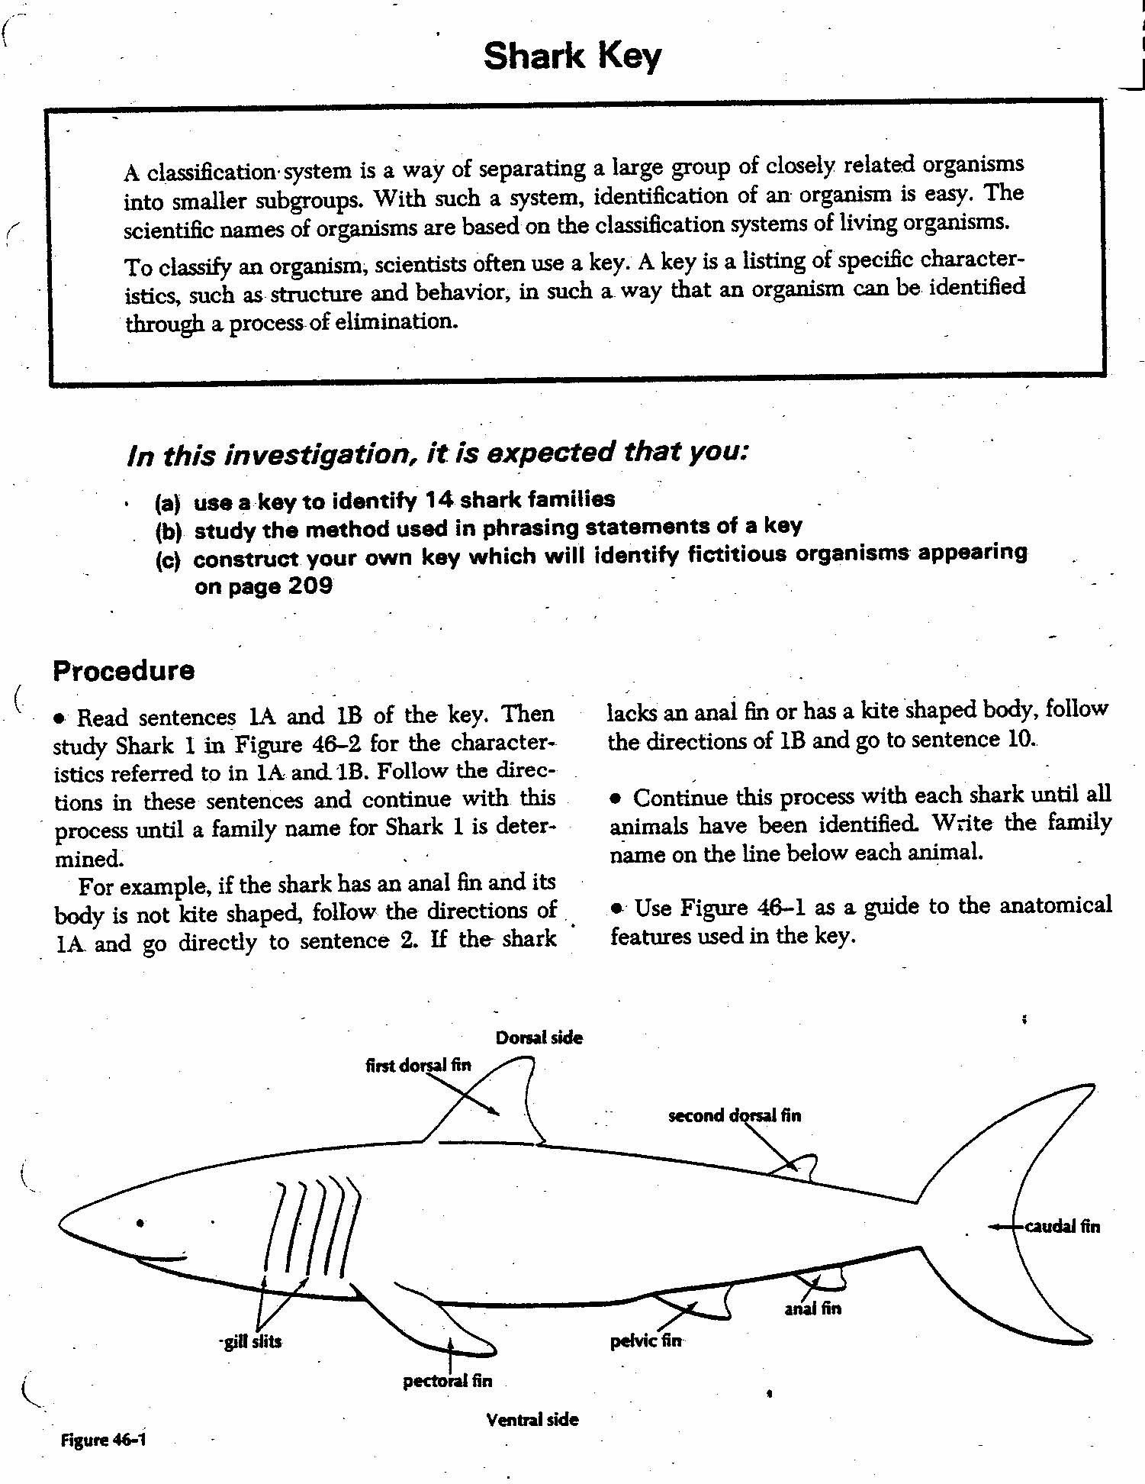
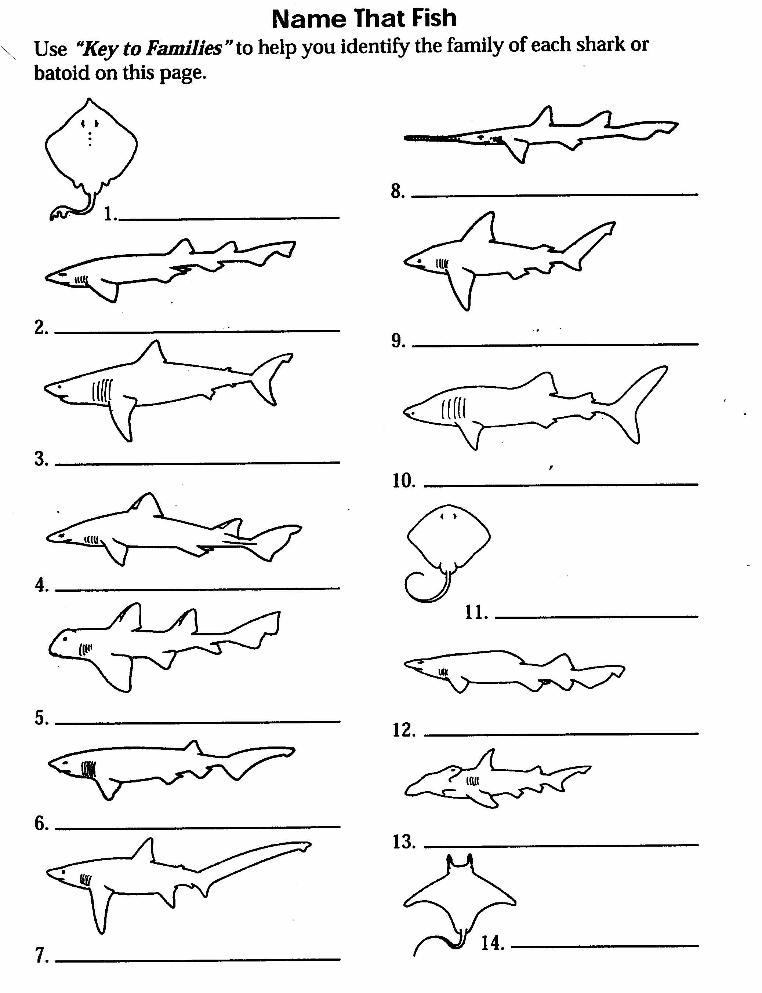
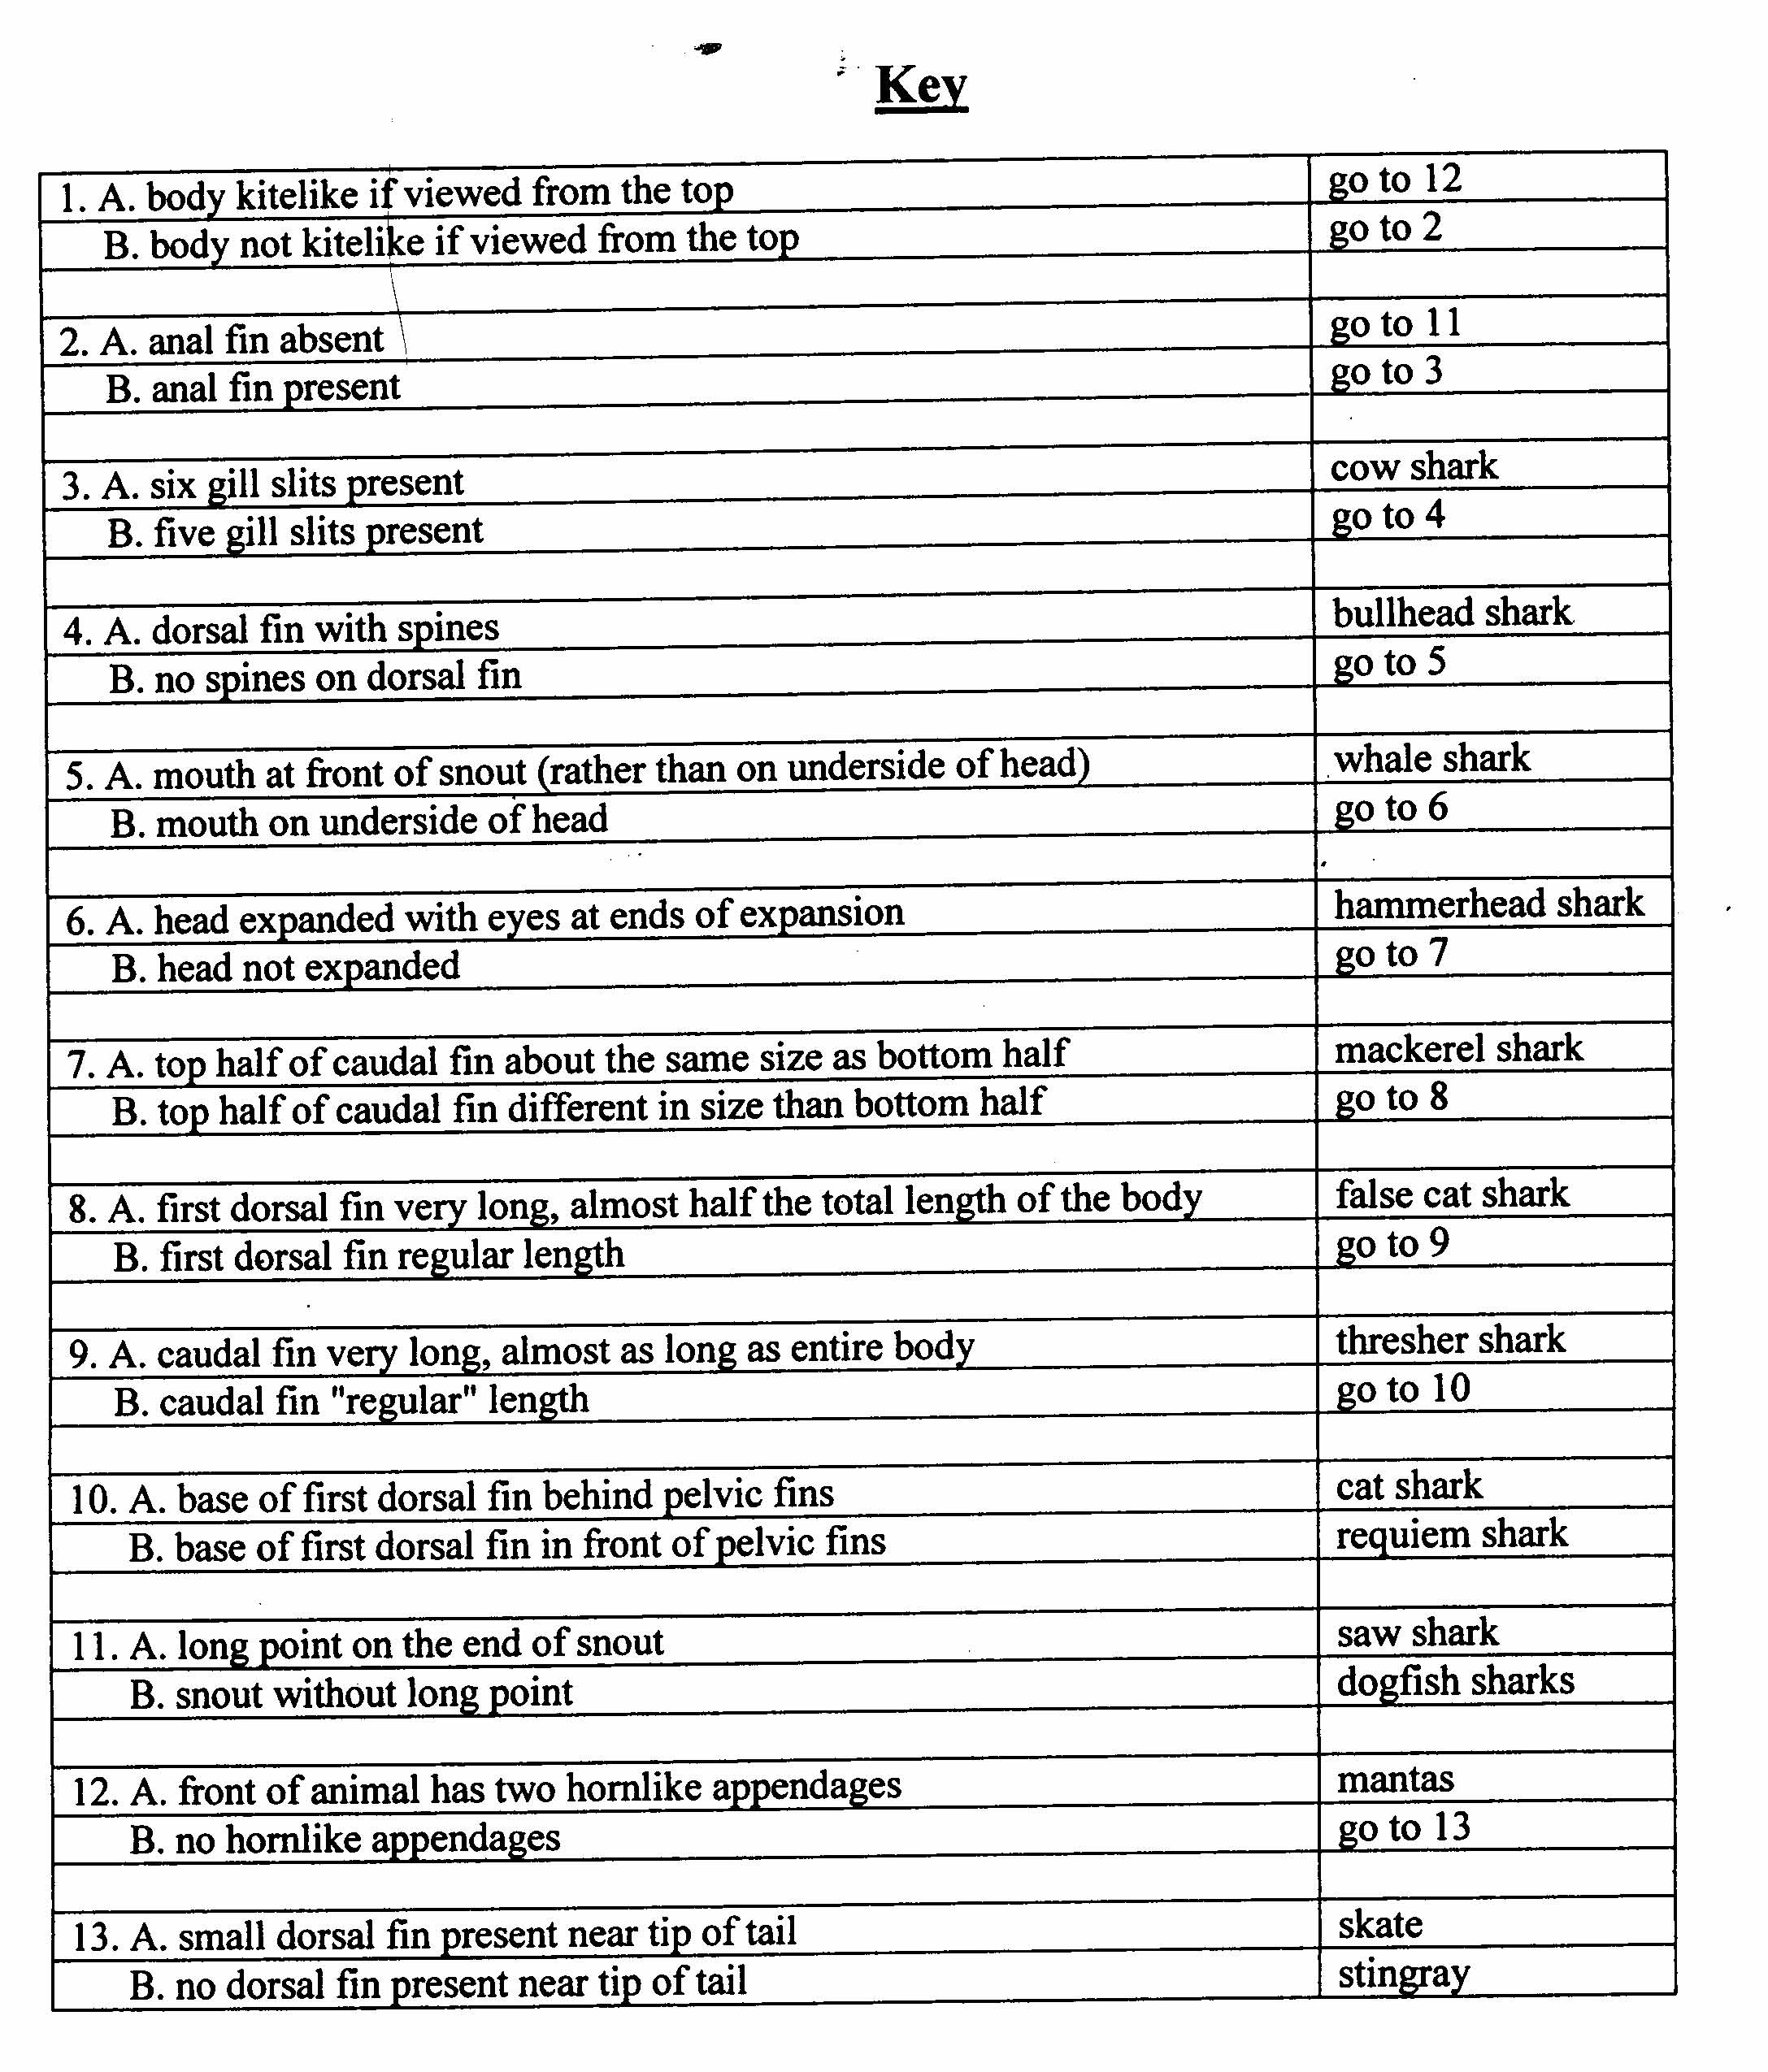
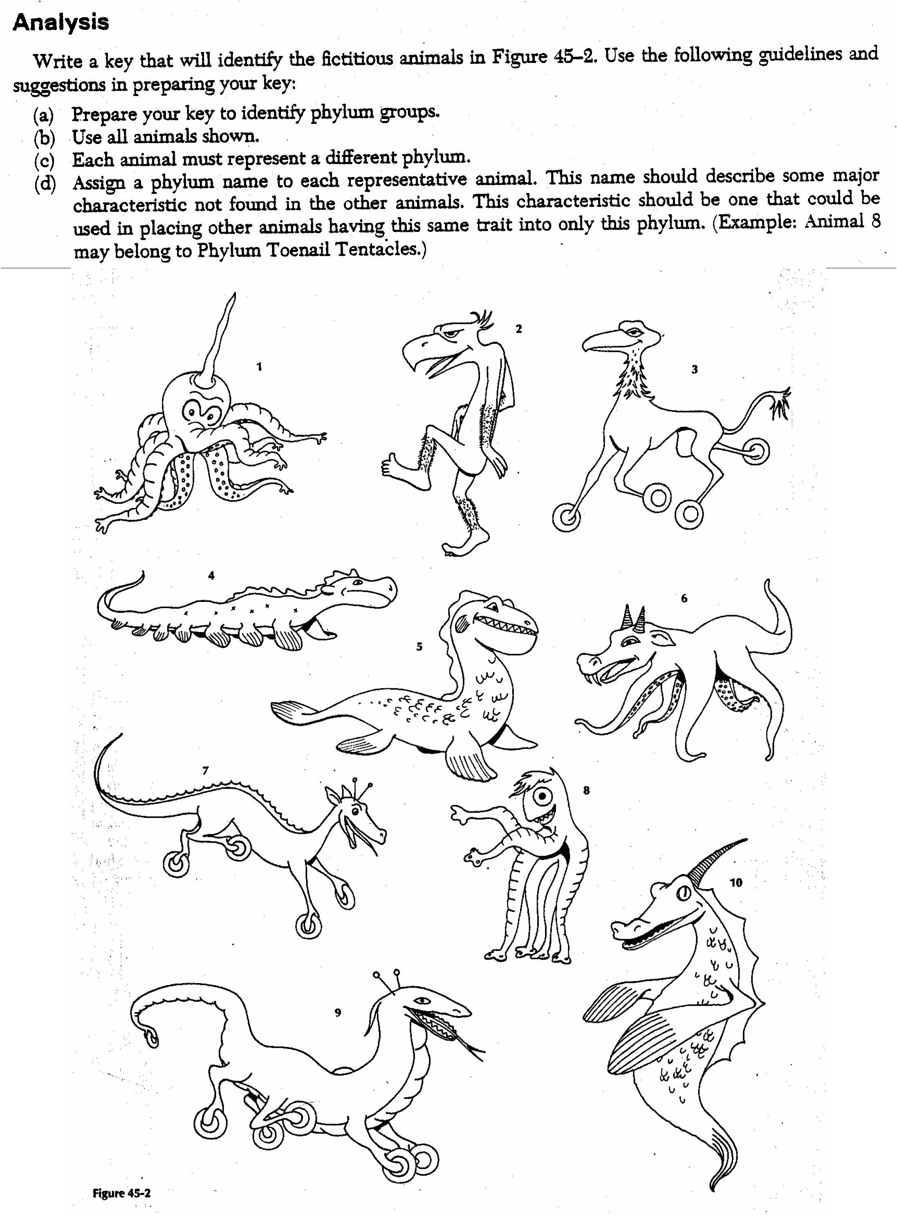

Cladistics Lab

You are a scientist trying to determine the relationship between the organisms below. Using your knowledge of cladistics create a cladogram that represents how these animals are related. Cut out each of the animals illustrated below and glue them on a separate sheet of paper to create your cladogram.

Consider the following characteristics when designing your cladogram. The terms in bold should be included on your cladogram. Be sure all of your animals are arranged at the top of the cladogram and the distinguishing characteristics are listed.
- Divide the animals into two groups depending on if they possess vertebrae.
- Divide the vertebrates into groups according whether they have an amniotic egg or not. (Hint: keep the animals who give live birth with the amniotic egg animals.)
- Divide those who have amniotic eggs according to the presence of an exoskeleton.
- Divide those with endoskeleton according to whether or not they give live birth.
- Divide those with live birth depending on if they possess opposable thumbs.
- Return to your invertebrates. Divide them according to the presence of an exoskeleton.
- Divide those with exoskeletons according to whether they possess wings.

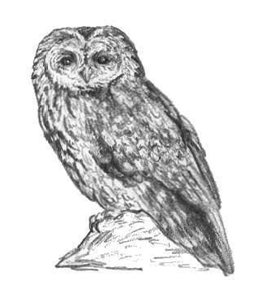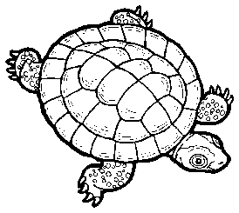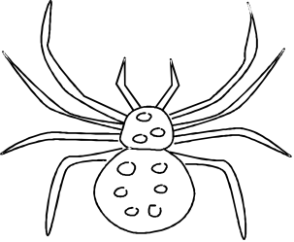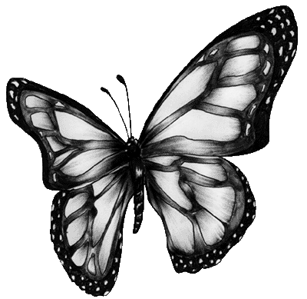
Owl Turtle Spider Butterfly

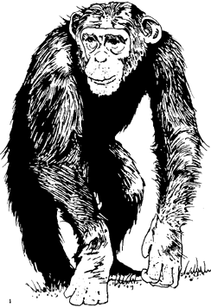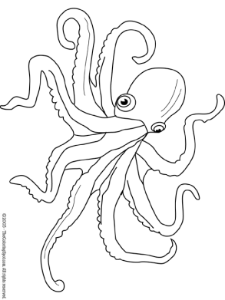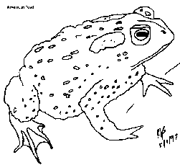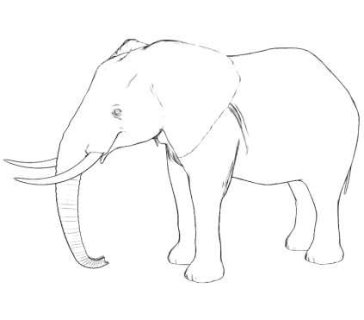

Chimpanzee Octopus Toad Elephant

