1. Which picture below represents a protein? ______
2. Which picture represents glucose? _______
3. Letter A belongs to which of the 4 groups of organic compounds? ______________
4. Which picture is an unsaturated fat? _________
5. Which picture shows a starch? ___________ What is the monomer of this starch? ________________
6. Which picture shows a disaccharide? _________
7. Letter E is the monomer for what group of organic compounds? __________
8. Which picture shows a phospholipid? ________ Phospholipids make up what cell structure? ___________________
9. Letter K is the monomer of what group of organic compounds? ___________________
10. What compound is letter H? __________________
11. What compound is letter A? _________________________
12. Which pictures are carbohydrates? ___________
A. 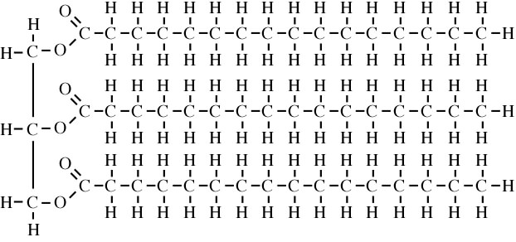
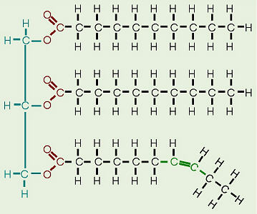

B.

C. 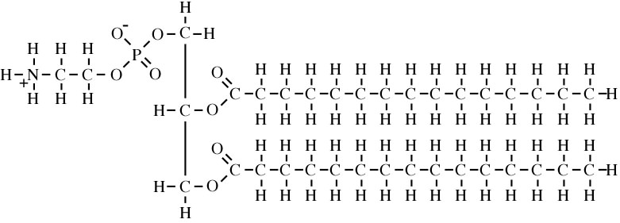

D. E.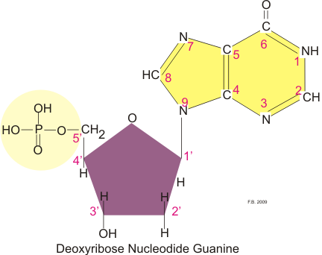

F. 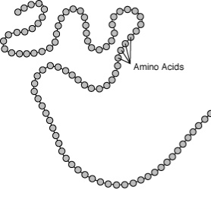 G.
H. 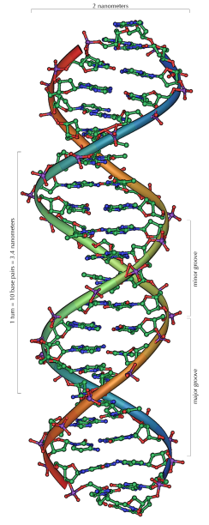 I.

J. 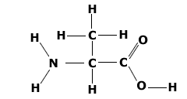 K. 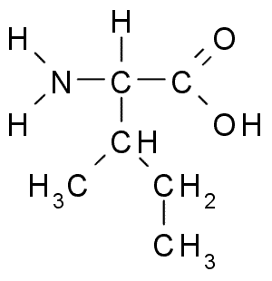
1. Which picture below represents a protein? __F____
2. Which picture represents glucose? __D_____
3. Letter A belongs to which of the 4 groups of organic compounds? ____lipids__________
4. Which picture is an unsaturated fat? ___B______
5. Which picture shows a starch? __I_________ What is the monomer of this starch? ____glucose____________
6. Which picture shows a disaccharide? _G________
7. Letter E is the monomer for what group of organic compounds? __nucleic acids________
8. Which picture shows a phospholipid? __C______ Phospholipids make up what cell structure? __cell membrane____
9. Letter K is the monomer of what group of organic compounds? ______proteins_____________
10. What compound is letter H? _____DNA_____________
11. What compound is letter A? _________triglyceride________________
12. Which pictures are carbohydrates? __D, G, and I_________

